Dear Parent/Carer
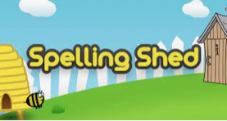
To improve spelling across the school we have signed up to Spelling Shed. Spelling shed can be accessed online (for free) or via and app (at a cost)

Once your child has their login information they can access our online game via https://play.spellingshed.com.

The Spelling Shed helps children to practise and learn their spellings via a simple game. The game gives four different degrees of support in the form of difficulty modes; Easy, Medium, Hard and Extreme. Higher levels allow a higher score to be achieved but children can practise as much as they like on lower levels before trying to gain high scores.

The scores achieved give a league position. Children will move along the ‘bees’ in the classroom until they reach royal bee. If they reach royal bee by Thursday, they will receive a treat for their amazing efforts.

Children are also awarded honeypots within the app. They can use these honeypots to design their own avatar. Teachers can also give honeypots to children who have worked hard.

We have seen a huge improvement in spelling scores from children who use the app regularly. It also allows children to practise independently to supplement strategies already used at home.

If you have any questions please do not hesitate to ask.

Thank you
Miss Exley

