Anti-Bullying Policy

Leadership Team Responsibility: | DHT Behaviour
Version Date: | June 2020/21
Presented to Interim Executive Board on: | 14th September 2020
Review Date: | September 2022

To be read in conjunction with:
- Eastlea Safeguarding Policy
- Eastlea Behaviour Policy

1. Anti-Bullying Policy
Definition
Cyberbullying
Key Staff and Responsibilities
Working with the School Community
Preventing Bullying
Identifying and Responding to Bullying

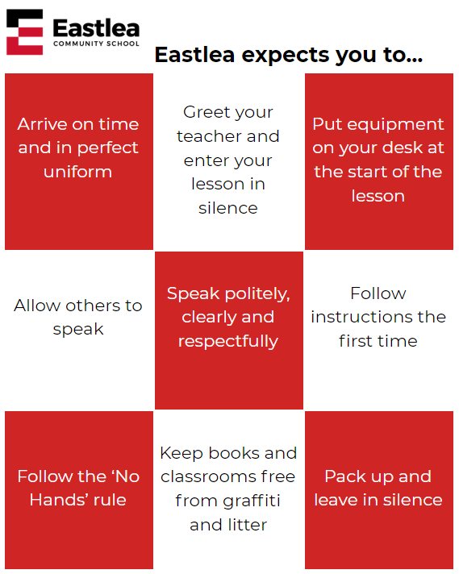

1. Anti-Bullying Policy
All members of Eastlea School Community have the right to learn and work in an environment where they are treated with respect and are free from fear and intimidation. Bullying damages self esteem and confidence and can impair a child’s academic achievement;. Bullying can have long term consequences for the victim, and can contribute to a negative atmosphere in the school which affects other students as well as the victim.

Bullying is damaging and unacceptable. Eastlea Community School will take all possible steps as laid out in this policy to reduce and eradicate instances of bullying and also to empower all stakeholders to take action in order to rebuild and counteract the impact of bullying on the victim.

Definition
Bullying is behaviour by an individual or group, repeated over time, that intentionally hurts another individual or group either physically or emotionally. Bullying can take many forms (for instance, cyber-bullying via text messages or the internet), and is often motivated by prejudice against particular groups, for example on grounds of race, religion, gender, sexual orientation, or because a child is adopted or has caring responsibilities. It might be motivated by actual differences between children, or perceived differences. Stopping violence and ensuring immediate physical safety is obviously a school’s first priority but emotional bullying can be more damaging than physical. Many experts say that bullying involves an imbalance of power between the perpetrator and the victim. This could involve perpetrators of bullying having control over the relationship which makes it difficult for those they bully to defend themselves. The imbalance of power can manifest itself in several ways, it may be physical, psychological, derive from an intellectual imbalance, or by having access to the support of a group, or the capacity to socially isolate. It can result in the intimidation of a person or persons through the threat of violence or by isolating them either physically or online. Bullying can happen to anyone. Specific types of bullying include:

- Bullying related to race, colour, nationality (including citizenship) or ethnic or national origin
- Bullying related to learning difficulties or disability
- Bullying related to sexual orientation (homophobic bullying)
- Sexist or sexual bullying
- Transphobic bullying
- Bullying related to appearance or health conditions

Cyberbullying
- Cyberbullying is when someone uses technology (such as the internet or a mobile phone) to bully others. Being a victim of cyberbullying can be very distressing for a young person as most of the time they don’t know who is bullying them. Cyberbullying includes things such as sending nasty text messages or emails, or setting up a hate group on a social networking site. The bullying may also happen 24/7 and the victim is often targeted even when they are in the comfort of their own home. Images and text messages can be circulated very quickly and widely on the internet which makes it very hard to combat cyberbullying.

- Bullying is not new, but some features of cyberbullying are different from other forms of bullying:

  - Cyberbullying can take place at any time and can intrude into spaces that have previously been regarded as safe or personal.
  - The audience can be very large and reached rapidly. The difficulty in controlling electronically circulated messages means the scale and scope of cyberbullying can be greater than for other forms of bullying. Electronically forwarded content is hard to control, and the worry of content resurfacing can make it difficult for targets to move on.
  - People who cyberbully may attempt to remain anonymous. This can be extremely distressing for those being bullied. The person cyberbullying may never be in the same physical space as their target.
  - The profile of the bully and target. Cyberbullying can take place both between peers and across generations; teachers have also been targets. Age or size are not important. Bystanders can also become accessories to the bullying; for example, by passing on a humiliating image.
  - Some instances of cyberbullying are known to be unintentional. It can be the result of not thinking (something sent as a joke may be deeply upsetting or offensive to the recipient) or a lack of awareness of the consequences – for example, saying something negative online about another student, or friend that they don’t expect to be forwarded or viewed outside their immediate group.
  - Many cyberbullying incidents can themselves act as evidence. This is one of the reasons why it’s important to know how to respond.

Key Staff and Responsibilities
There are several post-holders across the school who contribute directly or indirectly to the prevention and eradication of bullying within Eastlea Community School:

- Deputy Headteacher for Behaviour coordinates all Anti-Bullying work across the school including the use of restorative practice.
- Pastoral Manager - investigate, sanction and complete restorative work for all incidents of bullying.
- Achievement Leaders - Manage the academic progress and pastoral wellbeing of students.
- Head of PHSE - responsible for the Anti-Bullying message within the curriculum
- Deputy Headteacher overseeing Whole-School SMSC - Ensures that students regularly reflect on the rights and responsibilities of all members of the community and the importance of tolerance and treating all members of the community with kindness, respect and consideration.
- The online safety lead- ensures that students are made aware of how to keep themselves safe online and the effects of cyberbullying.
- All members of staff - are responsible for identifying and reporting suspected cases of bullying. All staff are also responsible for challenging unacceptable language and
- School Governors and the Headteacher - are responsible for monitoring and review of this policy.

Working with the School Community
Eastlea Community School:
- Discusses, monitors and reviews our anti-bullying policy on a regular basis involving all stakeholders
- Ensures that all staff understand the impact that bullying can have, can identify bullying, are aware of what to do when bullying is suspected or reported
- Ensures that students are aware that all bullying concerns will be dealt with sensitively and effectively
- Ensures that parents/carers know who to contact at school about bullying-related issues.
- Reports back to parents/carers regarding their concerns on bullying and deals promptly with complaints
- Seeks to learn from good anti-bullying practice elsewhere

Preventing Bullying
Eastlea Community School:

- Recognises that bullying often happens because of perceived or actual differences and can be motivated by prejudice
- Recognises that cyberbullying has some features that are different to other forms of bullying and consequently needs to be treated differently
- Uses curriculum, PSHE and assemblies opportunities to raise awareness of bullying relating issues
- Actively provides systematic opportunities to develop students’ social and emotional skills including their self esteem and resilience
- Involve students in anti-bullying campaigns in schools
- Publicises the details of helplines and websites
- Creates “safe spaces” for vulnerable children and young people
- Ensures students know how to express worries and anxieties about bullying
- Has a peer support programme that students can access if they feel they are being bullied
- Seeks to systematically collect the views of students and parents in order to evaluate and improve anti-bullying practice
- Records all incidents of bullying including specific types and means of bullying in order to evaluate and improve anti-bullying practice
- Ensures that students and staff know how to identify and deal with cyberbullying in its own right

Identifying and Responding to Bullying
Eastlea Community School:
- Will ensure that all reported cases are fully recorded on the school’s ‘Bullying Log’, investigated and sanctioned
- Will ensure that students who experience bullying: feel heard; know how to access support; feel confident in the school’s ability to deal with the bullying; have steps taken to make them feel safe and rebuild confidence and self esteem
- Will ensure that students who engage in bullying behaviour are sanctioned or held to account using restorative means for the harm they have caused and supported to learn to behave in ways that do not cause similar harm in the future
- Will ensure that bystanders and supporters are aware that the behaviour they have witnessed is thoroughly unacceptable and will not be tolerated.

Reporting and investigating bullying
Children are able to report instances of bullying to any member of staff at Eastlea and trust that they will be appropriately supported. Members of staff should ensure that the student's Pastoral Manager or Achievement Leader is informed when they become aware of bullying. Parents can report bullying to any member of staff but may wish to report directly to their child's Tutor, Pastoral Manager or Achievement Leader. If they are concerned that there is not an appropriate and adequate resolution then they should forward their concerns to the Deputy Headteacher for Behaviour.

If you witness or are involved in any form of bullying you can report it to:

Pastoral Manager
Tutor
Achievement Leader
Safeguarding Team
All Staff
This will be investigated by the student’(s) Pastoral Manager

Deputy Headteacher (behaviour)

All student’s families will be notified
Sanctions will be agreed
Restorative sessions and support

