Summary Risk Assessment (SRA) for Wider Opening of Schools September2020*
Academy / School | Eastlea Community School | Trust | Newham Community Schools Trust
Headteacher | Sarah Morgan (HoS) / Charlotte Robinson (EHT) | Location | Pretoria Road, Canning Town, E16 4NP
Amended | 21.9.20

The government has announced that all schools will reopen fully from September 2020. As part of this wider opening we have completed a risk assessment to ensure that we keep our school community as safe as possible. The risk assessment is based on the public health advice that schools should use the ‘systems of control’. By following these ‘controls’ the risk of transmission will be significantly reduced. The systems of control are:

- Minimising contact with individuals who are unwell - anyone with COVID-19 symptoms (or a member of their household) should not attend school.
- Clean hands thoroughly and more than usual.
- Ensure good respiratory hygiene ‘catch it, kill it, bin it’.
- Enhanced cleaning, particularly frequently touched surfaces.
- Minimise contact between individuals and keep socially distanced where possible.
- If necessary wear appropriate PPE (e.g. First Aiders).
- Engage with the NHS Test and Trace process.
- Manage confirmed cases of COVID-19 in the school community.
- Contain any outbreak by following local health protection team advice.

Eastlea Community School is taking the following actions to follow the ‘systems of control’ and reduce the risk of transmission of COVID-19. We are confident that by taking these actions we will significantly reduce the risk of any transmission within school. We will be thoroughly briefing all students and staff on these measures in the first few days of term and we will be regularly reviewing our practice to make sure that everybody understands what is expected of them.

Actions:
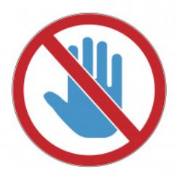  Minimising contact with individuals who are unwell | Nobody should enter the school site if they have Coronavirus symptoms.
 | Parents and visitors will not be allowed onto the school site without a prior appointment.
 | All visitors will be asked at reception if they have coronavirus symptoms or have been in contact with anyone who has symptoms. If so, they will not be permitted onto the school site.
 | Visitors to the school site will be welcomed by appointment only and only where necessary.
 | Parental meetings will take place by telephone or online where possible. If face to face meetings must take place it will be in well-ventilated rooms and socially distanced.
 | Children with COVID-19 symptoms must not come to school. They must self-isolate at home and book a test. If a child tests positively for COVID-19 they should remain at home for at least 10 days. If a member of the child’s household has tested positively for COVID-19 then they should self-isolate at home for 14 days. The school attendance team will advise you. Parents can book a test here: https://self-referral.test-for-coronavirus.service.gov.uk
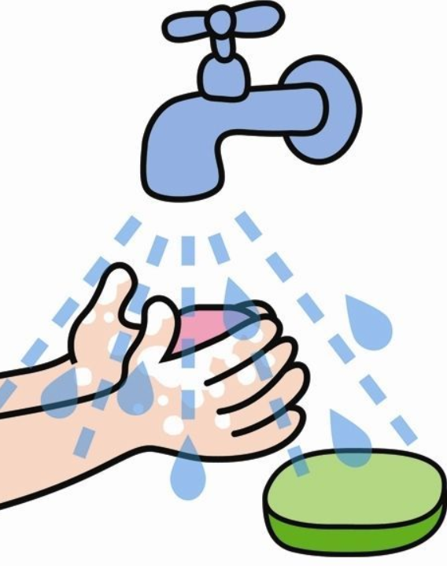  Cleaning hands more often than usual | Hand sanitising stations will be available at the school gates for students to sanitise their hands at the start of each day.
 | Hand sanitising units and handwashing facilities are located throughout the school and at key entry points to the building.
 | Students will be encouraged to sanitise their hands frequently throughout the school day.
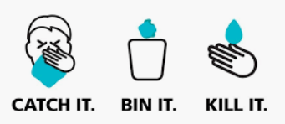  Ensuring good respiratory hygiene by promoting the ‘catch it, bin it, kill it’ approach | There will be boxes of tissues in every classroom so that students can ‘catch it, bin it, kill it’.
 | Students will be briefed on this as part of the student training at the start of term and will receive regular reminders at the start of each day..
 | Classroom windows will be opened to ensure good air circulation and ventilation.
 | All air conditioning units within the school have been serviced and filters changed. All units have been checked for COVID-19 compliance.
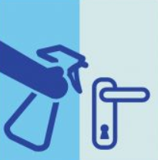  Cleaning frequently touched surfaces | The school has employed additional cleaning staff to clean frequently touched surfaces throughout the school day.
 | Each classroom will be equipped with spray detergent so that furniture can be cleaned between classes.
 | Classroom doors will be held open at the start and end of lessons so that students do not need to touch door handles / touch points.
 | All classrooms will be thoroughly cleaned at the end of each day.
 | The lifts within the school have had the internal surfaces treated with an anti-viral agent.
Minimising contact and mixing and maintaining social distancing wherever possible.  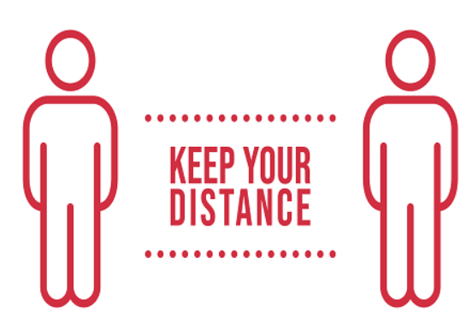 | Each year group will remain in their year group ‘bubble’:
Students will start and finish school at the following times in order to keep them in their separate bubbles:
    - Year 7 - start: 8.45am/ finish: 2.45pm
    - Year 8 - start: 9am / finish: 3pm
    - Year 9 - start: 9.15am / finish: 3.15pm
    - Year 10 -start: 9am / finish: 3pm
    - Year 11 - start: 8.45am / finish: 2.45pm
 | All students will be required to use separate gates to enter and leave the school site: years 7, 8 and 9 will enter and exit the school via the Exning Road gate. Years 10 and 11 will enter and exit the school via the Chester Road gate
Students will have break and lunch at the times set out below in order to keep them in separate year group bubbles:
    - Year 7 and 11 - break: 10.15am / lunch: 12.15pm
    - Year 8 and 10 - break:10.30am / lunch: 1.15pm
    - Year 9 - break: 11am / lunch: 1.15pm
 | The playground will be divided into zoned areas for different year groups so that students can remain in year group bubbles.
 | The Dining Hall will serve a bagged sandwich lunch. This is to minimise contact and speed up service so there will be less queuing.
 | Students will move around the school using the one way system.
 | Years 7, 8 and 9 will move to their lessons 2 minutes before years 10 and 11 to lessen the numbers of students moving through the corridors.
 | In classrooms students will sit side by side and facing the front, where possible. Students will sit according to their seating plan.
 | Students will not share equipment and will be provided with their own plastic wallet, board pen and mini whiteboard.
 | We will adapt the curriculum in certain subjects to ensure better social distancing (e.g. PE will teach athletics to ensure outside teaching this term).
 | After school intervention and year 11 revision sessions will take place online through remote learning.
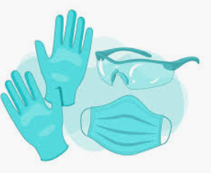  Where necessary, wear Personal Protective Equipment (PPE) (i.e. First Aiders) | First Aiders and staff who work closely with those students who require close supervision will use PPE when appropriate.
 | Students and staff must wear a Face Covering in communal spaces ( corridors etc) where it is less possible to maintain a 1m + distance.
 | Wearing Face Covering in Classrooms where lessons are taking place is not required.
 | Guidance on how to use/remove and store/dispose of Face Coverings will be shared with students and staff.
Response to any infection:
Engage with NHS Test and Trace process | Information for all staff and students regarding the NHS Track and Trace is available on the school website.
Manage confirmed cases of COVID-19 | Staff and students should NOT attend school if they or a member of their household have a confirmed case of COVID-19.
Contain any outbreak by following local health protection team advice | Parents must inform the attendance team if a student or a member of their household has a confirmed case of COVID-19. The school is in regular contact with the local public health protection team.
*This Summary Risk Assessment has been adopted by all NCST schools September 2020

Amendments:

21.9.20 - Students and staff should wear face coverings in communal areas inside the building.

