**The Sue Hedley Nursery School**

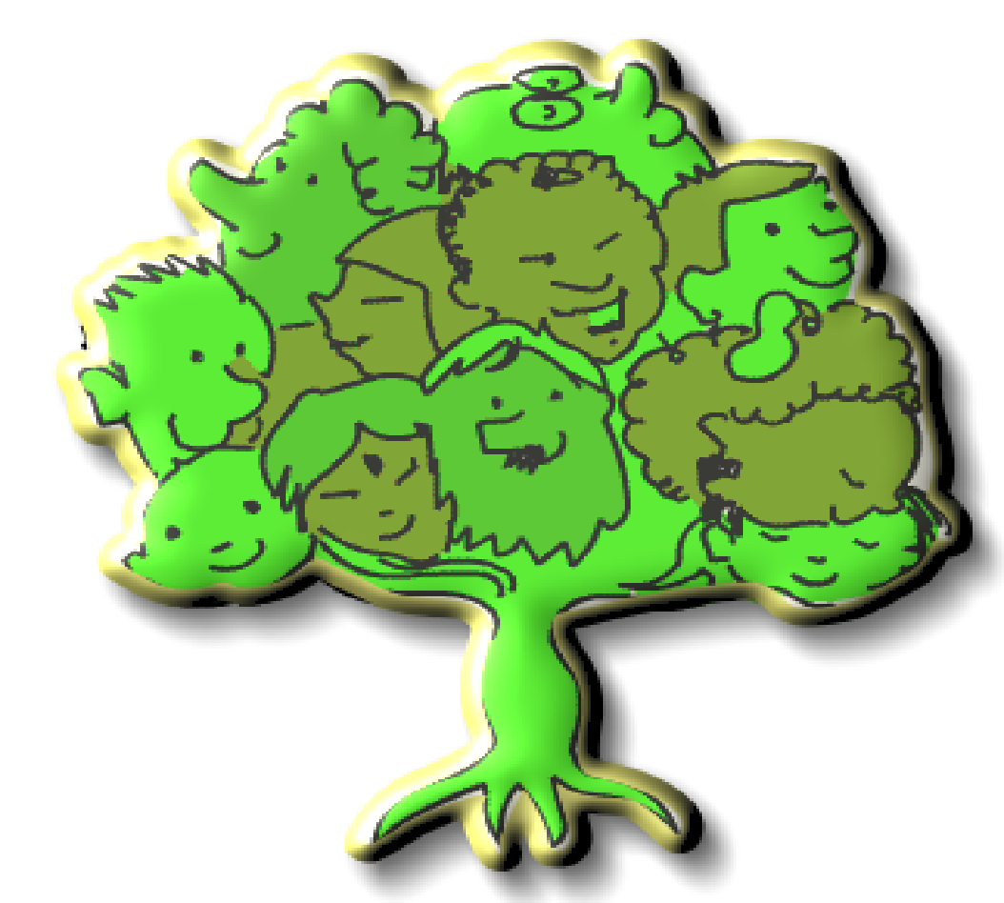

**Two-Year-Old**

**Little Acorns**

**Curriculum**

**Little Acorns**

The Little Acorns two-year-old provision at The Sue Hedley Nursery School offers children who are eligible for funded sessions, access to 15 hours free early education. This has now been extended to working families under the new childcare expansion. The group offers a calm, safe and supportive environment that is welcoming for all children, with an additional breakout sensory space to support any additional requirements that need to be met. The group follows the HighScope approach/framework. The team is made up of two Early Years Practitioners and Early Years support staff, who support children who have been identified as needing additional support. The ratio of the group is 1 adult to 5 children, unless identified as needing 1:1 support. Children's learning is shaped and recorded through weekly observations which are shared with parents via a Tapestry app and practitioners' knowledge of the child, which is supported through positive adult/child relationships. Children who have been identified as requiring additional support, have individual action plans for staff to support children reaching targets, these plans are made from targets set by Early Years Practitioners and external agencies such as, speech & language, portage & preschool, and the school SENCO. The team works closely with all outside professionals regularly, including health care professionals, the SALT team and Portage & Preschool to provide a holistic way of supporting the child and family.

**First words together**

A 5 week, short course that is attended by parents and their child that offers fun and informative activities. The aim of the sessions is to support parents with the understanding and skills to develop their children's language and communication, where parents learn key communication tips. The ‘First words together’ training and resources are supplied from the National Literacy Trust. The National Literacy Trust data shows a large success rate of improvement in children's speech & language skills following attendance of the group.

Staff will use monitoring and evaluation forms filled in by themselves and parents to reflect on the group.

**Progress Report**

The Little Acorn’s staff will review the progress of their ‘Key Children’ in the group and provide parents and/or carers with a short-written summary of their child’s development in the prime areas as they prepare to leave the Little Acorns group. The progress check will identify the child’s strengths, and next steps. Where significant emerging concerns, or an identified special educational need or disability, are identified practitioners will work alongside the settings SENCO to develop a targeted plan to support the child’s future learning and development.

**Little Acorns HighScope Daily Routine**

|  |  |
| --- | --- |
| 9am - 9:20am | Children arrive- Welcome Time |
| 9:20 am - 9:30 am | Small group time |
| 9:30am | Planning time |
| 9:45am | Work time |
| 11:15am-11:20 am | 5 minute warning then Tidy up time |
| 11:30 am | Recall |
| 11:40am | Snack and story of the week |
| 11.50am | Song bag time |
| 12:00 pm | Home time |

**Welcome Time**

The children are welcomed into the group by the Early Years Practitioners. As they come in the children are encouraged to hang up their wooden rounds with their picture on for self-registration then sit on a cushion. The session begins by singing a welcome song, and referring to the message board, firstly to identify the special helper. This supports name recognition and a sense of self. Each child has a turn being a special helper following a rota to support them knowing when it is their turn. The special helper will collect the register and bring it to the group, where each child is marked by saying “good morning (child name)”. This supports children to recognise who is in and prompts conversations for who is missing and why? Next the children will join in with the days of the week song and weather song, where the special helper is encouraged to identify the weather. Children are asked about their feelings, if they are feeling ‘happy’ or ‘sad’ with the use of speech and Makaton signs. Then the special helper will ask their peers what they would like to drink for a snack and mark it on the board, this is then counted with the whole group to promote mathematical skills. Throughout welcome time children's communication is supported with the use of simple visual cue cards and Makaton signing.

**Large group time (circle time)**

Large group time (circle time) builds a sense of community for the children where they join together with other groups from the nursery to share movement activities, songs, interactive stories, share special news and learn about the world around them with special circle times throughout the year learning about celebrations such as Easter, Diwali and Chinese New Year.

**Small Group**

Every day the children participate in a Small Group time. Small Group time is an opportunity for staff to model specific skills, introduce new vocabulary and expose the children to new resources and experiences. During this time the adults observe the children and assess how to move them forward in their learning and what they need support in.

**Work Time**

During this time the children are given an extended period of play time to explore the environment and resources available with adults modeling play, observing and scaffolding play strengths and encouraging friendships.

**Recall time**

The children are encouraged to tell with practitioners and peers where they have played in work time. This is aided for the 2’s using photos on Ipads adults have taken throughout the session.

**Snack Time**

Snack time allows the children to enjoy a variety of fruit and savory snacks such as breadsticks or crackers and promotes independence as the children choose milk or water to drink. It aids social skills and is a relaxed time for the children where classical music is played as they eat and drink.

**Story Time**

Each week we have a ‘Book of the week’ from our reading spine which is shared with the children daily.

**Song Time**

The session ends with a song bag sing-along-time, where children have the opportunity to choose a familiar song from a bag, and take it in turns to choose a prob. Song Time offers the children the opportunity to be fully immersed in music. The children use musical instruments, listen to music, are encouraged to move and dance along to the music and join in with actions.

**Forest School**

The children attend our on-site Forest School on a weekly basis. They get to explore the outdoor environment and experience nature throughout the seasons.

**Plan, do, review**

In the ‘plan, do, review’ process, children make plans (planning time), carry them out (work time) and reflect on what they have done after (recall time). In doing so children learn to take initiative, solve problems, work with others, accomplish their goals and their play becomes more purposeful and focused.

**Friendships**

Practitioners promote and aid the children to make friendships and to take the lead from the older nursery children as their role models. Friendships benefit children by creating a sense of belonging and security. By sharing experiences, feelings, and interacting with one another, children learn how to meet the social needs of others and of their own. They learn how to take turns, share, and include others at home and in nursery.

**Year Curriculum Plan – Prime Areas of Learning**

**Two Year Olds**

|  |  |  |  |
| --- | --- | --- | --- |
|  | **Communication and Language** | **Personal, Social and Emotional Development** | **Physical Development** |
| **First Term** | To use gestures and single words to engage with others.  Imitate words, sounds and gestures.  Express needs.  To follow simple instructions.  To be aware of visual aids.  To use familiar words and phrases during play.  Focus with intent on an activity of their own choice.  To be able to listen to others for up to one minute.  Show an interest in play with songs and sounds. | Settling into their new environment.  Making relationships with familiar adults.  Engage with others through gaze, gesture and sounds.  Beginning to follow some routines.  Begin to respond to boundaries and rules.  Separate from main carer.  Begin to recongise own self and belongings.  Beginning to show some independence skills (help to take own coat off). | Show high interest in filling and emptying containers.  Show an interest in messy / sensory play.  To pull self-up on large play equipment.  To squat with readiness to play.  To balance – to walk.  Use gross motor skills to push and pull objects.  To walk up stairs using two feet to one step.  Pick objects up using whole hand grasp.  To begin to balance blocks on top of each other.  Enjoy moving around indoors and outside. |
| **Second Term** | Begin to put words together to form basic sentences.  Begin to ask ‘w’ questions.  Recognise and point to objects they are asked about.  Listen to and enjoy basic songs, stories and jingles.  Begin to listen to others with interest.  Focus with intent on an activity chosen by adults.  To understand sentences with 2-part instruction.  Begin to understand simple questions.  Recognise and respond to familiar sounds. | Find ways to calm themselves.  Begin to express a range of emotions.  Begin to show interest in other’s play.  Play alongside others involved in the same interest.  Begin to share resources with others.  Be aware of and able to follow most of the routine.  Show understanding of rules and boundaries.  Showing more independence and beginning to help self with dressing / undressing.  Begin to show interest in toilet training. | Begin to show control is using basic tools like rolling pins and musical instruments.  Show confidence in climbing on large play equipment.  To balance on large play equipment.  Use chucky mark making tools to create circle and line shapes.  Build and balance with various size blocks.  Push and pull big objects.  Enjoy starting to throw and kick balls.  To walk upstairs using alternative feet, holding onto a rail. |
| **Third Term** | Use simple sentences.  Understand more complex sentences.  Make themselves understood.  Develop and hold a conversation with another even if jumping from topic to topic.  Listen to others with interest and respond to what they are saying.  To use basic language to describe sensory exploration.  Listen to and follow a story using pictures as support. | Begin to manage emotions.  Be able to see self as a separate person.  Play alongside and sometimes with others.  May begin to form friendships.  Confidently share resources with others.  Confidently follow and understand routines.  Be independent with most self-help skills. | Show good control over using tools and objects.  Move freely both inside and outside in a range of ways (running, jumping crawling, rolling).  Jump using both feet together.  Use a variety of mark making tools to create marks (paint brushes, pens, pencils, crayons).  Begin to show preference for dominant hand.  Begin to use fingers and tips of fingers to grasp objects. |

**Year Curriculum Plan – Prime Areas of Learning**

**Two Year Olds**

**How this will be met**

|  |  |  |  |
| --- | --- | --- | --- |
|  | **Communication and Language** | **Personal, Social and Emotional Development** | **Physical Development** |
| **First Term** | When talking to young children give a good response time (up to ten seconds)  Show a genuine interest, join in and respond to words and gestures used by the children.  When children use language, adults to repeat to reaffirm.  Encourage children to use their gestures and words to express what they want.  Ask questions relating to what you can see and then wait for an appropriate response.  Provide simple instructions with the command at the end  To introduce and use visual key rings and timetables throughout sessions and at group times so children become familiar with these  Adults to show a genuine interest in the play and interests of the children, providing next steps and enhancements to play  Have focused group times where an adult or child is speaking and others are waiting and listening (holding and passing an object can help focus)  Provide lots of opportunities during play and adult led teaching for songs, jingles, stories and musical instruments  Provide lots of opportunities for small world play, adults to provide language and modeling | Each child will have a key worker (familiar, secure adult) to whom they will build up a strong relationship with  Speak with parents/carers to gain background information on the child that might help them to settle such as comforters, interests and dislikes  Take the lead of the child as to how well they will settle, build up time if necessary  Providing lots of opportunities to interact with others and explore their bodies and objects around them  Encourage children to make choices, starting with limited options so they are not overwhelmed (“Would you like the red train or the blue train?”)  Establish a strong routine from day one so that it becomes familiar to the children.  Use visual timetables to break the day down, taking away each transition to show it has happened.  Be consistent in approach to expectations (all staff do the same)  Have mirrors in the environment for children to explore what they look like  Have pictures of children on their peg and tray so they can recognise what is theirs and where it goes  Encourage independence with hand over hand to take off slippers and unzip coat  Have resources stored at child level which are easily accessible for their own choosing. | Provide lots of opportunities for emptying and filling with a range of containers and resources (buckets, scoops, cups, bowls, bags, sand, water, sensory, small resources like stones, gems and play food)  Provide groups times and activities during play where sensory and messy play can be explored (shaving foam, jelly, water, sand, rice, lentils, noodles, gloop).  Provide specific outside time for exploration of large equipment like the climbing frame, slide and tunnel (the adult with model and support exploration)  Provide soft play for exploration  Provide trampoline  Provide large and small wheeled toys to use indoors and outside (cars, trains, trucks, wheelbarrows, prams)  Provide big blocks and tubes through continuous provision for building and balancing with (adults to model play)  Provide lots of different things for children to grasp, hold and explore, like clay, finger paint, spoons, brushes, shells. |

|  |  |  |  |
| --- | --- | --- | --- |
| **Second Term** | Wait for the child to speak or communicate with a sound or a look first - so that they are leading the conversation. When responding, expand on what has been said (for example, add a word)  Create opportunities for exploration and questioning (natural resources, small world play, pictures and signs in the environment)  Adults to ask lots of simple questions and wait for and be attentive to responses.  Provide lots of opportunities through play and adult led teaching where children can listen to and join in with songs, rhymes, jingles and stories  Provide lots of opportunities for shared play where conversations take place and children can share their interests with one another.  Create interesting and engaging group times where listening is required (song box, story stack, sand stories)  Adults to give instructions to children that have 2 parts, emphasising, the main points (“Go put your slippers away and get your wellies” “**slippers away, get wellies**”)  Play listening games that involve real objects (sound box-horn, bell, rattle) | Introduce the coat trick, working with the child each session to build up independence skills  Encourage children to put away/collect their own belongings  Encourage children to hang their own coat up and to put their slippers in their tray (some guidance may be needed here)  Provide a ‘cosy area’ where children can relax and regulate themselves when upset or tired  Encourage children to make choices, provide more availability (“I have lots of trains, which colour would you like?”)  Continue to use a strong routine that children can now follow with simple instructions of what is coming next  Continue to use a visual timetable to break the day down, with an adult or child taking away each transition to show it has happened  Be consistent in approach to expectations, explaining what you expect and why (all staff to do the same)  During play encourage turn-taking. Initially with an adult and then with another child (“my turn, your turn, _____ turn”) | Provide rolling pins, musical instruments, basic play tools like hammers and saws through continuous provision (adults to model use of)  Continue to provide specific outside time for exploration of large equipment like the climbing frame, slide and tunnel (there should be less need for adult support here)  Provide basic obstacle courses for balancing across and climbing up and down  Have a variation of chunky mark making tools in the indoor and outdoor environment for use (crayons, chalks, pencils)  Provide brushes and water/paint outside to encourage mark making  Provide big and small blocks and tubes through continuous provision for building and balancing with (adults to model play and extend children’s play)  Provide a range of resources for throwing such as sponges, pompoms, cotton wool, sensory balls  Provide large objects for transport like tyres, wheelbarrows, blocks, prams  Continue use of soft play to encourage new ways of moving, balancing and climbing. |

|  |  |  |  |
| --- | --- | --- | --- |
| **Third Term** | Encourage children to use their language throughout play and for a means of communicating with others, giving time for them to expand and providing responsive language that will hold a conversation  Ask complex sentences that may require a two-part response but remember to not ask too many questions (4 comments to 1 question)  Provide opportunities for children to express themselves (likes/dislikes/friends/experiences)  Model and encourage descriptive language through activities such as messy play (soft, smooth, hard, rough, squishy, etc.)  Offer children a daily story time as well as sharing books throughout the session (repeat the book for a week - story of the week)  Share picture books everyday with children  Encourage them to talk about the pictures and the story with adults commenting on the pictures. | When children show different emotions, comment on what you can see, ask what has made them feel that way (“I can see you’re crying. What has made you cry?”)  Talk about what could change the way the child feels  Offer comments and questions about our uniqueness  Be open to what children say about differences and answer their questions straightforwardly  Help children develop positive attitudes towards diversity and inclusion  Support children to find ways to join others’ play by watching or offering a toy to another child  Without limiting resources, provide a varied amount so that children share and take turns  Encourage children to use the coat trick and to put on or take off their own belongings | By this point children should know how to use objects and tools for a purpose through continuous role modelling during play or adult led teaching  Continue to provide specific outside time for exploration of large equipment like the climbing frame, slide and tunnel.  Have races (after time introduce running with an object)  Provide more complex obstacles courses for balancing across, over, under and climbing up and down  Provide trampoline  Introduce sticky kids to encourage new ways of moving  Provide a variety of mark making tools to create marks indoors and outside through continuous provision (paint brushes, pens, pencils, crayons, chalks)  Provide activities that require more precise grasping such as threading, peg boards, using tweezers to pick up pom-poms |

In the Little Acorns we use a range of books and authors and we link our key texts closely to related rhymes and use of instruments for a multi-sensory experience.

* Where’s Spot
* Dear Zoo
* Fox’ Socks
* Oh Dear!
* A Busy Day for Birds
* That’s not my ………
* Squirrel’s Snowman
* Bear on a Bike
* How to brush your teeth with Snappy Croc
* Wow said the Owl
* Cluck Cluck Duck
* Imagine If …..Veggies
* Imagine If……Fruiy
* Elmer’s Weather
* Elmer’s Colours
* Elmer’s Friends
* I want to be a duck
* Noisy Farm
* I’m Hungry
* Dear Santa
* Spot’s First Christmas
* Meg and Mog Collection