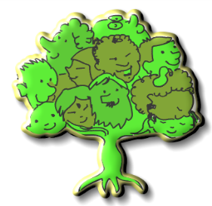**The Sue Hedley Nursery School**

**Supersonic Phonic Friends**

At The Sue Hedley Nursery School, we aim to provide our pupils with the firm foundations needed to access phonics teaching when they enter Reception. We focus on the following areas throughout the academic year, constantly revisiting each area to ensure our children get to practice and consolidate their learning in each aspect during both adult-led and child-led activities. During small group time we may look at games such as Kim’s Game or Cross the River, linking to one of the aspects below. During work time, we carefully observe children’s play and teach in the moment to further their phonetic development. This could be singing rhymes, exploring instruments, listening to the sounds around us, thinking of rhyming or alliterating names or recreating familiar stories.

|  |  |  |  |  |  |
| --- | --- | --- | --- | --- | --- |
| **Aspect 1**  **Environmental Sounds**   * Listening to the sounds around us. * Identifying sounds within our environment. * Recreating sounds orally. * Using sounds within imaginative play (like saying ‘Oink’ when playing with a toy pig). | **Aspect 2**  **Instrumental Sounds**   * Exploring the sounds of percussion instruments. * Exploring the sounds of tuned instruments. * Identifying instruments by sound. * Describing the sounds instruments make. * Recreating sounds orally. | | **Aspect 3**  **Body Percussion**   * Joining in with clapping and tapping activities, sing different dynamics and tempos. * Singing rhymes along to a rhythmic pulse. * Copying simple repeated rhythms. | | **Aspect 4**  **Rhythm and Rhyme**   * Learning songs and rhymes. * Making rhyming strings (cat, mat, rat, sat, bat…) * Reading stories with rhyming words. * Reciting poems with interesting rhythms and refrains. * Finding the odd one out (pig, net, dig). |
| **Aspect 5**  **Alliteration**   * Reading books and rhymes that feature words beginning with the same sound (nosy knight, fantastic fox). * Pairing objects that begin with the same sound. * Building a repertoire of rhymes and songs. | | **Aspect 6**  **Voice Sounds**   * Recreating sounds with our voices (hissing like snakes, ticking like a clock). * Starting to listen for the different sounds that make up words (c-a-t….cat). * Adding sound effects to stories. | | **Aspect 7**  **Oral Blending and Segmenting**   * Modelling segmenting the sounds in words for children to blend back together (pass me the p-e-n). * ‘Sound talk’ – saying each sound in a word. * Playing games, like Cross the River and Kim’s Game. | |