

**The Sue Hedley Nursery School**



**Attendance Policy**

| Date of next review | March 2025 |
| --- | --- |
| Author | Ashley Honey/Amy Hindes |
| Approval | Head teacher/Governing body |
| Date of approval | April 2023 |

**Attendance Policy**

The Sue Hedley Nursery SchoolAttendance Policy takes into account the guidance set out in the DFE Document ‘Working together to improve school attendance’ for maintained schools, academies, independent schools and local authorities May 2022. **This policy applies to any child that attends the nursery the term following their fifth birthday.**

At The Sue Hedley Nursery School we believe the foundations of securing good attendance begins by ensuring our school creates a calm, orderly, safe and supportive environment where all pupils want to be and are keen and ready to learn.

Regular and punctual school attendance is important. Pupils need to attend school regularly if they are to take full advantage of the educational opportunities available to them by law. The Sue Hedley Nursery School fully recognises its responsibilities to ensure pupils are in school and on time, therefore having access to learning for the maximum number of days and hours.

Our policy applies to any child registered at this school the term following their fifth birthday and this policy is made available to all parents/carers of pupils who are registered at our school on our school website or available from reception for those without access to the internet.

This policy has been written to adhere to the relevant Children Acts, Education Acts, Regulations and Guidance from the Department for Education in addition to guidance from the Local Authority.

Although parents/carers have the legal responsibility for ensuring their child’s good attendance, the Headteacher and Governors at our school work together with other professionals and agencies to ensure that all pupils are encouraged and supported to develop good attendance habits. Procedures in this policy are followed to ensure this happens.

Children who are persistently late or absent soon fall behind with their learning. Children who are absent from school frequently develop large gaps in their learning which will impact on their progress and their ability to meet age related learning expectations. A child whose attendance drops to 90% each year will, over their time at primary school, have missed two whole terms of learning.

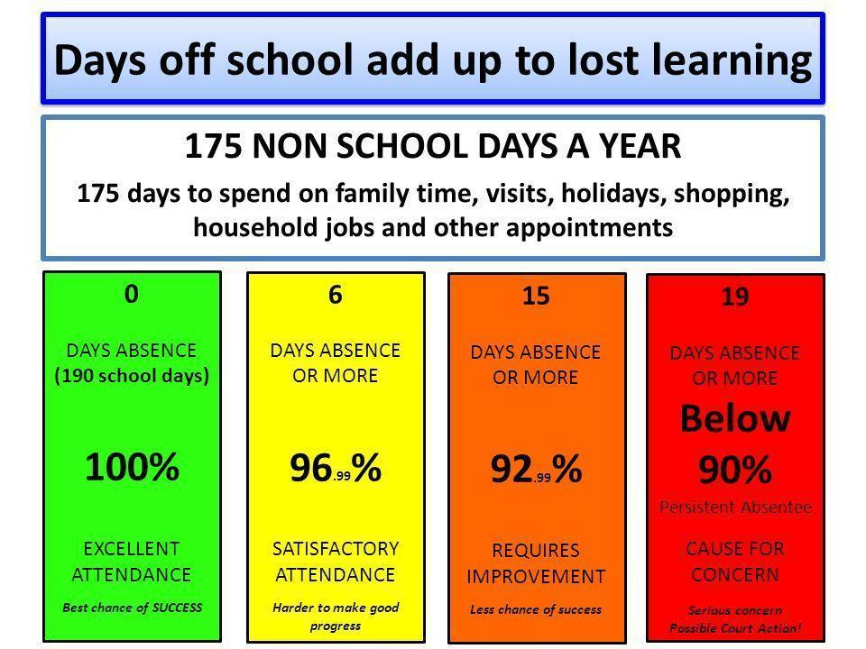

**Aims and Objectives**

This attendance policy ensures that all staff and governors in our school are fully aware of and clear about the actions necessary to promote good attendance.

**Through this Policy we aim to:**

* Improve pupils’ achievement by ensuring high levels of attendance and punctuality.
* Achieve a minimum of 97% attendance for all children, apart from those with chronic health issues.
* Create an ethos in which good attendance and punctuality are recognised as the norm and seen to be valued by the school.
* Raise awareness of parents, carers and pupils of the importance of uninterrupted attendance and punctuality at every stage of a child’s education.
* Work in partnership with pupils, parents, staff and external agencies so that all pupils realise their potential, unhindered by unnecessary absence.
* Promote a positive and welcoming atmosphere in which pupils feel safe, secure, and valued, and encourage in pupils a sense of their own responsibility.
* Establish a pattern of monitoring attendance and ensure consistency in recognising achievement and dealing with difficulties.
* Recognise the key role of all staff in promoting good attendance.
* Recognise the role of class teachers as they will be able to identify where attendance is having an impact on attainment.

**We maintain and promote good attendance and punctuality through:**

* Raising awareness of attendance and punctuality issues among all staff, parents and pupils.
* Ensuring that parents have an understanding of the responsibility placed on them for making sure their child attends regularly and punctually.
* Equipping children with the life skills needed to take responsibility for good school attendance and punctuality appropriate to the child’s age and development.
* Maintaining effective means of communication with parents, pupils, staff and governors on school attendance matters.
* Developing and implementing procedures for identifying, reporting and reviewing cases of poor attendance and persistent lateness.
* Supporting pupils who have been experiencing any difficulties at home or at school which are preventing good attendance.
* Developing and implementing procedures to follow up non-attendance at school.

**Procedures**

**Our school will undertake to follow the following procedures to support good attendance:**

* To maintain appropriate registration processes.
* To maintain appropriate attendance data.
* To communicate clearly the attendance procedures and expectations to all staff, governors, parents and pupils.
* To have consistent and systematic daily records which give detail of any absence and lateness.
* To follow up absences and persistent lateness if parents/carers have not communicated with the school.
* To inform parents/carers what constitutes authorised and unauthorised absence.
* To strongly discourage unnecessary absence through holidays taken during term time.
* To work with parents to improve individual pupils’ attendance and punctuality
* To refer to appropriate agencies any child whose attendance causes concern and where parents/carers have not responded to school initiatives to improve.
* To report attendance statistics to the Local Authority and the DfE where requested.
* All staff should be aware that they must raise any attendance or punctuality concerns to the nominated person with responsibility for monitoring attendance.

**Responsibilities**

All members of school staff have a responsibility for identifying trends in attendance and punctuality. The following includes a more specific list of the kinds of responsibilities which individuals might have.

**The Head teacher is responsible for:**

* Overall monitoring of school attendance.
* Trends in authorised and unauthorised absence.
* Hold regular meetings with the Senior Leadership Team to ensure effective strategies are in place.
* Update and train staff during briefings, staff meetings and in-service days.
* Meet families where concerns are raised about absence and improvements are not made.
* Monitoring individual attendance where concerns have been raised
* Liaising with other professionals to determine potential sources of difficulties and reasons for absence.

**The SENCO is responsible for:**

* Have an overview of any child on the SEND register who has been identified as having attendance issues.
* Meet with a member of the SLT and Class Teachers to discuss attendance and punctuality concerns for all pupils on the SEND Register. This will take place as part of termly team meetings, as a minimum requirement.

**Staff in the School Office are responsible for:**

* Collating and recording registration and attendance information.
* Taking and recording messages from parents regarding absence.
* Recording details of children who arrive late or go home early.
* First Day Response: Contacting home if no reason for absence is received (phone call or email messages).

**Key workers and teachers are responsible for:**

* Maintaining class registers and completing them accurately in accordance with school policy, ensuring the school office staff have access to them after registration closes.
* Informing the nominated person where there are concerns and acting upon them.
* Where poor attendance reoccurs, ensuring appropriate school staff are informed.
* Emphasising with their class the importance of good attendance and promptness.
* Ensuring appropriate school staff are informed of additional information provided by the child so it can be recorded in line with school policy.

**Parents/Carers are responsible for:**

* Ensuring that their child attends school regularly and punctually unless prevented from doing so by illness or attendance at a medical appointment.
* Contacting the school office, by telephone message or by using [ahindes@thesuehedleynurseryschool.co.uk](mailto:ahindes@thesuehedleynurseryschool.co.uk) on the first morning of absence.
* Informing the school in advance of any medical appointments in school time. For the absence to be recorded as a medical absence we do require evidence from the doctor or dentist. (Appointment card/letter/text message)
* Making requests for authorised absence in term time, only if absolutely necessary as these are not automatically authorised.
* Talking to the school as soon as possible about any child’s reluctance to come to school so that problems can be quickly identified and dealt with.

**Authorised absence**

An absence is classified as authorised when a child has been away from school for a legitimate reason and the school has received notification from a parent or carer.  For example, if a child has been unwell and the parent telephones the school to explain the absence.

Only the school can make an absence authorised.  Parents do not have this authority. Consequently not all absences supported by parents will be classified as authorised.

**Unauthorised absence**

An absence is classified as unauthorised when a child is away from school without the permission of the school.

Therefore, the absence is unauthorised if a child is away from school without good reason, even with the support of a parent.

**Registers**

* 1. Registers are legal documents and will be marked twice a day.
  2. Parents must always give reasons for absence to the school.
  3. Schools are to determine whether absence is authorised or unauthorised in exceptional circumstances, considering factors such as frequency, duration, attendance patterns, i.e. within reason. Staff must be observant of situations where absence is continually condoned by parents.

The guidelines below clarify possible actions

| **Authorised Absence** | **Unauthorised Absence** |
| --- | --- |
| Illness | Absence without a valid reason |
| Medical Appointment / Dental (For the time of appointment including travelling) | Latecomers beyond 30 minutes after the session has started |
| Family Bereavement | Persistent lateness within the first 30 minutes of the day |
| Religious Observance | Special occasions, e.g. birthday. |
| Interview / Work Experience | Holidays |
| Excluded Children |  |

**Personal Information**

Please inform the school office immediately of any changes regarding:

* Address
* Contacts
* Phone Numbers

**Reintegrating Long Term Absentees**

Following a long period of absence, a child may feel vulnerable, so staff may wish to arrange a phased or gradual return, allocation of a ‘Key Worker’, consider whether Special Needs support is appropriate, ensure that all staff are aware of the situation and nominate a key person to monitor the child’s reintegration into school. All children must feel welcomed back and know from whom they can seek help. Children should not be left sitting in corridors or outside an office for long periods.

**Lateness**

Repeated absence at the beginning of a school session can amount to failure to attend regularly for the purpose of the 1996 Education Act. The school seeks to improve general punctuality and to improve attitude of persistent offenders by:-

* 1. Informing parents of our expectations and offering ways of helping combat lateness.
  2. Praise and acknowledge latecomers who improve.
  3. Ensure that staff set a good example by arriving punctually for lessons.
  4. All children and parents must understand that lateness is actively discouraged, although sensitivity may be appropriate in some cases.
  5. Schools may use other incentives to improve levels of punctuality

Records are kept of those pupils who are late, this is documented on the electronic register for each pupil (Attendance code L).

Children who have attended a dentist or doctor’s appointment and subsequently come to school later than 9.05am will have the absence recorded as a medical absence (Attendance code M).

Where there have been persistent incidents of lateness parents/carers will receive a letter advising them of the concerns and the school will provide opportunities for parents/carers to seek support and advice to address these issues.

**Absences**

Parents/carers should contact the school on the first day of their child’s absence. When parents/carers notify us of their child’s absence it is important that they provide us with full and accurate details of the reason for their absence and expected date of return. This information is used to determine whether the absence is authorised or unauthorised. The Head teacher has the responsibility to determine whether absences are authorised or unauthorised

**First Day Contact**

When a child is absent from school and we have not received any verbal or written communication from the parent, then we initiate a first day contact process. Office staff check all of the registers from 9.00am to 9.30am on a daily basis, to identify those pupils who are absent. There are occasions when we are unaware why the child is absent and we will attempt to contact the parent to check the reasons for the child’s absence.

**Illness**

Where over the course of an academic year, a child has repeated periods of illness, the school will write to parents to ask them to provide medical evidence for each future period of illness related absence. This evidence could be a Doctor’s note, appointment card/letter or copy of a prescription. We may seek written permission from you for the school to make their own enquiries.

**Parental Request for Absence from School for Holiday**

With effect from September 2013 the government abolished the right of Head teachers to authorise absence specifically for holidays of up to 10 days per year if special circumstances exist. Instead, Head teachers will only be allowed to grant leave of absence for any reason if they are satisfied exceptional circumstances exist. Parents are encouraged to keep open lines of communication with school over absence as persistent absence can be considered a safeguarding matter.

Any parent who takes their child out of school in term time for an unauthorised absence may be liable for a fine by South Tyneside Council.

At The Sue Hedley Nursery School, we do not routinely authorise holidays during term time. If parents are unable to avoid requesting absence during school time, an application must be made to the Head Teacher on an application form available from the school office. This should not be less than 4 weeks before the absence is due to start and state clearly the reasons why exceptional circumstances should be considered. Please note before any special consideration will take place your child must have a history of good attendance in school. In the event of unauthorised holidays, the attendance enforcement team may issue a statutory fine. Parents must be aware that the failure to comply with these procedures could also result in the Local Authority taking legal action

This legislation can be viewed on the Department for Education’s website at [www.education.gov.uk](http://www.education.gov.uk)

**Addressing Attendance Concerns**

The Sue Hedley Nursery School expects attendance of at least 96%. The current target is 97%

It is important for children to establish good attendance habits early on in their school career. It is the responsibility of the Head teacher and the governors to support good attendance and to identify and address attendance concerns promptly. In our school parents are to ensure their child attends school regularly and punctually and therefore when we become concerned about attendance we will inform parents/carers of our concerns. Initially concerns about attendance are raised with parents via telephone calls or letters which are sent home, parents may be invited to an AIMs meeting. An AIMs meeting is used to form an agreement / action plan which looks at ways to work together to improve attendance. (See Appendix A) There will be opportunities for the parent/carer to discuss reasons for absence and support to be given by the school with the aim to improve attendance. Where a child’s attendance record does not improve over a period of time then the school has a responsibility to make a referral to the LA Attendance Officer.

**Monitoring Attendance**

Early intervention is essential when tackling issues of attendance and punctuality.

School Admin System Absence Codes

Attendance

| **Code** | **Description** |
| --- | --- |
| / | Present (AM) |
| \ | Present (PM) |

Authorised Absence

| **Code** | **Description** |
| --- | --- |
| I | Illness (not appointments) |
| C | Other Circumstances |
| E | Excluded |
| H | Family Holiday (agreed) |
| F | Extended Family Holiday (agreed) |
| M | Medical/Dental appointments |
| R | Religious observances |
| S | Study Leave |
| T | Traveller absence |

Present

| **Code** | **Description** |
| --- | --- |
| P | Sporting Activity |
| V | Educational Visit or Trip |
| W | Work Experience |
| B | Educated off Site (not Dual) |
| L | Late Registration |
| D | Dual Registration |
| J | Interview |
| K | School Discretion |

Unauthorised Absence

| **Code** | **Description** |
| --- | --- |
| G | Family Holiday (not agreed) |
| N | No reason yet provided |
| O | Other |
| U | Late after registration |

**National contacts**

[www.direct.gov.uk](http://www.direct.gov.uk) School attendance, absence and your child

[www.education.gov.uk/schools/pupilsupport](http://www.education.gov.uk/schools/pupilsupport) Behaviour and attendance - Parental responsibility

familylives.org.uk Truancy Helpline:0808 800 2222

**Local contacts**

[www.southtyneside.gov.uk](http://www.southtyneside.gov.uk) Attendance Monitoring Team

You can phone the Attendance Monitoring Team on 0191 4247400 or

Email [syp@southtyneside.gov.uk](mailto:syp@southtyneside.gov.uk)

**Individual Attendance Plan**

| **Name:** | **DOB:** |
| --- | --- |
|  |  |

| **Date of meeting:** | **In attendance** |
| --- | --- |
|  |  |

| **Attendance Zone** | **Less than 90%** | **91% - 95%** | **96% - 100%** |
| --- | --- | --- | --- |
| **Review 1** |  |  |  |
| **Review 2** |  |  |  |
| **Review 3** |  |  |  |

| **What are the reasons for absence? (please tick)** | | | | |
| --- | --- | --- | --- | --- |
| Genuine Medical |  | | Illness |  |
| Parent Mental Health |  | | Truancy / lesson avoidance |  |
| No Reason Provided |  | | Student Mental Health |  |
| Behaviour / exclusions |  | | Bullying |  |
| Historic Attendance Issues |  | | Peer/Relationship Issues |  |
| Parent having difficulties getting child to school |  | | School based anxiety |  |
| Other: |  | | | |

| **What actions have been taken? (please tick)** | | | | |
| --- | --- | --- | --- | --- |
| Telephone calls home |  | | Early Help |  |
| Meeting with parent/carer |  | | Referral to Outside Agency: |  |
| Early Help |  | | External agency support (please specify) |  |
| Attendance improvement meeting |  | | Other |  |
| Legal Action |  | |  |  |

| **Historic Attendance:** | | | |
| --- | --- | --- | --- |
| Nursery (1) | Nursery (2) | Reception | Y1 |
|  |  |  |  |

| Information Shared: |
| --- |
|  |

| Target: | Strategies | Monitoring Milestones | Responsible person | Outcome |
| --- | --- | --- | --- | --- |
|  |  |  |  |  |
|  |  |  |  |  |

| Signed: | |
| --- | --- |
|  |  |
|  |  |

| Date and time of next meeting: |
| --- |
|  |