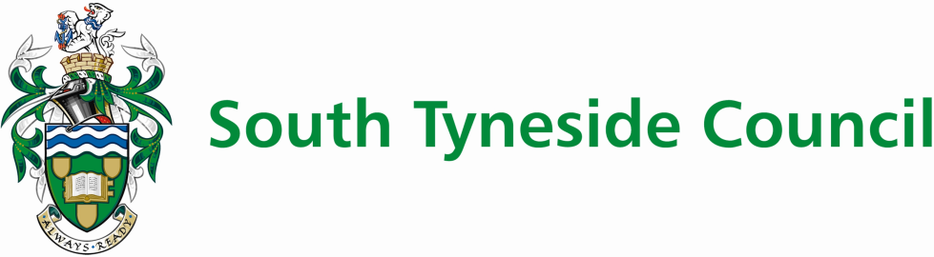

**The Sue Hedley Nursery School**



**Assessment Policy**

| Date of next review | March 2025 |
| --- | --- |
| Author | Amy Hindes |
| Approval | Head teacher/Governing body |
| Date of approval | April 2023 |

**ASSESSMENT POLICY**

For every child throughout our nursery, before and throughout the Foundation Stage of children’s learning, we make regular assessments, which we then use to ensure that future planning reflects identified needs.

Assessment takes the form of observation and this involves the teacher, key worker and other adults.

Observation is the foundation of education in the early years. It is through recording and reflecting on children’s activities and interests that we can gather information necessary for the construction of an appropriate curriculum.

The methods used are:

* Observation.
* Structured activities and tasks.
* Baseline assessment.

Record Keeping:

* Area observation stations
* Child observations assessment files
* Local Authority Foundation Stage baseline sheets
* Individual children’s files
* Written reports to parents

**Parents as Partners**

* To raise the awareness of parents to the importance of their role in the education of their child.
* To respect, understand and value the contribution parents make towards their child’s learning.

Parents will be made to feel welcome through a range of different opportunities and activities. They will be kept fully informed about the curriculum through a variety of means. i.e. newsletters, parent’s notice boards, parent’s evenings, displays and formal discussions. They will have access to relevant educational materials e.g. library books, brochures, leaflets to support home learning, and be provided with regular written reports giving details of their child’s progress.

**Liaison with other Agencies**

Through observation and assessment individual children are referred to the appropriate agency.

We work cooperatively with staff from these agencies to provide the best learning opportunities for each child.

The agencies involved may consist of Health Visitor, School Nurse, Speech Therapy, Hearing Impaired, Portage, Education Welfare Officer, Children's Services, Educational Psychological Services, and English as an Additional Language.

To develop the children’s understanding of the wider community, we encourage visits by the following services: - police, fire, dentistry, road safety, and health in conjunction with children’s interests in these areas.

Partnerships are promoted by valuing and building on children’s previous learning from: home, play groups, parent and toddler, nurseries and feeder variety of pre-school setting.