
The Sue Hedley Nursery School
Campbell Park Road,
Hebburn,
Tyne and Wear,
NE31 1QY.
Phone: (0191) 4287656
Fax: (0191) 4287651
Website: www.thesuehedleynurseryschool.co.uk

29th November 2023

Dear Parents/Carers,

I am writing to confirm the arrangements for the Three Bears Pantomime visits next week.

Tuesday 5th December - Hazel group (Victoria)
- Meet at Hebburn metro at 9.00am
- Pantomime starts at 10.00am (running time of 45 minutes)
- Travel back on metro. You can then either take children home or bring them back to nursery. If your child is coming back to nursery you must accompany them. If you are taking your child home, please let me know in advance so you are not charged for a school meal on this day.

Wednesday 6th December at 10am - Elder group (Charlotte) and Oak 2.5 day group (Cheryl)

- Meet at Hebburn metro at 9.00am
- Pantomime starts at 10.00am (running time of 45 minutes)
- Travel back on metro. Oak group can go home from the metro as it is their half day. Elder group can either go home or come back to nursery.
If your child is coming back to nursery you must accompany them. If you are taking your child home, please let me know in advance so you are not charged for a school meal on this day.

Thursday 7th December at 10am - Maple morning group (Kate)

- Meet at Hebburn metro at 9.00am
- Pantomime starts at 10.00am (running time of 45 minutes)
- Travel back on metro. You can then take children home from the metro station.

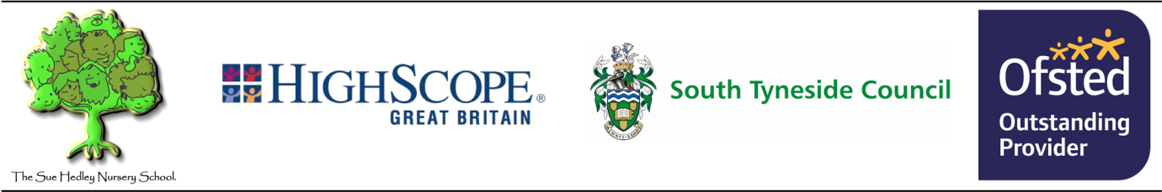
The Sue Hedley Nursery School
Campbell Park Road,
Hebburn,
Tyne and Wear,
NE31 1QY.
Phone: (0191) 4287656
Fax: (0191) 4287651
Website: www.thesuehedleynurseryschool.co.uk

Friday 8th December at 1pm - Maple afternoon group (Kate)

- Meet at Hebburn metro at 12.00pm
- Pantomime starts at 1.00pm (running time of 45 minutes)
- Travel back on metro. You can then take children home from the metro station.

Reminder – If your child is not going to the Pantomime, their group will be closed on that day due to staff being on the trip.

Nursery will cover the cost of the metro tickets for parents/carers (children under 5 are free).

Please bring a drink for your child and they will be provided with a snack from staff.

If you have any questions, please let me know.

Kind Regards,

Amy Hindes
Administration Officer

