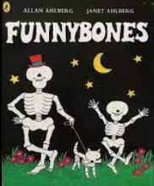

Dear Parents/ Carers
At the Sue Hedley Nursery School, we all share a love of books.
To celebrate our love of books we would like to invite parents/carers into nursery for a large story time on Wednesday 25th October. We will be reading ‘FUNNYBONES’ and would love it if you could join us.
Please see timings below:

‘FUNNYBONES’ Wednesday 25th October
9.15 AM | Oak, Maple AM, Little Acorns
2.30PM | Hazel, Maple PM, Elder

Just a reminder that nursery will close at the end of the day on Thursday 26th October. We are closed on Friday 27th October for an In-service day. Children will return after half term on Monday 6th November.

Thank you

The Sue Hedley Nursery School Staff

