

**The Sue Hedley Nursery School**

Campbell Park Road,

Hebburn,

Tyne and Wear,

NE31 1QY.

Phone: (0191) 4287656

Fax: (0191) 4287651

Website: www.thesuehedleynurseryschool.co.uk

26th April 2023

Dear Parent / Carers,

You may be aware from media coverage that teaching members of the National Education Union (NEU) have continued to declared strike action. The strikes will take place on the 27th April and 2nd May.

I can confirm that The Sue Hedley Nursery School will be open as normal on Thursday 27th April and Tuesday 2nd May for all children.

If you are planning to keep your child off due to local school closures could you please let us know.

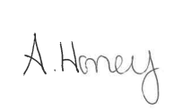

Yours sincerely,

Ashley Honey

Head Teacher

