

**The Sue Hedley Nursery School**

Campbell Park Road,

Hebburn,

Tyne and Wear,

NE31 1QY.

Phone: (0191) 4287656

Fax: (0191) 4287651

Website: www.thesuehedleynurseryschool.co.uk

9th March 2023

Dear Parent / Carers,

You may be aware from media coverage that teaching members of the National Education Union (NEU) have continued to declared strike action. The strikes will take place on the 15th and 16th March 2023.

I can confirm that The Sue Hedley Nursery School will be open as normal on Wednesday 15th and Thursday 16th March for all children.

If you are planning to keep your child off due to local school closures could you please let us know.

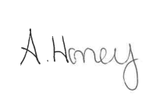

Yours sincerely,

Ashley Honey

Head Teacher

