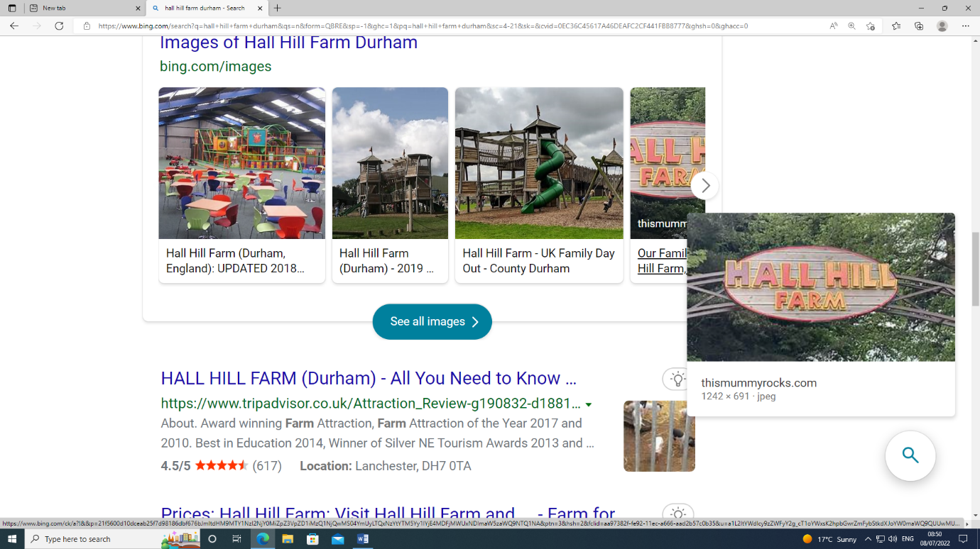**Hall Hill Farm**

A huge thank you to all the parents/carers, staff and not forgetting the children for making the Hall Hill Farm visit a huge success.

A special thank you to Amy Hindes for her tireless efforts in planning and organising a fantastic trip.

