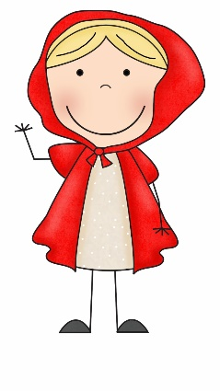 | Hello Everyone,  This week we are onto our final story in Reception ‘Little Red Riding Hood’. I hope you enjoy the story as much as I do! As with each week please do visit the sites daily such as https://www.thenational.academy/and https://whiterosemaths.com/  as they have daily lessons for Reception. I’d love to see all of your work so don’t forget to email me at mtrotter@dunnstreet.s-tyneside.sch.uk
Personal, Social and Emotional Development | - We will be talking about the events of this year and how school has been different.  - We will be looking back the year we have had and what changes have been made.  - We will be looking at all of the things we couldn’t do at the start of the year and what we can do now.  - We will be looking at what is going to happen next, talk about our summer holidays and what will happen in our new classes.
Communication, Language and Literacy | 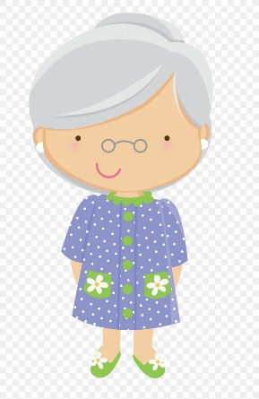  - We will be acting out the story of Little Red Riding Hood.  - We will be asking questions about the story.  - We will be retelling the story in our own way.
Physical | - We will be having races this week and giving awards to first, second and third places.  - We will be learning how to make cakes and what makes a healthy balanced diet.
Literacy | 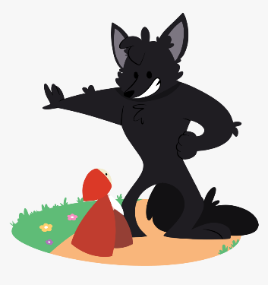  - We will be writing speech bubbles for the characters in Little Red Riding Hood.  - We will be writing a sentence about our favourite characters.  - We will be writing a description of Grandma for a kissing poster.  - We will be reading all of our set 1 and 2 sounds and reading and writing words containing those sounds.  - We will be singing the alphabet and naming letters.
Mathematics | - We will be counting to 100 in 1’s.  - We will be counting in 2’s, 5’s and 10’s.  - We will be singing familiar number rhymes such as five speckled frogs and ten green bottles.
Understanding the World | - This week we are going to be making some cakes for Grandma. We will be talking about the ingredients, introducing some technical vocabulary such as mix, whisk and fold.  - Look at what happens to the cake mixture when it is cooked. How does it change and why?
Expressive Arts and Design | - We will be drawing pictures of wolves and Little Red Riding Hood.  - We will be acting out the story.  - We will be singing nursery rhymes and fairy-tale songs.  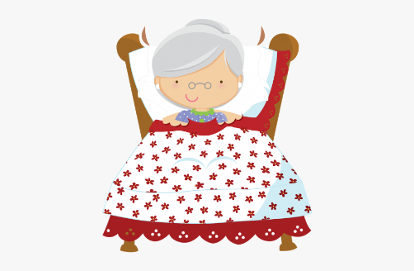  - We will be painting some flowers for Grandma.  - We will be taking apart flowers and putting them back together again.  - We will be seeing the story come to life in the film ‘Hoodwinked’.
Useful websites to use everyday
https://www.oxfordowl.co.uk/
https://www.thenational.academy/
https://www.bbc.co.uk/cbeebies
https://www.oliverjeffers.com/abookaday
https://www.tentown.co.uk/
https://www.ruthmiskin.com/en/find-out-more/parents/
https://whiterosemaths.com/

