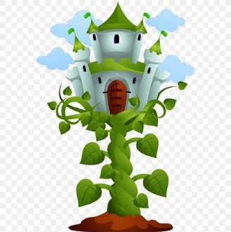 | Hello Everyone,  This week we are continuing to develop our understanding of traditional tales and next up is ‘Jack and the Beanstalk’. I hope you enjoy the stories as much as I do! As with each week please do visit the sites daily such as https://www.thenational.academy/and https://whiterosemaths.com/  as they have daily lessons for Reception. I’d love to see all of your work so don’t forget to email me at mtrotter@dunnstreet.s-tyneside.sch.uk
Personal, Social and Emotional Development | - This week we are going to focus on the story of the ‘When I am Sad’. We will be talking about the times we have felt sad and what we can do to help people who are feeling sad.  - Jack and the Beanstalk gives us a lot to talk about with regards to feelings as Jack’s Mum was angry, do you know why? Why was the Giant mad? What made Jack happy?
Communication, Language and Literacy | - We will be retelling the story of Jack and the Beanstalk and using our voices to play the different characters.  - We will be following instructions on how to create a map of the story. What did Jack do first? Then what happened next?  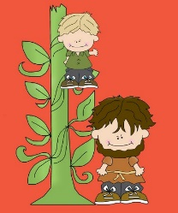  - We will be thinking of ways to describe the characters and items in the story using adjectives. We will be trying to think of as many as we can to make characters seem scary and objects come to life in our imaginations.
Physical | - This week we will be continuing to follow the cosmic yoga.  - We will be using wheeled equipment and seeing how fast we can ride our bikes and scooters.  - We will be making magic beans using playdough.  - We will be learning how to form our letters and numbers correctly.
Literacy | - We will be talking about speech bubbles and we will be making a speech bubble for the giant. What did he say in the story?  - We will also be using our phonic knowledge to write words and sentences.  - We will be reading words and sentences using our phonic knowledge.  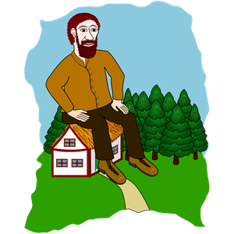  - We will be reading the story of Jack and the Incredibly Meanstalk and comparing the story.  - We will be singing the alphabet song and continuing to use letter names.
Mathematics | - Continue to count forwards and backwards to 20.  - Practise writing your numbers to 20.  - Put numbers in order from 1-20.  - We are continuing to count in 2’s.  - We are counting to count in 10’s.  - We are introducing counting in 5’s.  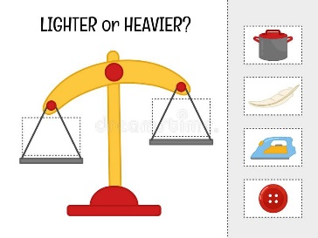  - We will be ordering items by height.  - We will be comparing items be their weight and using words such as heavier and lighter than to compare items.
Understanding the World | - This week we will be planting a seed and talking about the things that the seed will need for it to grow. We will be watching the process and recording our findings using an IPAD.  - We will be using blocks, lego and other constructions items to have a Beanstalk making competition. Who can make the tallest Beanstalk in your house? What height is it? What did you use? What was the strongest material?
Expressive Arts and Design | - We will be drawing pictures of castles and giants.  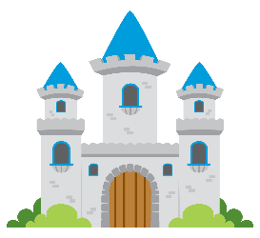  - We will be acting out the story.  - We will be singing nursery rhymes and fairy-tale songs.
Useful websites to use everyday
https://www.oxfordowl.co.uk/
https://www.thenational.academy/
https://www.bbc.co.uk/cbeebies
https://www.oliverjeffers.com/abookaday
https://www.tentown.co.uk/
https://www.ruthmiskin.com/en/find-out-more/parents/
https://whiterosemaths.com/

