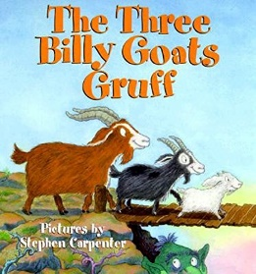 | Hello Everyone,  This week we are continuing to develop our understanding of traditional tales and next up is ‘The Three Billy Goats Gruff’. I hope you enjoy the stories as much as I do! As with each week please do visit the sites daily such as https://www.thenational.academy/and https://whiterosemaths.com/  as they have daily lessons for Reception. I’d love to see all of your work so don’t forget to email me at mtrotter@dunnstreet.s-tyneside.sch.uk
Personal, Social and Emotional Development | 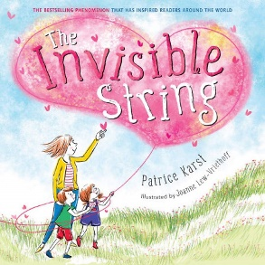  - This week we are going to focus on the story of the ‘Invisible String’ and talking about what and who we love.  - We will be working collaboratively to build bridges.
Communication, Language and Literacy | 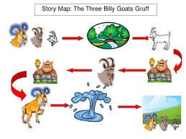  - Act out the parts of the goats and the troll in the story. Use different voices for each character.  - Make a story map of the story.
Physical | - This week we will be counting to follow the cosmic yoga.  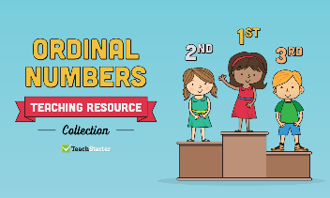  - We will be having running, hopping, skipping, jumping and walking races.  - We will be using scissors to cut the grass in the outdoor environment.
Literacy | - This week we are going to be telling the story of the three billy goats gruff. We will be introducing speech bubbles and trying to write what the troll and goats say in the story.  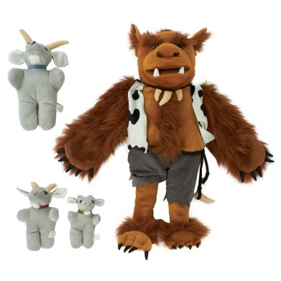  - We will be looking at a picture of Mr Troll and trying to write a description of Mr Troll using adjectives. He has brown, hairy eyebrows and green, beady eyes. Can you think of some descriptions for him?  - Continue doing your daily phonics and reading and writing simple words and sentences.  - Label a drawing of the three billy goats gruff.
Mathematics | - Continue to count forwards and backwards to 20.  - Practise writing your numbers to 20.  - Put numbers in order from 1-20.  - We are continuing to count in 2’s.  - We are counting to count in 10’s.  - We are introducing counting in 5’s.  - After reading the story we are going to be looking at size. The three billy goats gruff are all different sizes so why don’t you try to order the people in your house or find items around the house of different sizes and try to order them from the smallest to the biggest, shortest to the tallest and the shortest to the longest.  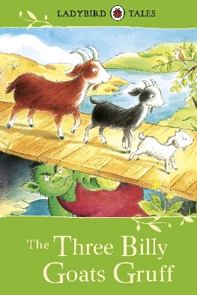  - We are going to be having some races and giving medals for first, second and third places. These are called ordinal numbers. In your family you could have a race and record who comes first, second and third.
Understanding the World | - We will be using lego, mobilo and blocks to build bridges for the three billy goats to cross over.  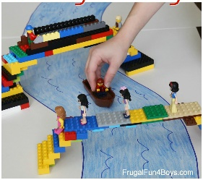  - We will looking at photographs of different bridges and seeing how we can adapt out designs to make the bridges stronger.
Expressive Arts and Design | 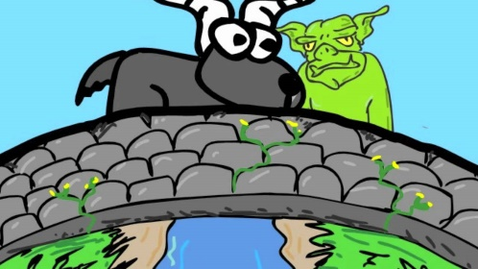  - Sing all of the nursery rhymes you know.  - We are going to be drawing the characters in the story.  - We will be acting out the story using our bodies and singing the three billy goats song.
Useful websites to use everyday
https://www.oxfordowl.co.uk/
https://www.thenational.academy/
https://www.bbc.co.uk/cbeebies
https://www.oliverjeffers.com/abookaday
https://www.tentown.co.uk/
https://www.ruthmiskin.com/en/find-out-more/parents/
https://whiterosemaths.com/

