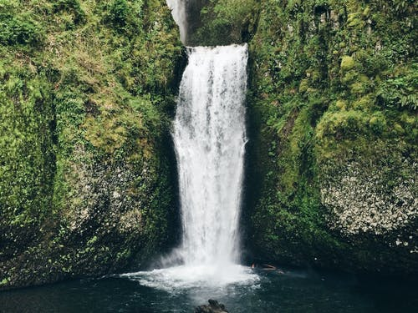

dangerous
magical
terrifying
stunning
deserted
tranquil
still
peaceful

