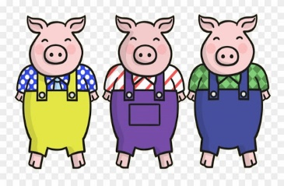 | Hello Everyone,  This week I have uploaded the story of ‘The Three Little Pigs’ for you to listen to. As with each week please do visit the sites daily such as https://www.thenational.academy/and https://whiterosemaths.com/  as they have daily lessons for Reception. Mrs Clough will be in touch with you all regrading some more opportunities to get involved with her ‘Google Classroom’ sessions. Have a great week.
Personal, Social and Emotional Development | 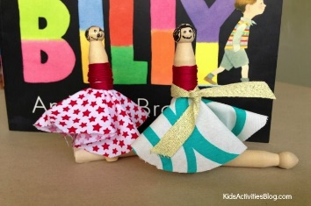  - This week we are going to be reading the story of ‘Silly Billy’ by Anthony Browne. It is a story about feelings and how to overcome those worries. After reading the story try finding a stick or peg and have a go at making your own worry doll
Communication, Language and Literacy | 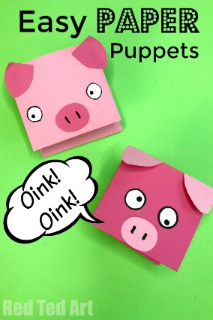  - This week’s story is a traditional tale. That’s a story that has been told for many years and a story that everyone in your family will know. After hearing the story make your own puppets using paper, card, wooden spoons or stones like I did and retell the story in your own way. Make sure you remember the repeated refrains in the story such as ‘I’ll huff and I’ll… and not by the hairs on…’
Physical | 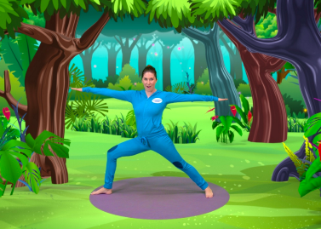  - This week we are going to try some yoga in class. We will be using cosmic kids, have a go everyday using https://www.youtube.com/watch?v=YKmRB2Z3g2s Yoga is very good for your mental health and well-being as well as being a great form of exercise so it’s something the whole family can get on board with
Literacy | - This week we will be continuing to read all of our set 1 and 2 sounds, our red words and green words more fluently  - After hearing the story of the Three Little Pigs, try to make a story map of what happens. Remember to think about the order of events, you might like to draw pictures or cut some out to help you  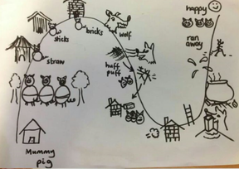  - We will also be making a ‘Wanted Poster’ to find the wolf. Remember to include a fabulous description of the wolf using your adjectives e.g. what colour was his fur? Were his teeth sharp? What were his eyes like? Don’t forget to draw a picture of him
Mathematics | - Keep counting everyday forwards and backwards to 20 and beyond  - This week we are going to be learning how to count in twos. Try to make a number line and then circle each of the numbers as you count in twos. What is the pattern?  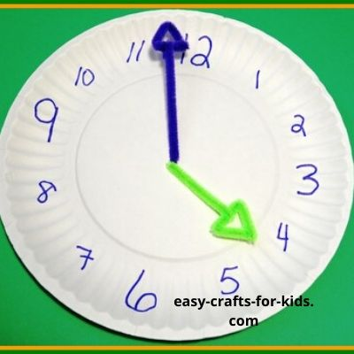  - This week we are going to be using the game that we loved to play at playtimes when we were altogether…What’s the time Mr Wolf? We are going to start to tell the time. Listen to the story and then read it again and see if you can tell the time using o’clock. Try and make your own paper clock, cutting out a circle and some hands. Add the number to the clock and then ask your grown-ups to give you an o’clock time to make. Make sure you have the longest hand pointing to the 12 and the shortest hand pointing to the hour  - Using all of the 2D shapes that you know, design and make a house. What shape would be good for the roof? The windows?
Understanding the World | 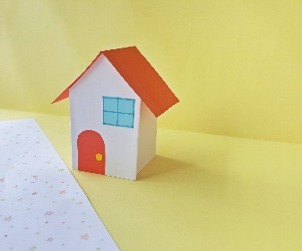  - The wolf has a very strong puff so we are going to investigate how to blow things away. With your grown up set up some of your toys and try to blow them over and using air. What are the easiest toys to blow down? Why? Would it be easier to blow them down inside or outside? Could you build a house with some of your toys and investigate to see whether it’s easier to blow a short house down or a tall house? What materials are the easiest to blow down? What materials are the strongest?  - Record your results
Expressive Arts and Design | - As we are reading a traditional tale this week try starring in your own play and get all of your house involved. Give each member of your family a part to play in the story, remember to use a loud, scary voice if you are the wolf  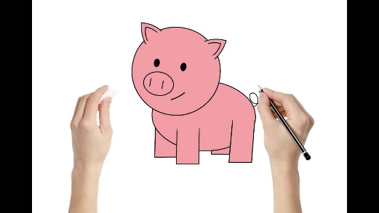  - Draw the characters from the story  - Sing the rhyme ‘Who’s afraid of the Big, Bad Wolf’
Useful websites to use everyday
https://www.oxfordowl.co.uk/
https://www.thenational.academy/
https://www.bbc.co.uk/cbeebies
https://www.oliverjeffers.com/abookaday
https://www.tentown.co.uk/
https://www.ruthmiskin.com/en/find-out-more/parents/
https://whiterosemaths.com/

