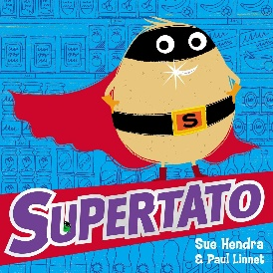 | Hello Everyone,  This week I have uploaded a few fantastic stories for you about the adventures of ‘Supertato’. I hope you enjoy the stories as much as I do! As with each week please do visit the sites daily such as https://www.thenational.academy/and https://whiterosemaths.com/  as they have daily lessons for Reception. I’d love to see all of your work so don’t forget to email me at mtrotter@dunnstreet.s-tyneside.sch.uk
Personal, Social and Emotional Development | - Supertato is a hero. Why? We’ve been talking a lot about real life heroes. Can you think of any? Has anyone in your family been a hero?  - For some of us we will be returning to school this week and some of us will be staying at home. It is really important to talk about how you are feeling with your grown-ups. We want to know how you feel and we will give you some strategies to help ease the worries. Don’t forget to listen to the story of the ‘Worry Monsters’ and look out for our school worry monster who will be eating up all of our worries  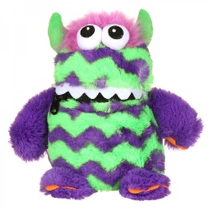  - As some of us return to school and some of us continue to stay at home our routines will be changing slightly as the ‘Lockdown’ eases. Talk through the changes together and how things might look slightly different in the coming days and weeks.
Communication, Language and Literacy | 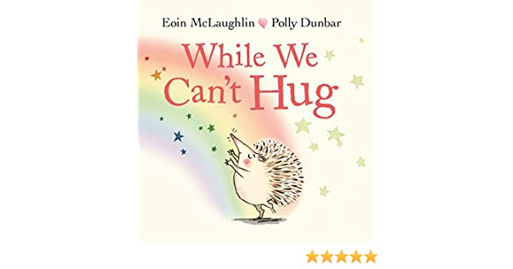  - Talk is so important at the moment for our children and for our grown-ups too. We must interact with each other and talk about the changes that are happening all around us. Share the video ‘While we can’t hug’ and talk about who will be the first person you’ll hug when it’s safe  - The ‘Supertato’ stories are excellent to share together and will give you lots to talk about. Who is Supertato? Who is the enemy? What happened to Supertato’s friends? How did Supertato save the day? What will happen next? At school we will be reading lots of stories and I hope you continue to read lots too
Physical | - All of our focus in recent times has been on keeping clean and healthy. Can you think of the ways you have been staying healthy? What healthy foods do you eat? Do you know how many pieces of fruit and vegetables you should have everyday?  - Do you know how long to wash your hands for? Can you remember watching a video when we were all last together sitting on the carpet?  - Listen to the story of ‘I don’t want to wash my hands’ and tell your grown up what you have found out  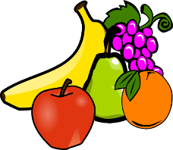  - As well as a healthy diet we must have daily exercise. What exercise have you been doing? Exercise makes us feel great and gives us lots more energy. Supertato stays fit by having races with his friends. Do you think you could have a race with the people in your house? What exercise could you do in the race?
Literacy | - The texts this week are based on ‘Supertato’ and the various adventures he has. Listen to the stories and talk about what happens in the beginning, middle and end of the stories  - Can you describe ‘Supertato’? What does he wear? What colour are his gloves?  - Can you make a story map of Supertato’s adventure? Where is he? What happens first? After? Next? How is it resolved?  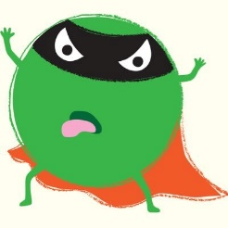  - Can you draw your favourite character from the story (mine is the evil pea) and write a sentence or your own story about another adventure they might have? Where does the story always start? What could the character do? How can they be rescued? Does your story have a happy ending?  - Can you practise forming all of your letters correctly? Remember we start on the line for all of your letters and say ‘up you go’ for each letter  - Say your sounds and practise reading your words
Mathematics | - Continue to count forwards and backwards to 20  - Practise writing your numbers to 20  - Put numbers in order from 1-20  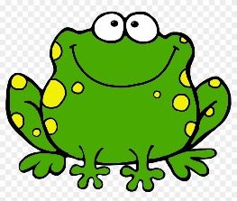  - Try and make an addition sentence out of the items in your house  - Could you try a subtraction?  - Sing your favourite number rhymes 5 little speckled frogs, 1,2,3,4,5, 5 little monkeys, 10 in the bed, 5 currant buns, 5 little ducks, 10 green bottles
Understanding the World | 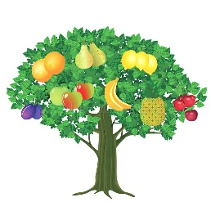  - Where do fruit and vegetables come from? What does our country grow? How do fruit and vegetables grow? What do they need to grow? What will happen if they don’t get those things?  - What happens to vegetables when they are cooked? What changes? Do they taste different?  - What can you make with a potato? What is your favourite type of potato product? How do potatoes grow?
Expressive Arts and Design | 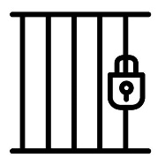  - Sing all of the nursery rhymes you know  - Can you make up a song about ‘Supertato’?  - Can you build a jail for the evil pea? Is it strong enough? How do you know? What other materials could you build it out of?
Useful websites to use everyday
https://www.oxfordowl.co.uk/
https://www.thenational.academy/
https://www.bbc.co.uk/cbeebies
https://www.oliverjeffers.com/abookaday
https://www.tentown.co.uk/
https://www.ruthmiskin.com/en/find-out-more/parents/
https://whiterosemaths.com/

