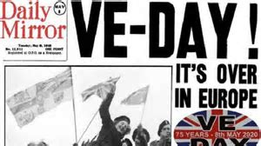
VE Day

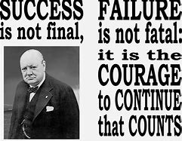
Victory in Europe Day, also known as VE Day, celebrates the unconditional surrender of the Nazi’s from World War 2. The final document was signed on 8 May 1945 and today many countries throughout the world celebrate VE Day annually to mark the occasion.

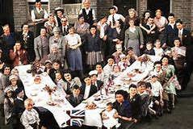
After the struggles of the last 5 years of war, there were street parties and parades throughout the Western world - especially in the UK. More than a million people took to the streets in Great Britain, with the greatest crowds in London and the day was declared a national holiday.
For lots of people, the day was a sad event as throughout Europe, wives had lost husbands and families had been torn apart by the war. VE Day was a chance to grieve and reflect on the sacrifices that had made by all.
Although the war was not fully over, VE Day signalled an end of the war that had started in 1939. It gave them a glimpse of what the future could be and for the families who were lucky enough to be reunited with loved ones, it was a day worth celebrating.

