Home Learning – Year 2
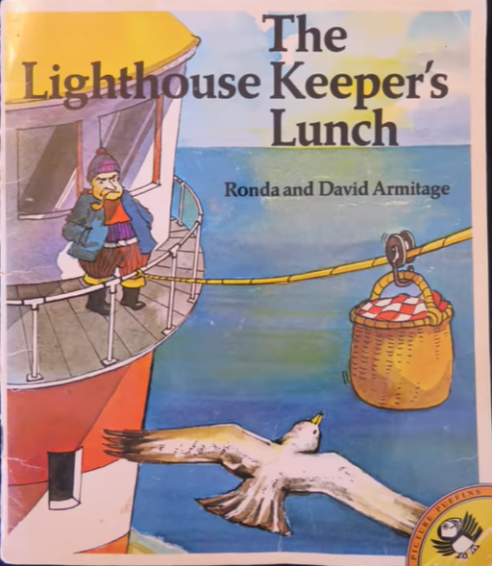
Week Beginning 11th May 2020

English, Art, Design and Technology – The Lighthouse Keeper’s Lunch
https://www.youtube.com/watch?v=46wCRq50Wwg
Reading

- Watch ‘The Lighthouse Keeper’s Lunch’ on the link above (or read the story if you have a copy in the house). It reminds me of the seaside!
- Discuss what happens in the story.
- What are the characters like?
- Does Mr Grinling like his job? Would you like to be a Lighthouse Keeper? Why?

Designing and Writing

Mr Grinling loves getting his sandwiches from Mrs Grinling.
- Make your favourite sandwich or a family member (with adult supervision)
- Write instructions to make your sandwich.
- Time connectives (First, next, then, after that, finally)
- Draw a picture and label your sandwich.
- Evaluate your sandwich. What do you like about it? What could you improve? Write two stars and a wish!!

Spellings
Choose a further 10 spellings from the list below.
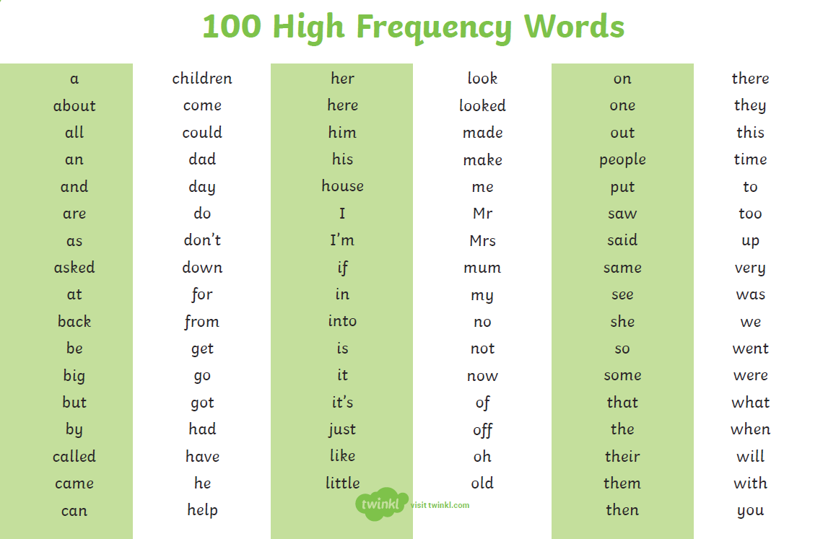

Maths
It’s National Numeracy Day on Wednesday 13th May. Can you complete all the challenges and win a prize? Remember to email your completed activities to kclough@dunnstreet.s-tyneside.sch.uk

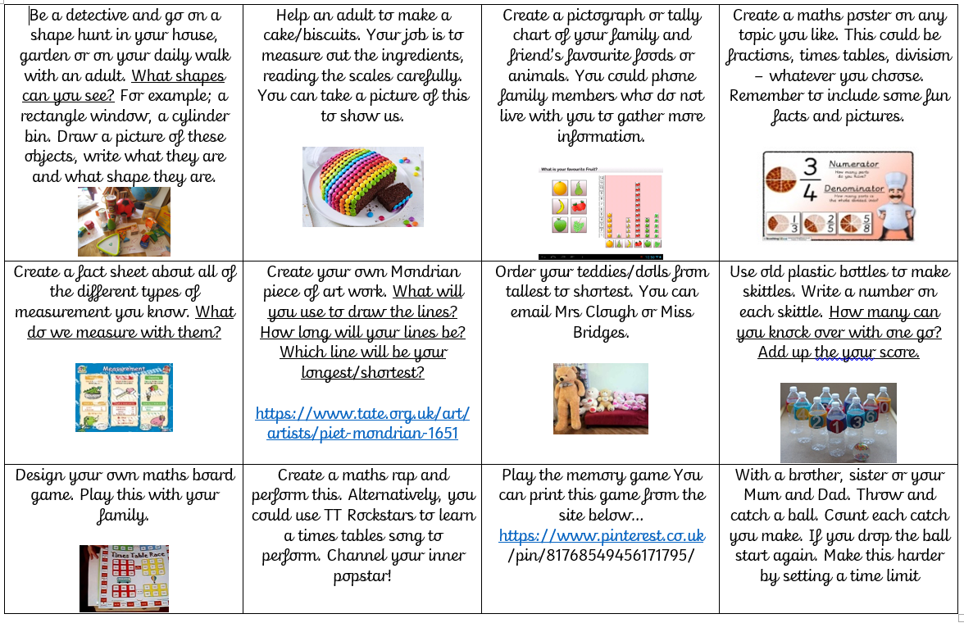

You can also find this on the school website under the tab ‘all news’

Complete the Times Table Rock Stars and NUMBOT activities.

Science
Challenge: Make a pulley system to communicate between the cottage and the lighthouse.
You will need:
- two pulley wheels that can rotate on a piece of dowel, with a loop of string running around both.
- Get two people to each hold a dowel and walk backwards until the string is tight.
- Pulling the string will cause the loop to move across the gap between the children – so you can tie a toy basket to the string to move it from cottage to lighthouse and back.
You may have to improvise with materials – extra points will be given for this

P.E
P.E. with Joe – daily sessions available on YouTube.

PE Skills Challenges – Start to Finish Sports https://www.youtube.com/channel/UC86a5L_iTDxgEfZDqXkkFCw
Websites covering a range of topics | www.twinkl.co.uk  www.topmarks.co.uk  www.bbc.co.uk/teach/supermovers  www.bbc.co.uk/bitesize  For additional resources, please see below on our class page..

