Home Learning – Year 2
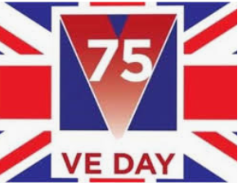
Week Beginning 4th May 2020

English and History
https://www.bbc.co.uk/newsround/48201749 (There are also lots of links on this website to learn about the war)

https://ve-vjday75.gov.uk/veterans_stories/

Wartime Stories

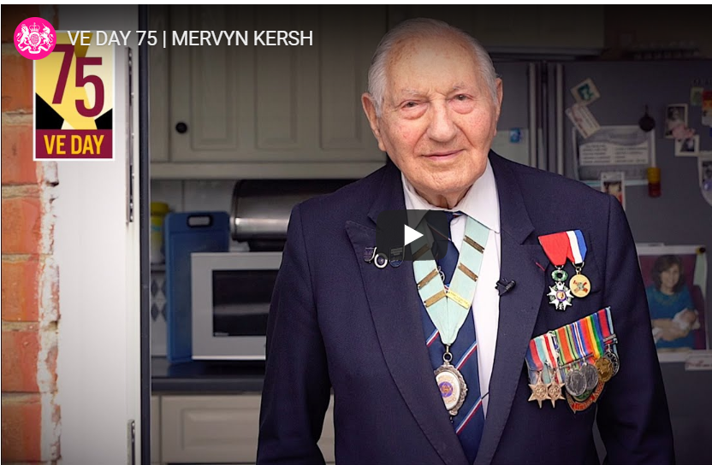

Read Mervyn and Joy’s stories – they are truly inspirational. Can you imagine being part of that amazing party at Buckingham Palace in 1945?

Get Involved

Can you create a dessert for a party? Or get involved with Dan Snow’s Challenge?

The challenge
We’re asking you to think about how you would tell the story of VE Day today. There are lots of ways you could bring the story of VE Day to life. You could:
- Write a short news report in the style of today or 75 years ago
- Make a short video that tells the story of VE Day, either in the style of 75 years ago or how you would tell it today
- Design a newspaper front page or article
- Write or perform a poem, song, drawing or other work of art
- Share the story of someone in your family or area who was involved in the War
- Write or perform a short play about VE Day and what it would have been like 75 years ago

Where to start
There are lots of online resources you use to find out more about VE Day and the Second World War:
- BBC
- CBBC
- Discovery Education’s free resources for schools and families
- Imperial War Museum
- National Army Museum
- Royal British Legion
- The National Archives
We’ve also got a range of logos and colouring in posters you can use on our toolkit page.

I think I might take my hand to baking Prue Leith’s flapjacks or something with the union jack on. I wonder what it will be? I’ll post a picture on the website. If you create anything you can send it to me at kclough@dunnstreet.s-tyneside.sch.uk. I would love to see your creations and anything from a party you might have at home with your family!!
Maths
https://whiterosemaths.com/homelearning/year-2/

Week beginning 4th May – Summer Term
Lesson 1- Fact families
Lesson 2 – Compare number sentences
Lesson 3 –Related facts
Lesson 4 - Add and subtract ones
Lesson 5 – Friday Maths Challenge (Coming soon)

Complete the Times Table Rock Stars and NUMBOT activities.

https://www.thenational.academy/online-classroom/schedule/#schedule

Watch the Video and play the game

https://www.bbc.co.uk/bitesize/articles/z6tv382 – Part whole relationships and fact families

P.E
P.E. with Joe – daily sessions available on YouTube (it might look a bit different this week)

PE Skills Challenges – Start to Finish Sports https://www.youtube.com/channel/UC86a5L_iTDxgEfZDqXkkFCw
Websites covering a range of topics | www.twinkl.co.uk  www.topmarks.co.uk  www.bbc.co.uk/teach/supermovers  www.bbc.co.uk/bitesize  For additional resources, please see below on our class page..

