Home Learning – Year 2
Week Beginning 27th April 2020

The following activities have been chosen to support the learning we have completed in Year 2 so far. It is not essential that every activity is completed.
English
https://www.storylineonline.net/books/peter-rabbit/

Reading

- Watch ‘The Tale of Peter Rabbit’ on the link above (or read the story if you have a copy in the house). It’s one of our favourites.
- Discuss what happens in the story.
- What are the characters like?
- Can you describe Peter’s personality and appearance? Do you think he’s a good adventurer? Can you explain why?

Writing

- Peter loves to get into Mr McGregor’s garden. Write a new adventure for Peter and his friends. Remember to include:
- Expanded noun phrases
- Conjunctions
- Capital letters, full stops and exclamation marks
- Inverted commas (for speech)

Spellings
Choose a further 10 spellings from the list below.
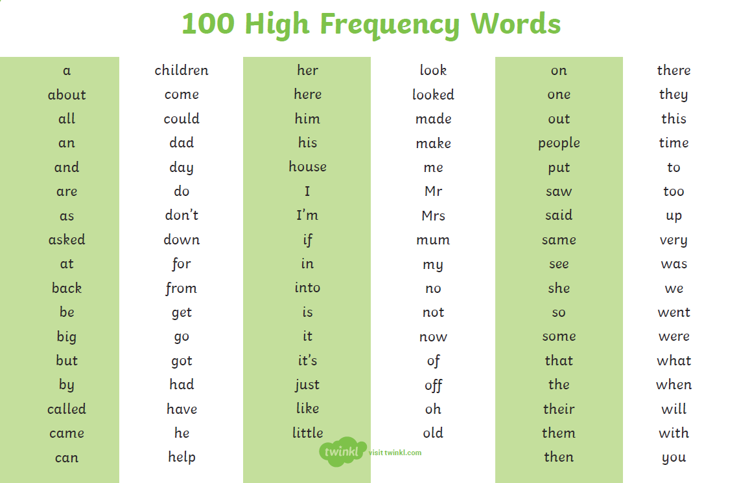

Maths
https://whiterosemaths.com/homelearning/year-2/

Week beginning 27th April – Summer Term
Lesson 1- Compare Lengths
Lesson 2 – Order Lengths
Lesson 3 –Four operations with length
Lesson 4 - Problem Solving
Lesson 5 – Friday Maths Challenge (Coming soon)

Complete the Times Table Rock Stars and NUMBOT activities.

https://www.thenational.academy/online-classroom/schedule/#schedule

Watch the Video and play the game

https://www.bbc.co.uk/bitesize/articles/z6tv382 - Recognising Coins

Art and Geography
Can you create your own map of your Mr McGregor’s garden?

http://www.childrens-books-and-reading.com/making-maps-of-mr-mcgregors-garden.html

Think about the shapes you could use for the vegetable patches, colours for the vegetables and fruit?

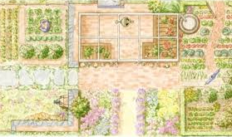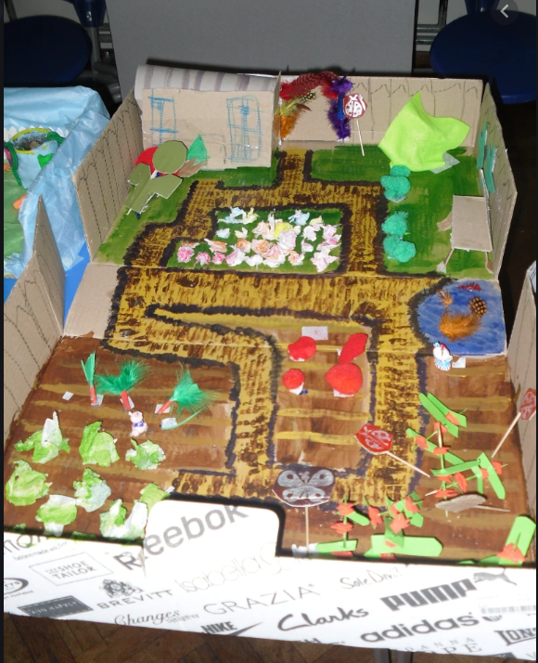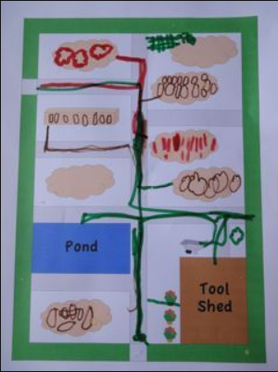

P.E
P.E. with Joe – daily sessions available on YouTube.

PE Skills Challenges – Start to Finish Sports https://www.youtube.com/channel/UC86a5L_iTDxgEfZDqXkkFCw
Websites covering a range of topics | www.twinkl.co.uk  www.topmarks.co.uk  www.bbc.co.uk/teach/supermovers  www.bbc.co.uk/bitesize  For additional resources, please see below on our class page..

