Home Learning – Year 2
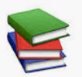
Week Beginning 20th April 2020

The following activities have been chosen to support the learning we have completed in Year 2 so far. It is not essential that every activity is completed.
English
- https://www.worldofdavidwalliams.com/watch-and-listen/

A selection of books read by the author David Williams.

Year 2 have loved being introduced to the author David Walliams. Listen to his books and be creative. Can you write your own story based on your favourite book? You could change the characters and make them as disgusting as he does – what about Windy Mindy and Peter Picker? Or even Geronimo?

- Read some of your reading book, a favourite book or listen to a free story on
https://www.audible.co.uk/

- Spellings - Choose 10 spellings from the list below.

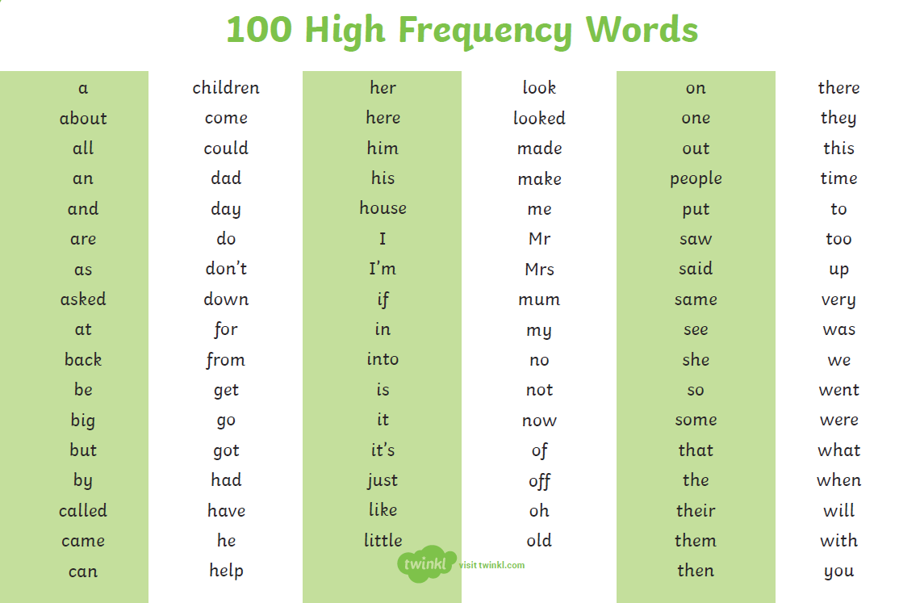
Maths
https://whiterosemaths.com/homelearning/year-2/

Week 1 – Summer Term
Lesson 1- Find three quarters
Lesson 2 – Count in fractions
Lesson 3 – Measure length (cm)
Lesson 4 - Measure length (m)
Lesson 5 – Friday Maths Challenge (Coming soon)

Complete the Times Table Rock Stars activities.

Geography
You’ve researched Ecuador, now research Brazil. Look at:
- Physical features (coast, mountains, rivers)
- Human features (houses, buildings)

Can you present your information in a poster or another way you choose?

Art
https://www.youtube.com/watch?v=6riMCump_CM

Follow the step by step instructions to draw your favourite animals.

P.E
P.E. with Joe – daily sessions available on YouTube.

PE Skills Challenges – Start to Finish Sports https://www.youtube.com/channel/UC86a5L_iTDxgEfZDqXkkFCw
Websites covering a range of topics | www.twinkl.co.uk  www.topmarks.co.uk  www.bbc.co.uk/teach/supermovers  www.bbc.co.uk/bitesize  For additional resources, please see our below on our class page..

