Dunn Street Primary School
Minster Parade
Jarrow
Tyne and Wear
NE32 3QH
6^{h} September 2018
Dear Parents and Carers
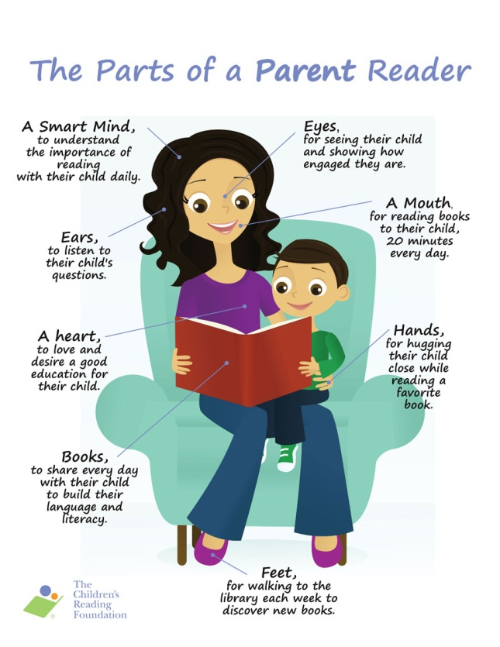
I am writing to you as Key Stage 2 and English Lead (as well as your child’s teacher) and asking for your support. We are increasingly concerned by the number of children who are not engaging with home-school reading. It is widely recognised that pupils who read at home are more likely to succeed in other areas of the curriculum and go on to be healthier and better educated.
If a pupil reads for 20 minutes a day, they are likely to score in the top 90th percentile of standardised tests. If they read for 5 minutes a day, they are more likely to appear in the 50th percentile. If they read a minute a day, they are likely to appear in the bottom 10th percentile.
Do you want your child to be a better reader? Simply read!!
Please help us help your child by:
- Ensuring their reading book is where they are – in school when they are and at home when they are.
- Hearing your child read as often as possible and filling in their reading record.
- Sharing stories and discussing what they have read.
- Allowing them to come to school 8.40am Monday / Wednesday to complete 20 minutes reading if they are struggling to do it at home.
There are lots of ideas on the school web-site: http://dunnstreetprimary.co.uk/reading-news/
If you have any questions, or want tips and ideas about how to help your child with their home reading, please do not hesitate to ask.
Yours sincerely
Miss Noble
………………………………………………………………………………………………………………………………………………………………..
My child ________________________(child’s name) would like to attend school at 8.40am on Monday and Wednesday to read.

Signed__________________________

