

**APPLICATION   
PACK**

|  |  |
| --- | --- |
| **POST OF** | Teacher of Science |
|  | |
| **DETAILS ABOUT THE POST** | |
| **GRADE** | Inner London Pay Scale – Dependent on experience |
| **TYPE OF POST** | Permanent |
| **START DATE** | September 2022 |
| **REASON FOR VACANCY** | Vacancy |
|  | |
| **INFORMATION PROCESS** | |
| **CLOSING DATE** | 8th July 2022 |
| **INTERVIEW DATE** | W/c 4th & 11th July 2022 |
| **INTERVIEW PANEL** | Principal, Head of Faculty and HR Advisor |
|  |  |
| **EMPLOYMENT CHECKS REQUIRED** | |
| * Completed application form * Employment history including explanation of any gaps * Proof of academic and professional qualifications * Receipt of two professional references * Enhanced DBS. Overseas criminal records check (if appropriate) * Prohibition from teaching check * Right to work in the UK * Health check | |

**Contents:**

1. Principal’s Letter to Candidates

2. Our Mission, Vision and Values

3. Safeguarding Strategy Statement

4. Ofsted Outcome Letter - November 2019

5. Job Description

6. Person Specification

7. Faculty Overview

8. Teachers’ Standards

9. How to Apply / Process of Selection



June 2022

Dear Applicant,

**RE: Teacher of Science**

Thank you for expressing interest in the above vacancy we have here at Duke’s Aldridge Academy.

Please find enclosed an application form and information about the post. I hope this provides the information that you need in order to decide whether to apply. If you would like any further information, do please contact Sonia East – Executive Assistant to the Principal on 020 8275 4803 or [recruitment@dukesacademy.org.uk](mailto:recruitment@dukesacademy.org.uk)

The academy enjoys a rich mix of culturally diverse students drawn from one of London’s most ethnically vibrant wards. This socio-economic profile shields a positive and vital aspect of our academy’s community. The academy’s specialism is for the arts (English, Media and Art). The academy is fully integrated with the secondary base of the Vale Special Academy for children with physical disabilities and complex needs which share the campus and buildings.

Duke’s Aldridge Academy is a member of the Aldridge Education family of academies. The link to the website is as follows: <http://aldridgeeducation.org/>

Duke’s Aldridge Academy (formerly Northumberland Park Community School) was judged as ‘good’ in its last Ofsted inspection in November 2019. We have set ourselves the goal of moving from being good to being outstanding in all aspects.

Duke’s Aldridge Academy places teaching and learning at the heart of everything we do and continuously supports and trains its teachers to become excellent. The academy has achieved a dramatic improvement in achievement over the past few years, breaking through the presumptions that social deprivation limits attainment. We intend to continue to raise achievement beyond national averages and that of academies whose children and families are in more fortunate circumstances, as for our children more than others, education and achievement is a vital basis for their future life chances.



When staff, students and families walk through our gates and onto our site, they belong to the Duke’s Aldridge Academy. In this community, we build meaningful relationships based on trust and mutual respect. Our classrooms, corridors and the academy environment are safe spaces where nobody is judged and everyone is valued. Our ethos, driven by our commitment to Duke’s values, is built on inclusion and our dedication to care for each member of our community as an individual. We put learning and learners first in every decision we make. We are proud of our academy and committed to supporting all staff and students to “be the best you can be”.

Once appointed, we expect that all staff will continue with their professional development which emphasises teamwork and the sharing of good practice. Our programmes for trainees and NQTs are particularly strong and have been highly praised by HMI. Staff are valued highly, moral is high and there is strong recognition that all play an important role to enable our academy to succeed.

In completing your application please note the details of the application process and the closing date in the pack. If you have not heard from us by the interview date stated in the applicant’s information sheet, I am sorry to say that your application will have been unsuccessful on this occasion.

If you feel that you have the necessary skills and commitment to work at Duke’s and relish the opportunity to contribute and make a difference then I look forward to hearing from you.

Yours sincerely,



Monica Duncan  
**Principal**

**Additional information about our academy can be found on the academy’s website:** [**www.dukesacademy.org.uk**](http://www.dukesacademy.org.uk)

**Our Mission**

Inspire to Excel

**Our Vision**

Duke’s Aldridge Academy provides an outstanding education within a vibrant community where the expectation is to excel. For each individual we promote achievement, success, strength of character, tolerance and a love for learning. We provide the support, challenge and breadth of experience which ensure our students become creative, resilient and successful adults.

**Our Values**

We are a values-driven organisation with a commitment to non-selective, inclusive  
schools providing children and young people with an exceptional educational experience.

**We value:**

* our students, their potential, their contributions and their aspirations
* the community we serve and its right to locally provided, high quality education
* the cultural diversity and richness of our community within the context of British  
  Values
* academic rigour at all stages to create a learning environment that provides challenge,  
  engagement and achievement
* respect, fairness, courtesy and the right to equality of opportunity as the entitlement of  
  each member of the academy community
* ‘professional integrity’ and transparency
* our staff and their right to professional development and growth

**SAFEGUARDING STRATEGY STATEMENT**

Duke’s Aldridge Academy Safeguarding Strategy forms a fundamental part of our approach to providing excellent pastoral care to all students. We believe that all students, regardless of age, special needs or disability, racial/cultural heritage, religious belief and sexual orientation have the right to protection from all types of harm and abuse.

The objective of the Safeguarding Strategy is to help keep our students safe by providing a safe environment for them and to educate them about keeping themselves safe.

The Safeguarding Strategy consists of:

1. Adridge Education Trust Safeguarding Policy
2. Duke’s Aldridge Academy Procedures
3. Training to equip staff and volunteers to carry out their responsibilities in relation to safeguarding and promoting the welfare of students

The Safeguarding Strategy provides a clear framework within which individual academies will develop systems and local procedures to:

* Prevent unsuitable people working with children
* Identify students who are at risk of, and/or are likely to suffer significant harm and take appropriate action with the aim of making sure they are safe
* Record and share information appropriately
* Respond to allegations against staff and volunteers
* Promote safe practice and challenge poor and unsafe practice

Adherence to the Duke’s Aldridge Academy Safeguarding Strategy is mandatory for **all** staff and volunteers.

We recognise that Safeguarding covers much more than child protection and so this strategy will operate in conjunction with related policies and procedures, such as effective whole academy policies on: health and safety, anti-bullying, behaviour management, IT and academy security.

Our approach to safeguarding is based on, and reflects the current principles recognised in UK legislation, including those around maintaining confidentiality and reporting concerns about students likely to suffer significant harm to the child protection agencies.

We are committed to working in partnership with parents; child protection agencies and diverse communities, to continuously develop and improve the Safeguarding Culture within our academy.

**September 2019**

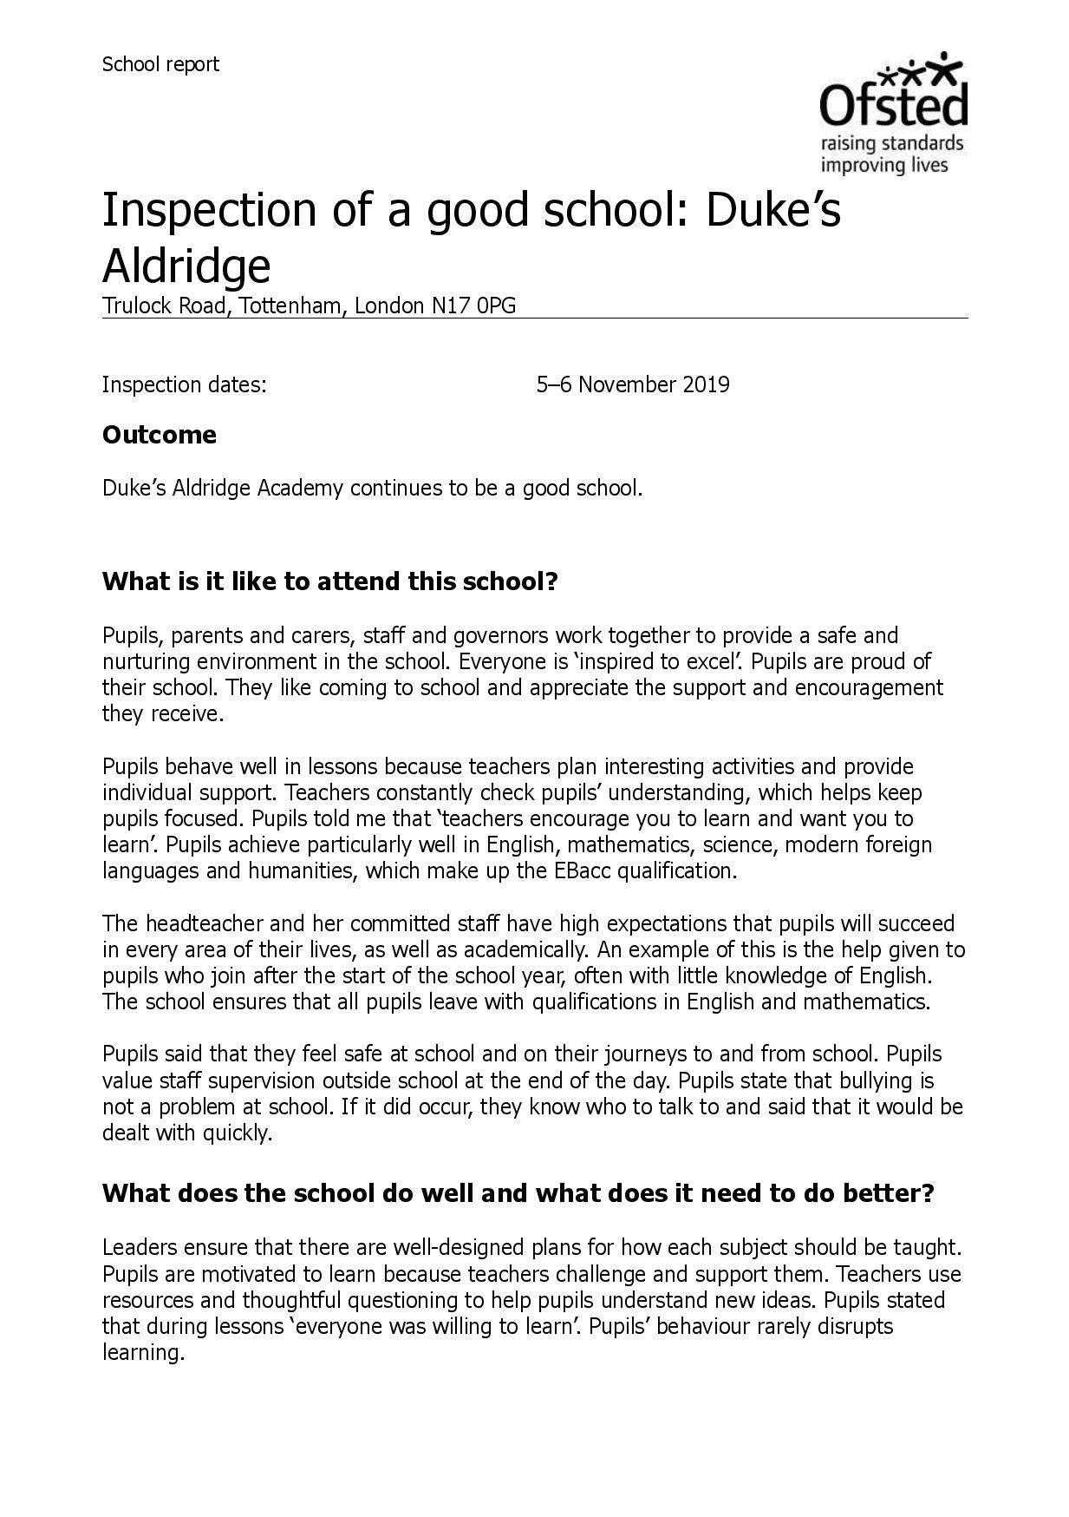

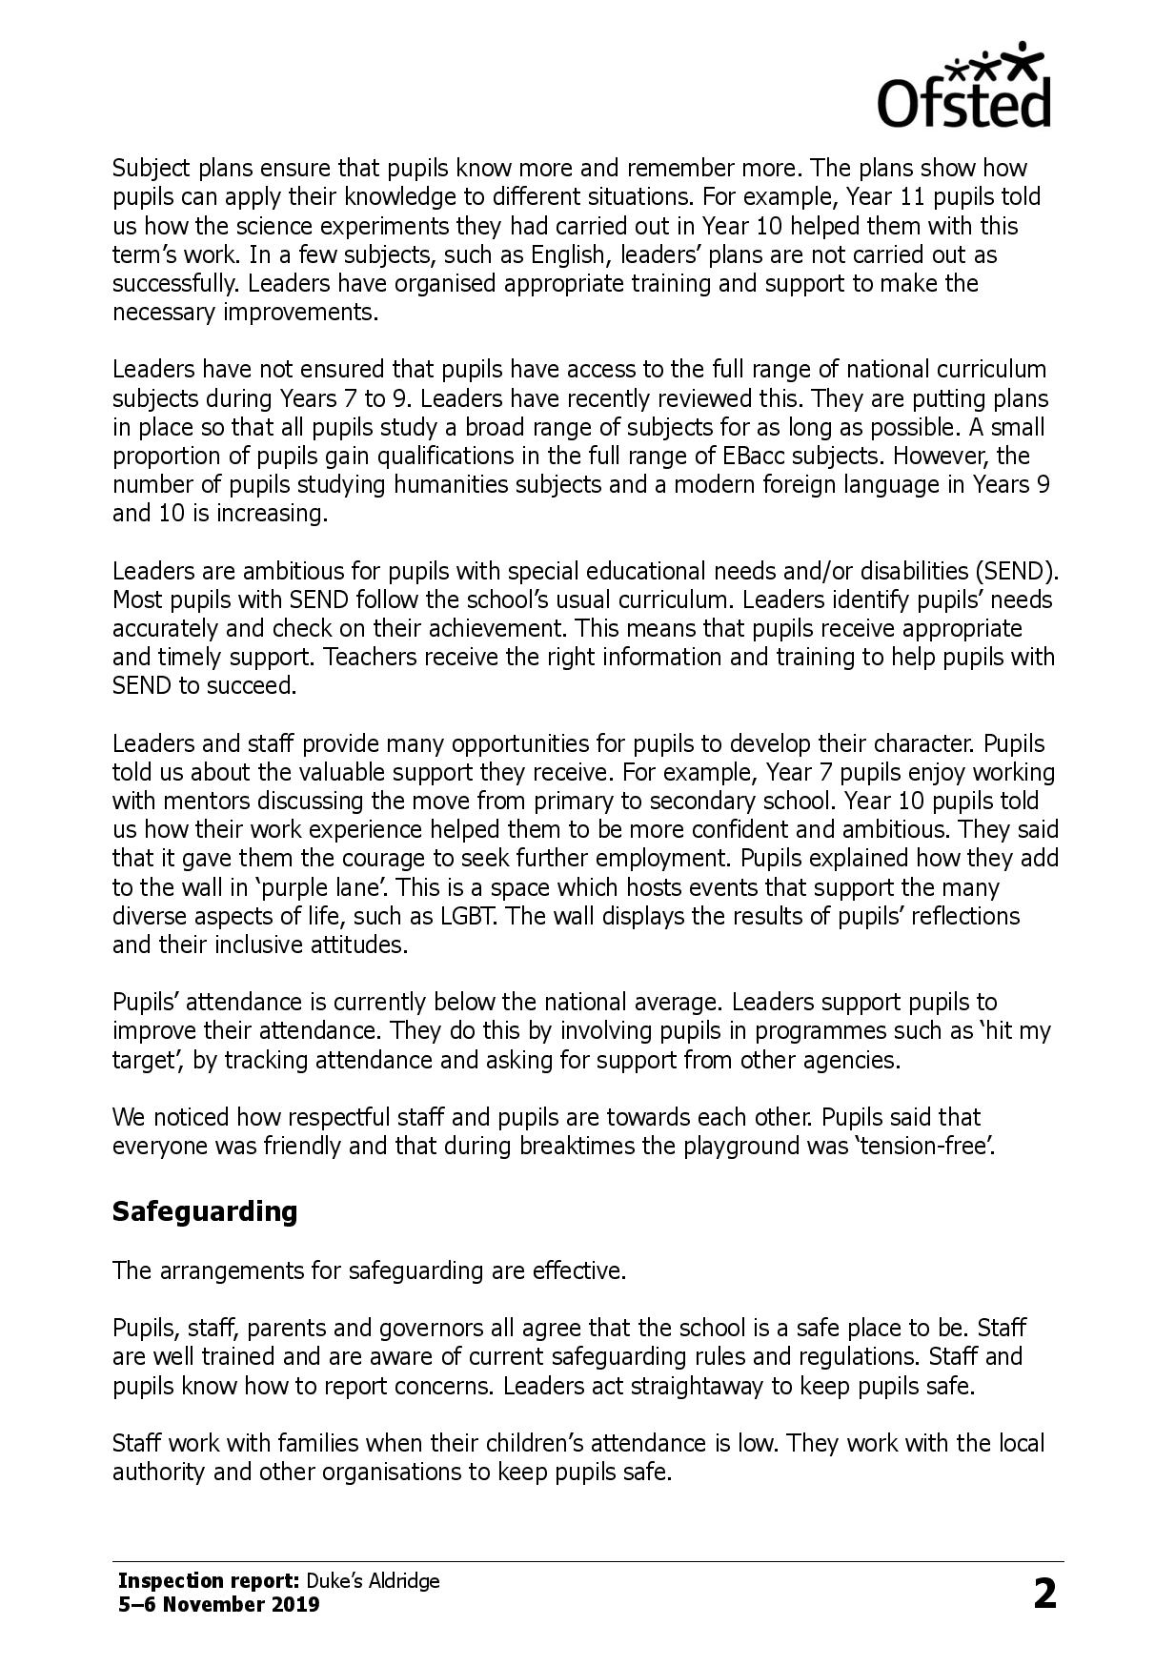

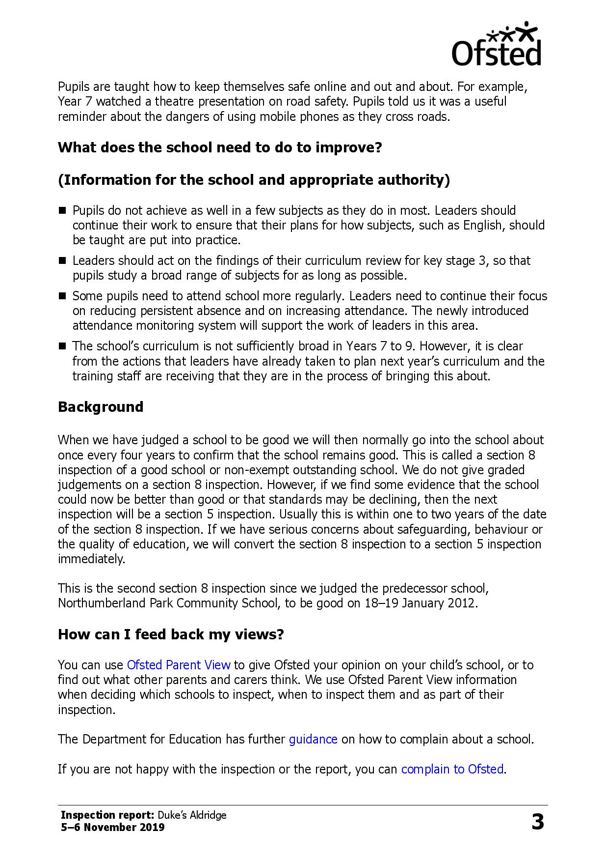



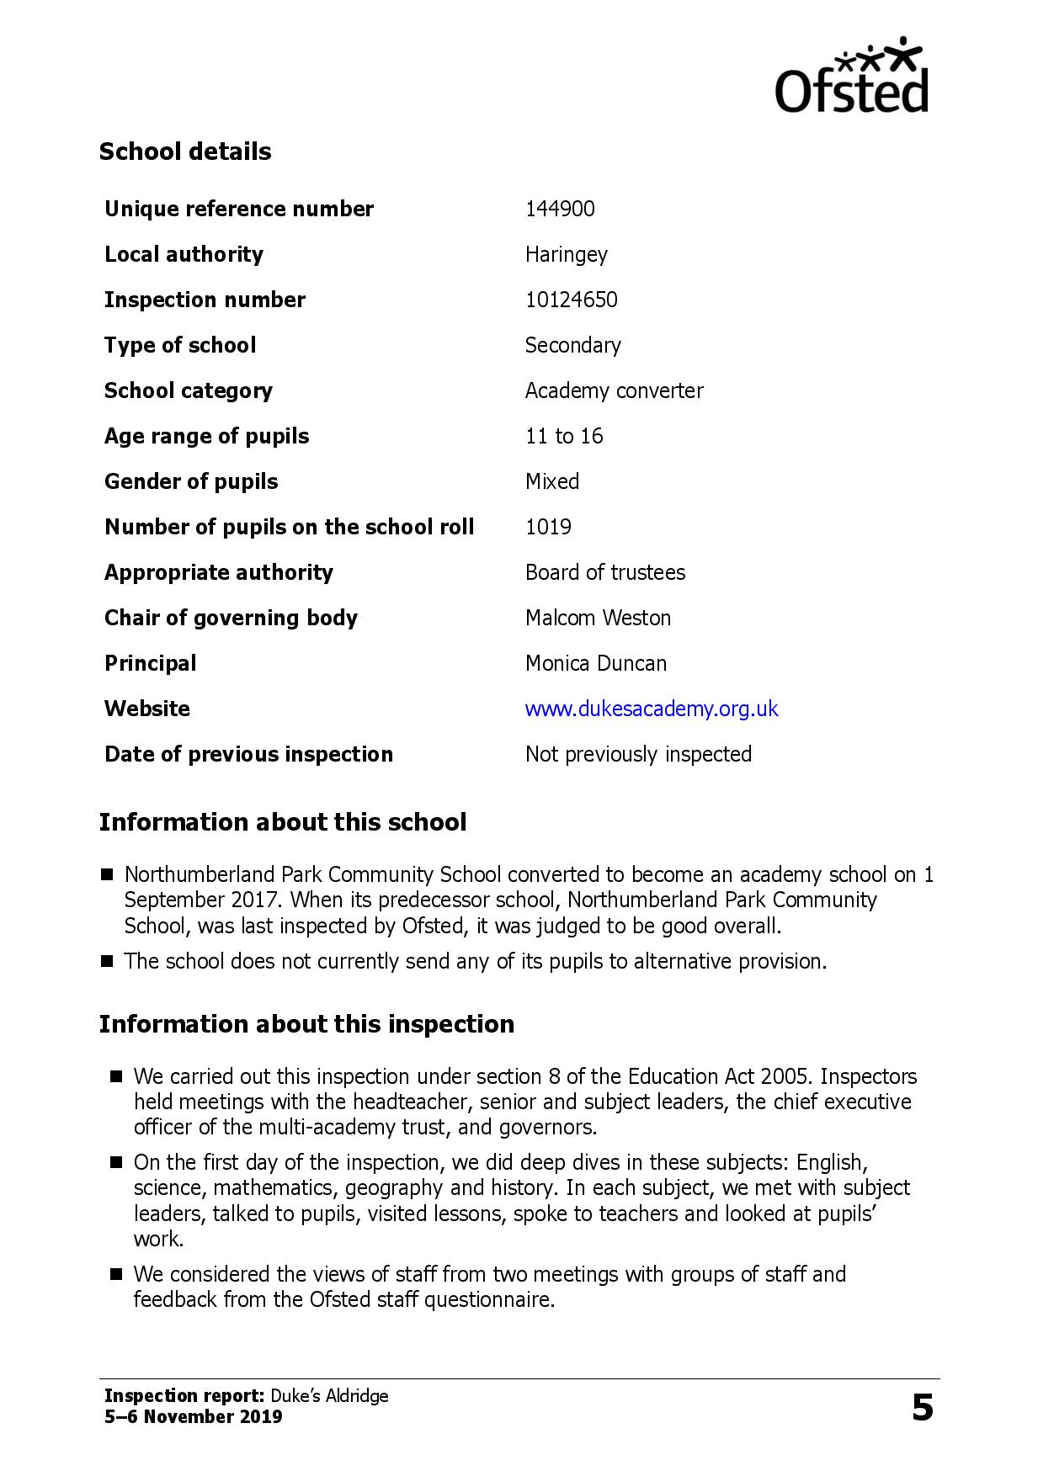

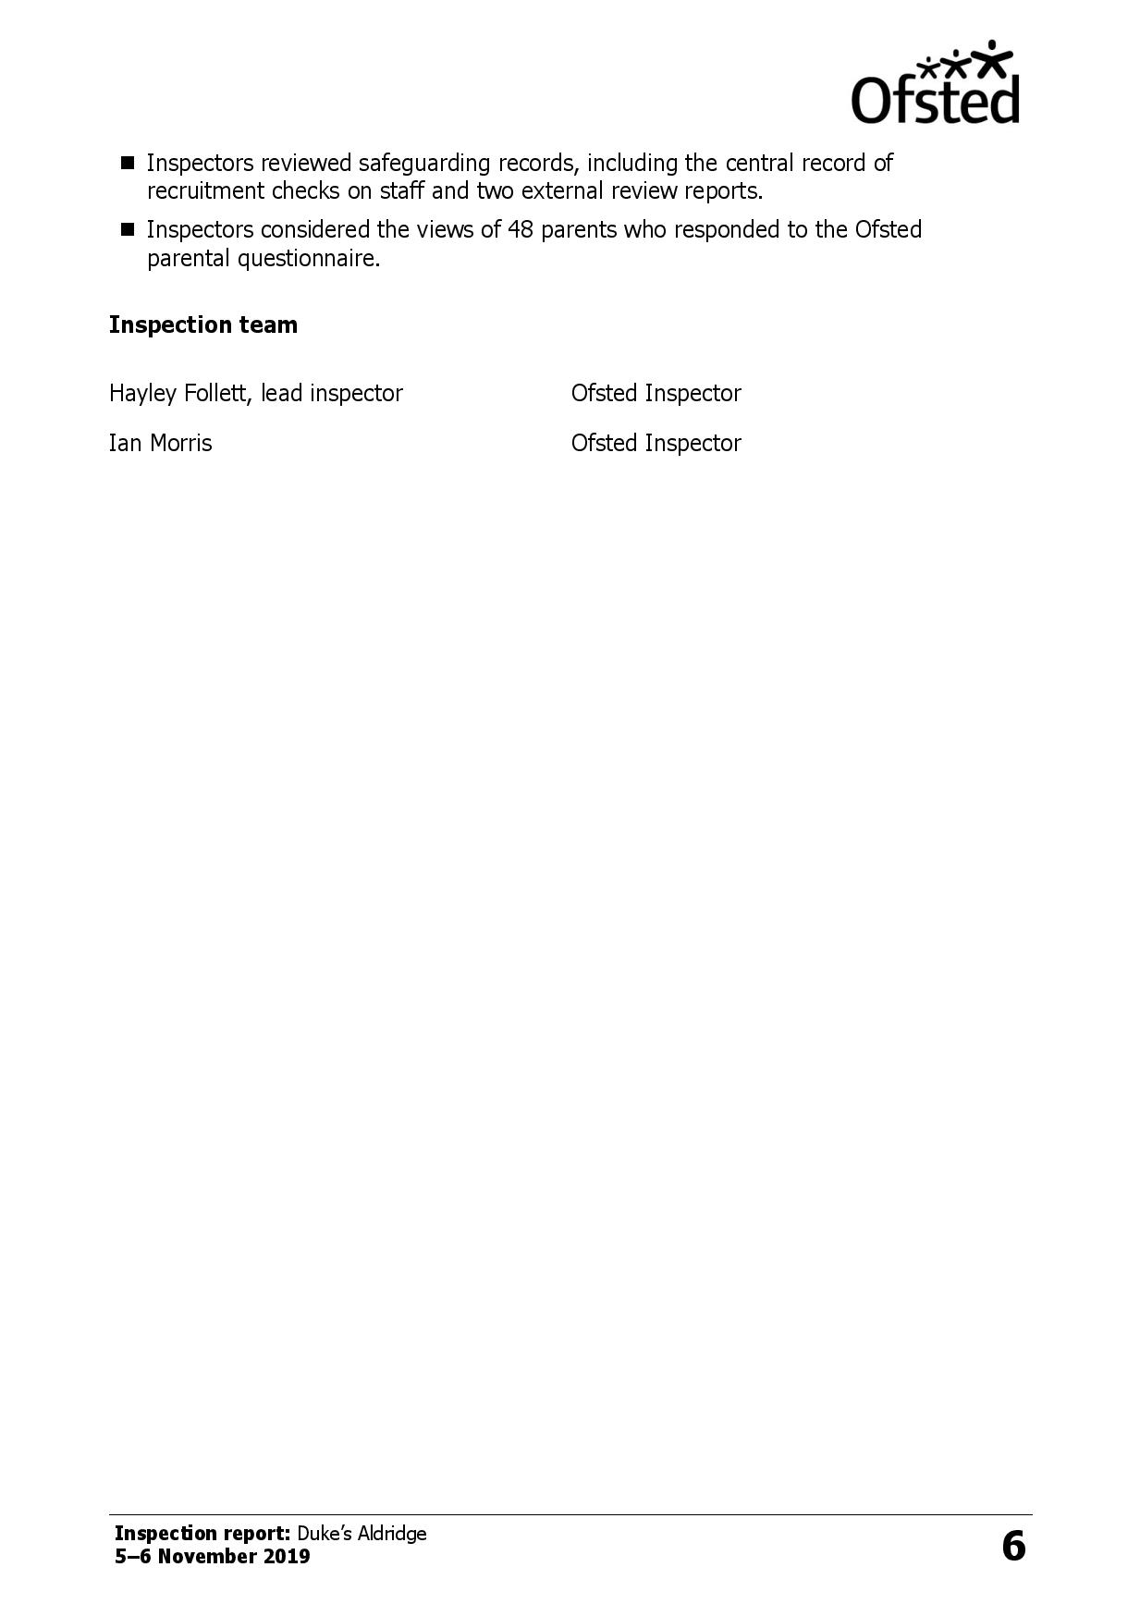

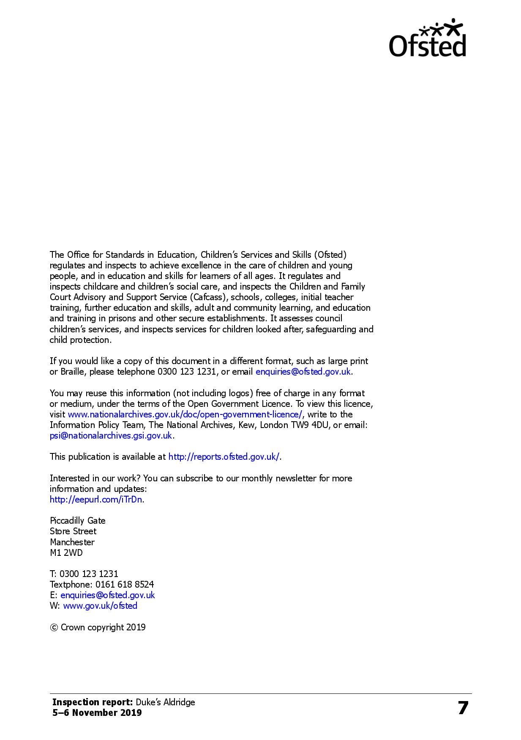

**JOB DESCRIPTION: SCIENCE TEACHER**

|  |  |
| --- | --- |
| **Post Title:** | Teacher of Science |
| **Location:** | Duke’s Aldridge Academy |
| **Purpose:** | **OVERALL OBJECTIVES FOR THE POST:**   * To perform the functions of a school teacher as set out in the School Teachers’ Pay and Conditions Document (STPCD) and in line with the Teachers’ Standards * To meet the Professional Standards for Teachers’, Core and Threshold, as applicable to the postholder |
| **Reporting to:** | Head of Faculty |
| **Liaising with:** | SLT, subject teachers and pastoral teams |
| **Working time:** | 195 days (Full time) |
| **Salary:** | MPS/UPS |
| **Responsibilities:** | **Learning, teaching, assessment and progress**   * To teach across key stages 3 & 4. * Plan and deliver high quality, appropriately resourced lessons to meet the needs of all learners * Reflect on lessons to continually improve own practice, through engaging in the school coaching programme * Have high expectations for the quality of work and provide good quality feedback to students to support their learning in line with academy policy * Work with the support team to ensure effective teaching of SEND and disadvantaged students, reviewing and reporting on their progress * Set high expectations for engagement, learning and behaviour in line with academy and department policy * Monitor and review schemes of learning for all groups taught * Carry out regular and appropriately benchmarked assessment activities with all students and report these in line with academy tracking systems * Maintain accurate and up to date attainment data for all assigned students * Ensure appropriate steps are taken when students are showing signs of underperforming and not reaching their target * Prepare students for external examinations * Mark students’ books & assessments regularly according to marking and assessment policy. * Contribute ideas for continuing development and improvement of the department * Contribute to the facilities extracurricular and intervention programme |
|  | **General:**   * Ensure that own teaching spaces used are a model of best practice and reflect best practice at all times * Use new technologies to engage and stimulate learning * Take responsibility for creating a pleasurable and stimulating learning environment for students to work in with thoughtful display and management of resources in the classroom * To be accountable for students’ performance, attendance and behaviour in line with academy procedures * Participate fully in professional development activities to develop practice further, sharing the learning from these as appropriate * Undertake all the duties associated with the role of a teacher as set out in the STPCD * To model the highest expectations and work to meet the criteria as outlined in the Teacher’s Standards   **Upper Pay Range Expectations:**  A teacher on the Upper Pay Spine is expected to demonstrate sustained and substantial contribution to the academy. In addition, teachers on UPS2 and particularly those on UPS3 must take a lead on a whole academy initiative and take an active role in developing others. Criteria for UPS are published annually in the School Teachers’ Pay and Conditions Document and in the School’s Pay Policy. |
| **Other Duties** | **Form Tutor Responsibilities:**   * Take responsibility for day to day discipline, routines and attendance in the tutor group * Review and discuss students’ work and welfare, setting targets as necessary * Promote good behaviour and positive attitudes at all times * Support tutor, year, house and academy activities/assemblies/events as appropriate |
| **Monitoring, Evaluation and Assessment** | * To monitor the effectiveness of teaching and learning within the subject area, through regular lesson observations, learning walks, work scrutiny and other data collection methods. * To regularly review the progress and attainment of all students, groups and subgroups with team members and plan, implement and oversee support and interventions. * To produce reports as required on student progress and attainment * To lead appraisal and monitor the effectiveness and impact of appraisal arrangements across the department and respond as appropriate. * To liaise with all appropriate personnel regarding support for students not making the required progress, including SENDCo, Senior Leader line manager, other members of the Senior Leadership Team as appropriate and parents/carers. |
| **EQUAL OPPORTUNITIES:**  Demonstrate and share in the academy’s commitment to equality and inclusivity.  **SAFEGUARDING:**  It is the post holder’s responsibility to promote and safeguard the welfare of children and young people with whom he/she comes into contact and to adhere to and ensure compliance with the Academy’s Safeguarding and Child Protection Policy Statement at all times.  If, in the course of carrying out the duties of the post, the post holder becomes aware of any actual or potential risks to the safeguarding or welfare of children in the academy she/he must report any concerns to her/his Line Manager or the Academy’s Designated Safeguarding Lead (DSL).  The academy is committed to safeguarding and promoting the welfare of children and young people and expects all staff and volunteers to share this commitment.  Disclosure level - Enhanced DBS  **HEALTH AND SAFETY:**  Be aware of the responsibility for Personal Health, Safety and Welfare and that of others who may be affected by your actions or inactions. Cooperate with the employer on all issues to do with Health, Safety and Welfare and fully comply with the Health and Safety Policy of the academy. | |

Whilst every effort has been made to explain the main duties and responsibilities of the post, each individual task undertaken may not be identified. The post holder will be expected to comply with any reasonable request from a manager to undertake work commensurate with its level of responsibility that is not specified in this job description.

**Development and Review of Job Description:**

Reviewers: Principal, HR.

This job description may be amended at any time following discussion between the Principal and post holder.

**PERSON SPECIFICATION**

|  |  |  |
| --- | --- | --- |
|  | **Essential** | **Desirable** |
| **Qualification** |  |  |
| Qualified teacher status | ✓ |  |
| Appropriate Degree | ✓ |  |
| Commitment to personal/professional development | ✓ |  |
| Evidence of continuing professional development |  | ✓ |
| **Experience** |  |  |
| Experience of teaching KS3 and KS4 students | ✓ |  |
| **Knowledge and Understanding** | ✓ |  |
| Secure knowledge and understanding of the concepts and skills in specialist subject | ✓ |  |
| Ability to employ a range of effective teaching, learning styles and assessment methods | ✓ |  |
| Strong command of subject area | ✓ |  |
| **Teaching and Learning** |  |  |
| Ability to raise achievement for all | ✓ |  |
| Committed to ensuring excellent standards of behaviour at all times | ✓ |  |
| Good communication skills | ✓ |  |
| Committed to the role of form tutor for a group of students and the benefits of pastoral care | ✓ |  |
| **Skills and Attributes** |  |  |
| Ability to establish good working relationships with students, parents and staff | ✓ |  |
| Good communication skills | ✓ |  |
| Enthusiasm and good sense of humour | ✓ |  |
| **Child Protection** |  |  |
| Commitment to form and maintain appropriate relationships and personal boundaries with young people | ✓ |  |
| Commitment to safeguarding and promoting the welfare of young people | ✓ |  |
| Understanding of how best to promote the health, safety and well-being of young people | ✓ |  |
| **Personal Qualities** |  |  |
| High expectations of students | ✓ |  |
| Highly motivated and able to motivate and inspire students | ✓ |  |
| Enthusiastic and committed | ✓ |  |
| A passion for teaching | ✓ |  |
| Excellent interpersonal skills | ✓ |  |
| Ability to be reflective and self-critical | ✓ |  |
| Willingness to take on other roles and responsibilities within the department |  | ✓ |

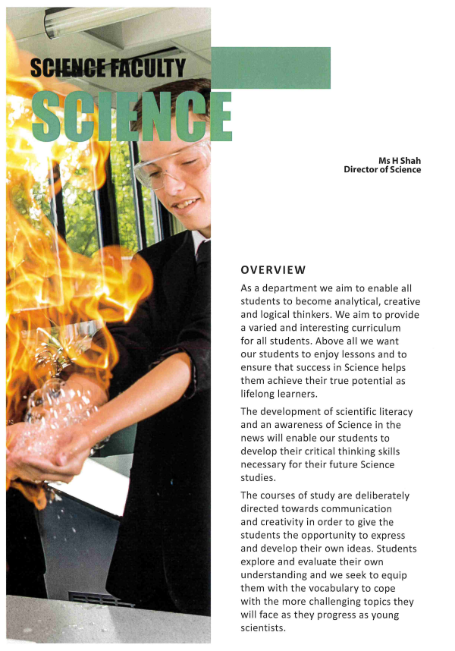

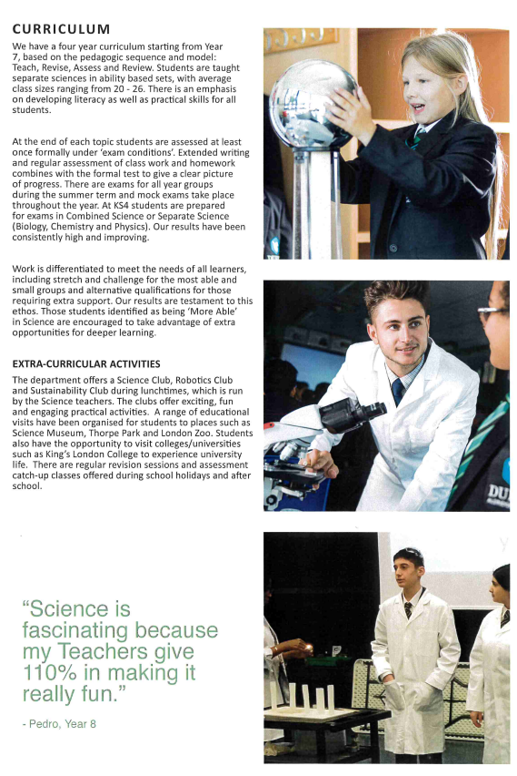

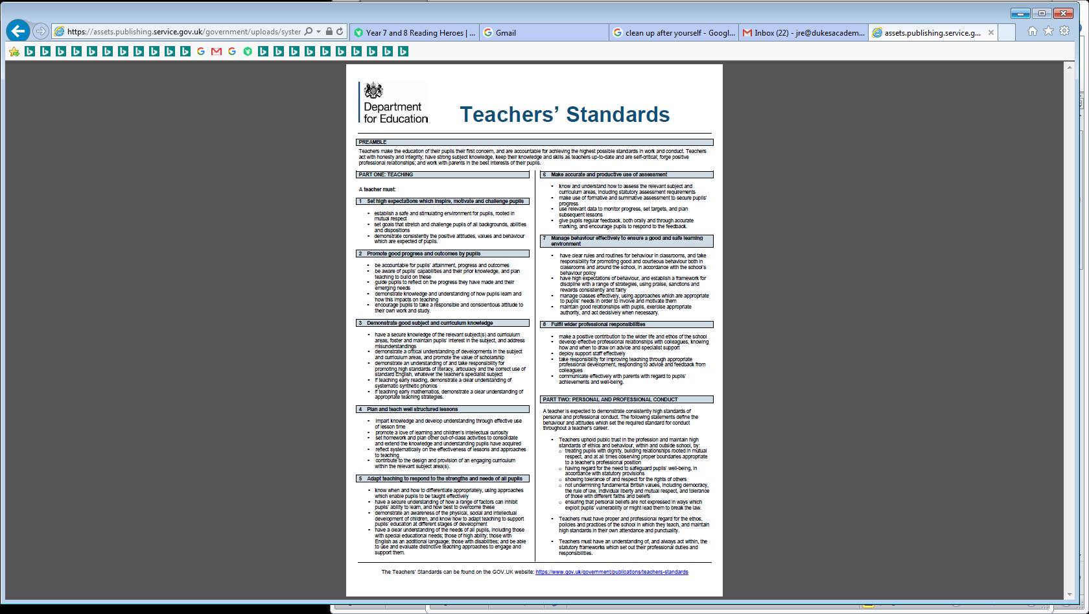**TEACHERS’ STANDARDS**



**HOW TO APPLY / PROCESS OF SELECTION**

If after reading the details you would like to apply for this post, please:

1. Complete the application form in full online via the Trust’s People HR Applicant Tracking System [Apply here](http://aldridgeeducation.peoplehr.net/Pages/JobBoard/Opening.aspx?v=826dee3f-6aa6-4ed1-8426-86e326d6c741)
2. DBS declaration **must** be completed and returned
3. Interviews are planned for: **W/c 4th & 11th July 2022**

**Completing the application**

Candidates are asked to complete all the standard information required on the application form and to submit a support statement addressing the job requirements.

**References**

Candidates are advised that references will be taken up immediately after shortlisting. Candidates are asked to ensure that their referees are aware of the need to respond within the timescale set. In all cases two professional references are required.

**Safeguarding children**

Prior to appointment, formal checks will be made in accordance with the current requirements relating to child protection, this will include an enhanced DBS check.

**Feedback**

Please note that we do not confirm receipt of applications. Feedback is available for shortlisted candidates who proceed to interview stage.

**Selection process**

Candidates who are shortlisted will be contact and invited in to participate in the selection process. We do not inform candidates if they have not been shortlisted.

We look forward to receiving your application.