Special Educational Needs and Disabilities (SEND) Information Report

Cardinal Wiseman Catholic School,
2023-2024

1.What is the purpose of this report?
- The SEND Information report summarises how Cardinal Wiseman Catholic School provides for students who have Special Educational Needs and Disabilities.
- It is organised into possible questions, which has information, including photos, real life examples and quotes from students.
- This report is updated annually, and is a key document as part of our Special Educational Needs provision, along with the vision and policy, (found on the website); and the Special Needs list, Development Plan, and Learning Support Plans, from which staff work to support students with Special Educational Needs and Disabilities.

2. Is a simpler version of this report available?
Simple version
- Cardinal Wiseman Catholic School supports students with different kinds of special needs.
- The school gathers information to help us know which students need support.
- This information is shared with teachers, so that they can support students’ needs in lessons.
- Students get extra support in small groups or one-to-one, when needed.
- Staff get regular training so that they are able to give students the support they need.
- The school takes advice from outside experts on how to support students.
- There are regular checks on how well support is working, so that we can change it if needed.
- Students and parents are given opportunities to talk about what support they would like.
- Arrangements are made so that students can access exams and trips without disadvantage.
- Key Stage 4 students are given regular one-to-one support with planning what they will do when they leave the school in Year 11.
- Extra visits are arranged for Year 6 students who will find moving to secondary school particularly difficult.

For quick access to the answers please click on the questions below;

1.What is the purpose of this report?
2. Is a simpler version of this report available?
3. What kinds of SEND need does Cardinal Wiseman Catholic School provide for?
4. How does Cardinal Wiseman Catholic School identify and assess SEND?
5. How does teaching of the curriculum support pupils with SEND?
6. What additional support is available to pupils with SEND?
7. What training have school staff had in relation to SEND?
8. How does the school use specialist support for pupils with SEND?
9. How does the school check that its provision for SEND?
10. How can pupils and their parents become involved in decisions about their education?
11. How does the school ensure children with disabilities are not treated less favourably than other pupils?
12. How does the school support pupils with SEND in transferring to the next phase of education?
13. Who is the Special Educational Needs Coordinator?
14. What can parents do to support their child’s Special Needs?
15. What else do our pupils think about the support they receive?
16. What should parents do if they have concerns about possible SEN or the school’s provision for SEND?
17. What other websites can give me information about SEND?

3. What kind of SEND does Cardinal Wiseman Catholic School provide for?
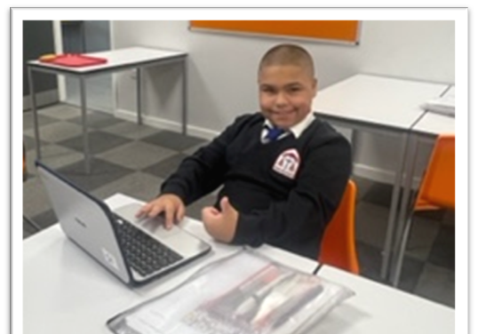
The following areas of need are identified:
- Moderate/Mild Learning Difficulties, (include learning at a slower pace than others, difficulty with memory and/or processing, and issues with literacy or numeracy;
- Social Emotional and Mental Health Needs;
- Speech Language and Communication Needs;
- Autism;
- Specific learning difficulties, including ADHD, dyslexia and dyspraxia;
- *Physical Difficulties, which include sensory impairments, like visual or auditory impairments; and issues which might affect a student’s mobility.
*(N.B. The school continually strives to improve our anticipatory capacity; however, we currently do not have disabled access to upper floors or the swimming pool, and the suitability of rooms for visual/auditory impairments is variable.

4.How does Cardinal Wiseman Catholic School identify and assess SEND?
The 2015 Code of Practice says that: ‘A person has Special Educational Needs if they …have significantly greater difficulty in learning than the majority of others the same age’.
At Cardinal Wiseman, the focus is not on labelling children, but rather on finding the right provision for them. If that provision needs to be special or additional then they will be included in our Special Educational Needs provision. This covers difficulties with integrating or accessing school, as well as difficulties with learning and making academic progress.
The 2010 Equality Act says that ‘reasonable adjustments’ should be made in case of a condition which is persistent, significant and long-term. Adjustments from SEND are identified at Cardinal Wiseman using the following;

- Information from primary schools, including prior attainment
- Baseline tests in Year 7 (in English and Maths)
- Cognitive Abilities Test - screening
- Specialist agencies to test for indicators of Special Educational Needs
- Concerns raised by school staff, pupils, and parents
- Medical diagnoses
- Persistent lack of progress tracking assessments
- SENCO to establish whether access arrangements are needed.
- Motional snapshots are used to assess and monitor the emotional wellbeing of students with Special Educational Needs and Disabilities
A student joined us in Year 7, for whom there had been no prior indication that he had Special Educational Needs. Subject teachers quickly alerted the SENCO to the fact that this student was struggling to spell and read basic words in their lessons, and that he didn’t appear to understand the lesson content. In response to this, the SENCO completed a range of standardised tests, which revealed the student to have very low reading, spelling, memory and processing skills. To quality-control these tests, Pupil Support Services also conducted tests with the student. The SENCO observed the student in lessons and it became apparent that the student was not able to access the mainstream curriculum. This student was temporarily withdrawn from mainstream lessons in order to receive intensive additional support for his word reading, spelling, phonics, and comprehension. This took place over 6 weeks, at the end of which the student was able to steadily reintegrate into mainstream lessons and to access the curriculum.
5. How does teaching of the curriculum support pupils with Special Educational Needs and Disabilities?
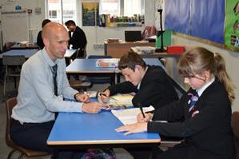
- Special Educational Needs and Difficulties are provided for in the first instance by teachers in the classroom.
- Teachers deliver a high quality of lessons, scaffolded to meet the needs of all students, giving access to a broad and balanced curriculum on which they can make progress in their learning.
- Teachers consider the learning environment and seating arrangements as a routine part of their teaching; and adapt tasks, outcomes or resources as necessary to suit the learning needs of pupils with Special Educational Needs.
- Teachers’ awareness of students with Special Educational Needs is established through a list of all the students for whom we have identified with SEND.
- Teachers have access to Provision Map which provides a Pupil passport for each student.
- The Pupil passport recommends strategies with which teachers can support students in the classroom, these are developed in consultation with students and/or parents.
- Teaching Assistants provide in-class support focusing on the highest concentrations of students with SEND as well as core subjects such as English, Maths and Science.
- The knowledge-rich curriculum ensures that all pupils are exposed to the same level of knowledge, which is not “capped” because of their Special Educational Needs.
6. What additional support is available to pupils with SEND?

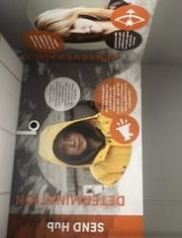
- Literacy and numeracy interventions are delivered one-to-one and in small groups.
- Social Skills and Resilience groups.
- Daily Checkin’s
- Mentoring
- Y6 Transition support
- Motivational interviewing
- Anger management
- Preparation for post-16 transition
- Key Stage 3 and 4 consolidations
- Reduced timetables based in SEND Hub
- SALT Interventions
- Physical and sensory access review
- Breakfast lunch and Homework club
- Social skills groups
- EAL support*

*We do not consider EAL (english as a second language) a special educational need, however we do provide support for students in the SEND Hub

All interventions run for set time-frames and are monitored and evaluated to ensure their impact on student outcomes. This enables the SEND Hub to adapt and introduce new interventions to support students when required. In delivering this support, the staff take a friendly, welcoming, and family-orientated approach to the pupils.

The SEND Hub is a new addition to the school, the facilities are brand new and it is very much a safe space which offers pupils a sanctuary during free time. The students are proud to go to the SEND Hub and there is no stigma around having SEN needs or Disabilities, because of the culture we strive to create. This environment supports the students’ personal development, directly and indirectly contributing to spiritual, social, and cultural aspects of their education.
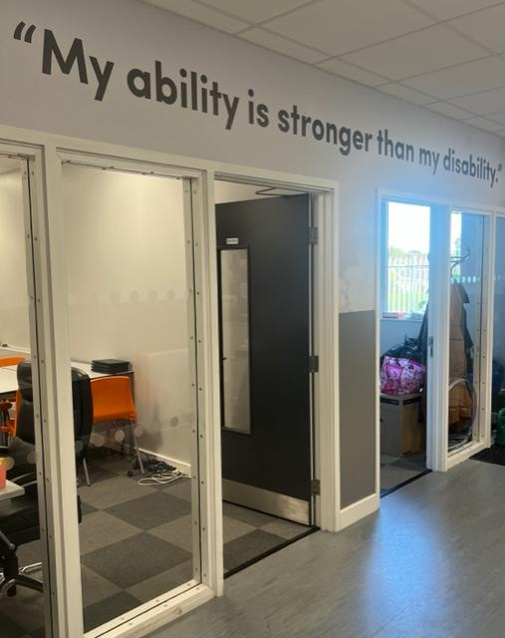
“My Chromebook helps in lessons because in am ”

“I was really shy and worried when I first came to the school. Now I am a lot more confident”

A student joined us with significant Speech and Language difficulties due to a cleft palate and English as an Additional Language. He was also diagnosed with a mild cognitive delay. His progress was regularly monitored by testing by the SENCO, Pupil Support Services and the Speech and Language Therapist. Throughout Key Stage 3, this student received a range of literacy and numeracy interventions to help empower him to access the curriculum. As he entered Key Stage 4 to begin GCSE courses, it became apparent that his needs were too substantial to allow him to succeed at this, in spite of the access arrangements put in place for his exams. Therefore, the decision was taken to balance his mainstream timetable with the provision of Entry-level courses in numeracy and communication. This enabled him to attain Entry-level 3 in these. He was supported in his transition to post-16 education and was successful in getting a place at a Special School Sixth form.

7. What training have school staff had in relation to SEND?
Teaching staff receive regular training as part of their Continuous Professional Development. This training utilises the expertise of external and internal specialists as appropriate. With regard to Special Educational Needs and Disabilities, this has included the following;

- How to make adjustments to teaching for students with low reading and vocabulary levels;
- How to make adjustments to application of the behaviour policy for students with Special Educational Needs;
- How to scaffold knowledge-based resources for students with moderate learning difficulties;
- How to plan precisely for pupils with Special Educational Needs and Disabilities;
- Ways to support pupils with Autistic Spectrum Disorders;
- How to use teaching strategies recommended by Specialist assessors;
- How the school vision of Special Educational Needs and disabilities applies to the roles of all staff.
The Special Educational Needs Coordinator is a qualified SENCO, and is trained in testing to establish eligibility for access arrangements.

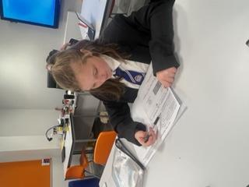
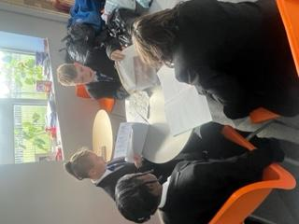

As the GCSE course progressed, one of our students with Special Needs began to feel increasingly anxious and suffered from low self-esteem to the point that we were worried about his well-being. This was made worse by his Autistic Spectrum Condition, ADHD, and dyspraxia. We involved the school’s Educational Psychologist who met with the SENCO, DSL, and the student concerned; as did the school’s worker from the Communication and Autism Team. As a result of their advice, the SENCO attended training in the FRIENDS Resilience programme, which was delivered to the student twice-weekly during Year 11. This, and personal mentoring with the SENCO, enabled the student to improve his attendance and continue to make progress in lessons. The student secured a post-16 destination and was supported by the Communication and Autism Team to make a successful transition, attaining well in his GCSEs.

8. How does the school use specialist support for pupils with SEND?
The school’s provision for Special Educational Needs and Disabilities uses the following specialist agencies to identify and advise on how to support students’ needs:
- Pupil Support Services -focus mainly on difficulties with Learning, and also advise on general policy and practice;
- The Educational Psychologist- focus mainly on Social Emotional and Mental Health Needs, and supports in applications for Education and Health Care Plans if and when these become necessary;
- The Communication and Autism Team - focus on individual pupils with Autistic Spectrum Disorders, and advise on overall training and strategy for supporting pupils with Autistic Spectrum Disorders;
“I have a Teaching assistant that helps me in my English and Maths lessons”
- The Physical Difficulties Support Service- focus on individual students with Physical Difficulties and also advise on the school’s accessibility in general.
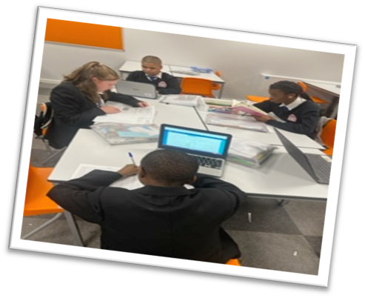
- The Sensory Support Team - monitor and advise on support for students with visual and auditory impairments.

One of our students with autism began to have unexplained mental health issues, (possibly linked to a post-traumatic response to an incident at his previous school), which caused him to stop attending school. We conducted regular home visits to support him in resuming attendance, and several of these visits involved the school’s Educational Psychologist and the worker from the Communication and Autism Team. These professionals were able to advise the SENCO about how to approach the situation so as not to exacerbate the issue, and they also helped to reassure the student’s mother. The student managed to resume attendance completed his education in school, excelling in his GCSEs.

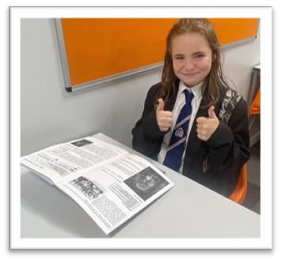

7

9. How does the school check that its provision for SEND is effective?

The effectiveness of the school’s provision for Special Educational Needs and Disabilities is continually monitored, to make sure the pupils make progress. This helps to review and adapt our support for pupils accordingly. The progress of pupils with Special Educational Needs is measured using the following information;

- Data from tracking assessments, on progress and attainment;
- Behaviour logs;
“The Hub has taught me how to deal with my emotions. The staff are a very important part of my life”
- Lesson observations, (which include observations of students’ responses and progress, through a variety of media, such as mini-whiteboards);
- Scrutiny of students’ books and work;
- Consultation with external agencies;
- Feedback from students and parents;
- Baseline tests to inform interventions;
- Transition information from Primary schools and in-year admissions;
- Individual diagnostic assessments, including specialist assessments for eligibility for access arrangements, (particularly in Year 9);
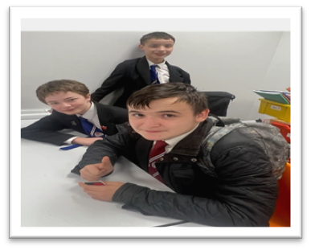
- Strategic review activities;
- Motional snapshots.
- Provision Map – SEN plan updates
- Pupil passport reviews
- Class Charts
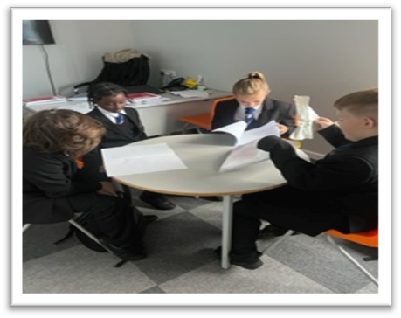

In Year 9, one of our boys with autism became disaffected from his learning and found it difficult to meet behavioural expectations of the school. The Behaviour Team made reasonable adjustments to the behaviour policy to try and protect him from exclusion, as his place at the school had become at risk. To explore whether mainstream provision remained appropriate for him, he and his mother participated in an emergency review of his Education Health and Care Plan, and visited local specialist provisions with the SENCO. They came to the conclusion that Cardinal Wiseman remained the most appropriate provision for him, and with the support of the Learning Support Department he managed to complete his GCSEs at our school, attaining well and going on to study A-levels at the sixth form of a local school.

10. How can pupils and their parents become involved in decisions about their education?

- Pupils with Special Educational Needs are involved in creating their own Pupil Passport which informs teachers’ planning. This gives students the opportunity to have their voice heard about their own learning preferences and ambitions.
- The SENCO attends parents’ evenings, to discuss the progress, integration, adjustments, and support for students with Special Educational Needs and Disabilities.
- A selection of pupils and parents help to review this SEN Information Report, annually.
- Parent are contacted to give their input on their child’s Pupil passport reviews and SEND provision. Parents views will be added to the child SEN plan on Provision Map
“Before I had help with from SEND Hub, I was always getting things wrong but now I find my work easier”

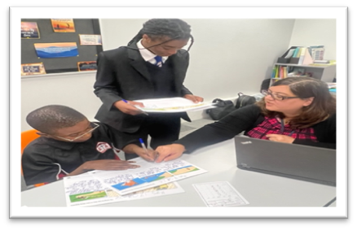

“Every week I go to a social skills group. I like it because I have new made friends”

A female student arrived in Year 7 with a recent diagnosis of autism, and high levels of anxiety. She would make regular inappropriate outbursts, which made it difficult for her to integrate with peers for a while. Because of these difficulties, her self-esteem was low, and she made comments which raised the concerns of our safeguarding team. She received mentoring, social skills, and resilience interventions. When necessary, she was able to spend time in the SEND Hub She was referred to Forward Thinking Birmingham, and received counselling. The Communication and Autism Team supported her and advised the school on how best to support her. There were regular meetings and conversations with her parents, and close collaboration with the Designated Safeguarding Lead and Pastoral Teams. All of this support throughout Keys Stage 3, meant that by Key Stage 4, the concerns about her wellbeing or social integration had reduced. significantly. Her attendance and progress are good, and she is broadly accepted by her peers.

11. How does the school ensure children with disabilities are not treated less favourably than other pupils?
- Cardinal Wiseman Catholic School complies with its duties under the Equality Act 2010. Reasonable adjustments are routinely made for students with a range of different Special Educational Needs, including students with challenging autistic traits who have been able to maintain access to mainstream education, by having regular support from the SEND Hub.
- Pupils with SEND are admitted to the school in line with the school’s admissions policy.
- Access arrangements for exams take account of pupils’ physical needs where necessary.
- Every effort is made to ensure pupils with disabilities are able to participate in all types of school activity, including school trips and PE lessons. For example, wheelchairs have been arranged to enable the participation of a student with mobility issues.
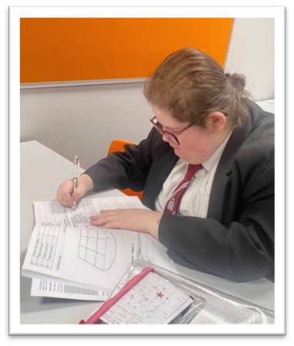
- The entire student cohort is educated about Special Educational Needs as part of PSHE and Citizenship, (in assemblies and tutor time). This has helped promote acceptance within the culture of the school, as part of its Catholic values.
“I didn’t come to school for months but it has helped me to get back into school environment and offered me hope when I found things tough supported me. They supported me when I was down”

A female student with ADHD joined us in Year 8 on a managed move from another school. This was done because her behaviour there had put her at risk of exclusion. She received mentoring and social skills interventions and attended the SEN Hub in unstructured time. There was close collaboration between the SEND and Behaviour Teams, and teachers were given detailed recommendations on how to make adjustments for her in lessons. This student passed her managed move, and although she continues to struggle with her organisation, she has gone on to make excellent academic and social progress.

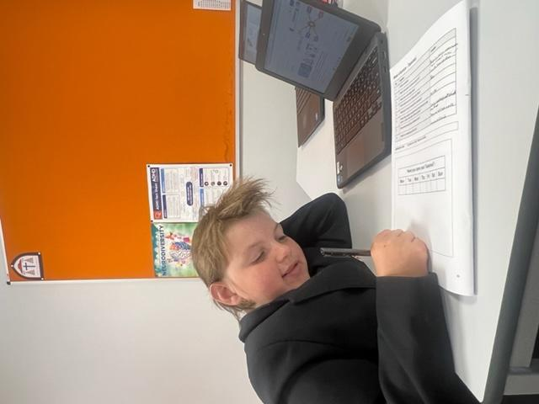

12. How does the school support pupils with SEND in transferring to the next phase of education?
- The school’s careers policy aims to prepare pupils with SEND for adulthood in the same way that it does for other pupils, helping them work towards independent living and participation in society.
- To support pupils in post-16 transition, the school provides support in application, and a personalised programme for helping pupils make the right choices for their development and progressions.
- Students with SEND, (especially those who might be at risk of not being in education, employment or training), are timetabled for weekly post-16 support during Year 11, and when required are escorted on visits to prospective post-16 destinations.
- The school create links with employers, Further Education institutions, and external service providers to be able to provide pupils with current information to assist their decision-making.
- During transition from Primary school, Cardinal Wiseman staff are proactive and rigorous in compiling information about the Special Needs of prospective students. This is done by fostering positive relationships with Primary schools, and maintaining regular communication.
- During transition from Primary school, students whose SEND needs are likely to make the transition a worrying experience are given the opportunity to visit the school as many times as they need to help them acclimatise to the change and feel secure.
“When I came in year 7, Mr Allen spoke to the teachers about my eyesight. I sit at the front in lessons and the teachers enlarge my work”
“I have a hip dysplasia, sometimes it’s painful to walk to lesson. The teachers will arrange for me to work in The Hub”
“When I came to this school I struggled with English. The teachers were kind and always helped me understand”
“I use to find it hard to read in lesson but my reader pen helps me and now I feel more confident”

One of our boys with autism suffered with autism-related anxiety and worried a lot about school and the future, which affected his attendance. He would feel ill from anxiety and struggled to function independently, despite being academically able. He also often misinterpreted other people’s intentions, which contributed to his low self-esteem.

13. Who is the Special Educational Needs Coordinator?
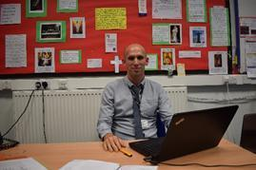
Name: Mr J Allen
Tel: 0121 360 6383 ext 1142,
Email: jallen@cardinalwiseman.net

- The SENCO is responsible for coordinating the provision for Special Educational Needs and Disabilities at Cardinal Wiseman Catholic School, to ensure that pupils with SEND are able to make progress on the curriculum and can participate fully in the school community.
- Provision for SEND is monitored by the Education Life committee and the SEN Governor: Dr. P. Manford. The governing body challenges the school and its members to secure necessary provision for any pupil identified as having special educational needs.

14. What can parents do to support their child’s Special Needs?
- Check your child’s homework planner and books each night.
- Discuss your child’s day with them, using their timetable.
- Share concerns about how their needs are being met with the SENCO.
- If you observe needs at home which could affect your child’s learning or integration, share this information with the school.
- Attend parent evenings to discuss the information and strategies being used to support your child, (as outlined in their Pupil Passport)
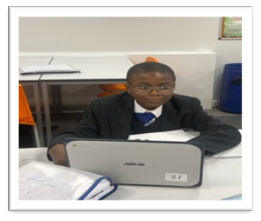
- If you have concern about an underlying need which might justify a diagnosis, arrange an appointment with your GP to discuss this.
- If you are able to, make time to practise basic literacy and numeracy exercises with your child, including reading aloud together.
- Encourage your child to access online resources provided by the school.

15. What else do our pupils think about the support they receive in the SEND Hub?

https://drive.google.com/file/d/1WBoawx20eSaibKnga904fy2Lk4atyFLw/view?usp=sharing

N.B. Birmingham Local Authority’s Local Offer sets out the support the council expect to be available for people with special educational needs (SEN) or disabilities, and can be found at: https://www.birmingham.gov.uk/localoffer .

16. What should parents do if they have concerns about possible SEN needs or the school’s provision for SEND?
If you have concerns about Special Educational Needs and Disabilities, please contact the school SENCO at jallen@cardinalwiseman.net

17. What other websites can give me information about Special Educational Needs and Disabilities?

https://accesstoeducation.birmingham.gov.uk/communication-autism-team/

https://accesstoeducation.birmingham.gov.uk/pupil-and-school-support/

https://accesstoeducation.birmingham.gov.uk/sensory-support/
https://birminghameducationsupportservices.co.uk/Services/4524#
https://www.birminghamcareersservice.co.uk/send-information/
https://www.bdadyslexia.org.uk/
https://www.autismeducationtrust.org.uk/
https://the-waitingroom.org/

