
Come follow Christ in the footsteps of St Chad Come follow Christ in the footsteps of St Chad Come follow Christ in the footsteps of St Chad Come follow Christ in the footsteps of St Chad Come follow Christ in the footsteps of St Chad Come follow Christ in the footsteps of St Chad Come follow Christ in the footsteps of St Chad Come
LDBE Learn: Flourishing Pathways
Developing High Quality RE
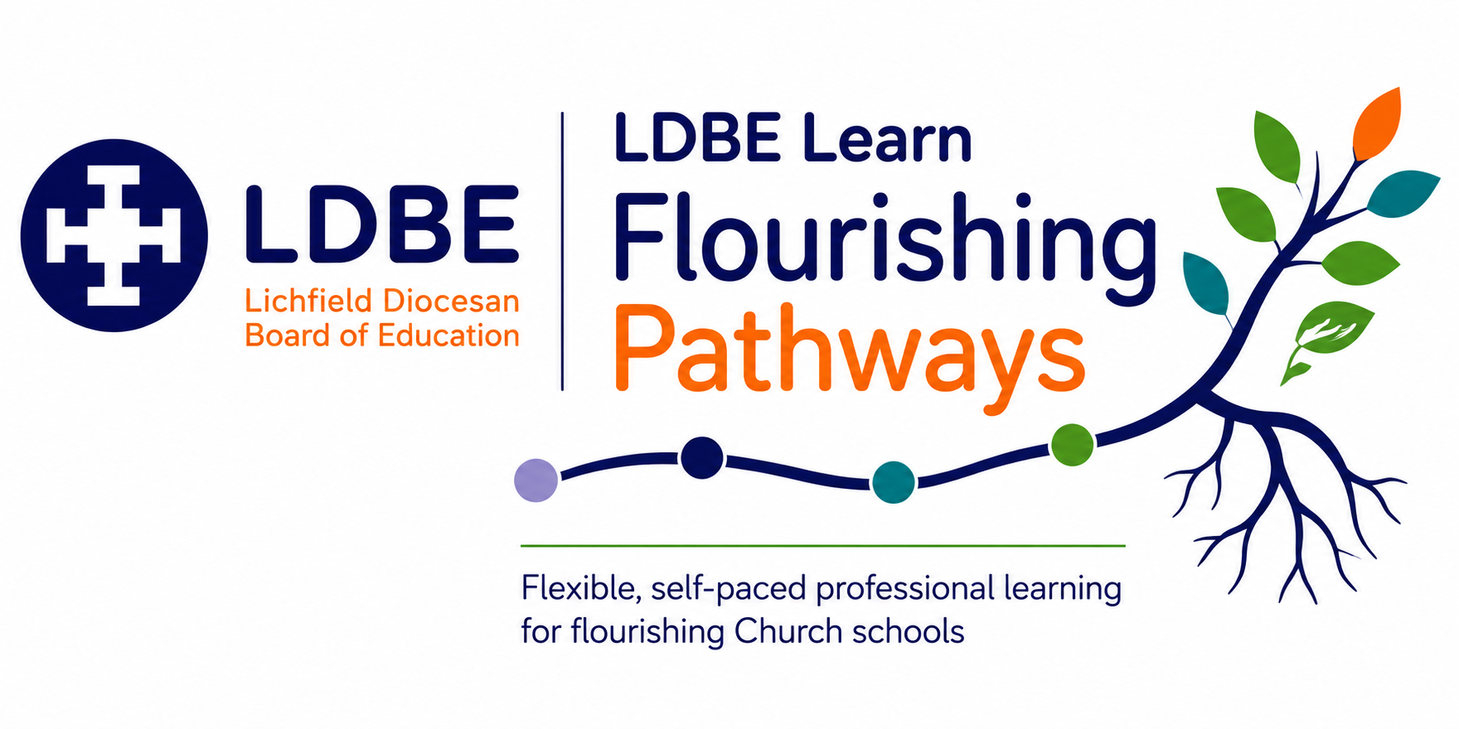

The importance of reflection
Professional learning is most powerful when we intentionally make sense of what we have learned and consider how it might influence our leadership and practice. Throughout this pathway, you will be invited to pause and respond to reflective questions. Taking time to write down your thinking can help deepen understanding, connect new learning with your own context and identify meaningful next steps.
As you reflect, you may find it helpful to use Driscoll's simple model of reflective practice. It provides a helpful structure for considering not only what you have learned, but also how that learning might shape your Church school's ongoing journey.
Driscoll's Reflective Model | Prompt
What? | What have I learned? What does this tell me about our school's RE curriculum and current practice?
So what? | Why does this matter? Does my teaching build knowledge about religious and non-religious teaching? Does it develop ways to learn about these traditions using theology, human/social sciences and philosophy? Are there opportunities for pupils to reflect on their own personal beliefs? Is RE creative and engaging? What difference is this making to pupils?
Now what? | What action might we take? How could this influence leadership, decision-making and the lived experience of pupils, adults and the wider community?

The SIAMS Framework reminds us that Church schools come in many different shapes and sizes. There is no one-size-fits-all approach to leadership or school improvement in RE. Instead, each school's context, together with its theologically rooted Christian vision, shapes the decisions it makes and the impact it seeks to have. As you complete your reflections, consider not only what you have learned, but how this learning could enhance your practice in RE.
There are no right or wrong answers. These reflections are for you. They are intended to support thoughtful professional learning, deepen your understanding and help you identify purposeful next steps. If you choose to record your reflections throughout the pathway, they may also provide a helpful foundation when completing the end-of-module reflection and evaluation required for certification.

Module: Initial Reflections
Reflection Question
How does your own worldview influence your leading of RE?

What difference does RE make to children flourishing in your setting?

How well does your RE curriculum provide opportunities for children to understand themselves and others?

Module: Training Aims
Reflection Question
What excites you about leading RE?

Module: Legal Requirements for RE
Reflection Question
How does current RE provision meet the legal requirements for RE?

Is sufficient time and priority given to the subject?

Are there any changes you need to make to current practice?

Module: Statement of Entitlement for RE (CE Schools)
Reflection Question
How does your current curriculum meet the requirements for of the Statement of Entitlement for RE?

What are the strengths of the RE taught in your school?

Are there any changes you need to make to current practice?

Module: Developing 3 Types of Knowledge in RE
Reflection Question
Reflect on RE across school:
Does the curriculum build knowledge about a variety of religious and non-religious traditions?
Does it explore beliefs and practices and where they came from?
Does it consider the impact of these beliefs on the believer?
Are there opportunities to ask and engage with 'big questions'?

Module: Ways of Knowing
Reflection Question
Consider the current curriculum and any evidence you have seen during monitoring
Is there balance of theology, human and social science and philosophy?
Where is practice most effective?
Are there any classes that might need support?

Module: Building the Curriculum
Reflection Question
Look at your RE curriculum:
How does it meet statutory requirements?

Is it progressive?

Are there any changes needed?

Module: Recognising Complexity
Reflection Question
Reflect on practice you have seen across the school:
- Do pupils encounter different ways of believing, practising and belonging within the same tradition?
- Do teachers avoid presenting religions as if all believers think and behave in the same way?
- Do resources include authentic voices and real-world examples from a range of people?
- Do teachers use careful language such as “some”, “many” and “most” rather than making universal statements?
- Do pupils explore how culture, family, community, geography and personal experience can shape lived worldviews?
- Is diversity explored within Christianity, Islam, Judaism, Hindu traditions, Sikhi, Buddhism and non-religious worldviews, rather than only between them?
- Are pupils encouraged to recognise that individuals within the same worldview may interpret beliefs and traditions differently?

Module: Planning for Progression
Reflection Question
Re-visit your current curriculum. Is it progressive? Does learning build each time a concept is revisited?

Module: Assessment
Reflection Question
Re-visit your current curriculum. Is it progressive? Does learning build each time a concept is Look at the current processes in school:
- How does assessment inform teaching and future planning?
- How do you know what pupils know, understand and can do?
- How do you identify gaps and misconceptions in pupils’ learning?
- How does assessment help pupils make progress in their substantive and disciplinary knowledge?
- What evidence shows that your approach to assessment is having an impact?

Module: Monitoring
Reflection Question
Have you planned a programme of RE monitoring across the year that gives you a clear picture of the quality of teaching, learning and pupil progress?

What will you monitor? When will you monitor it? How will you gather evidence? How will findings inform your next steps?

Module: RE 360
Reflection Question
Reflect on own leadership practice and provision in school:
Use the 360 tool or reflection questions in your reflection journal.

