
Come follow Christ in the footsteps of St Chad Come follow Christ in the footsteps of St Chad Come follow Christ in the footsteps of St Chad Come follow Christ in the footsteps of St Chad Come follow Christ in the footsteps of St Chad Come follow Christ in the footsteps of St Chad Come follow Christ in the footsteps of St Chad Come
LDBE Learn: Flourishing Pathways
Leading Collective Worship
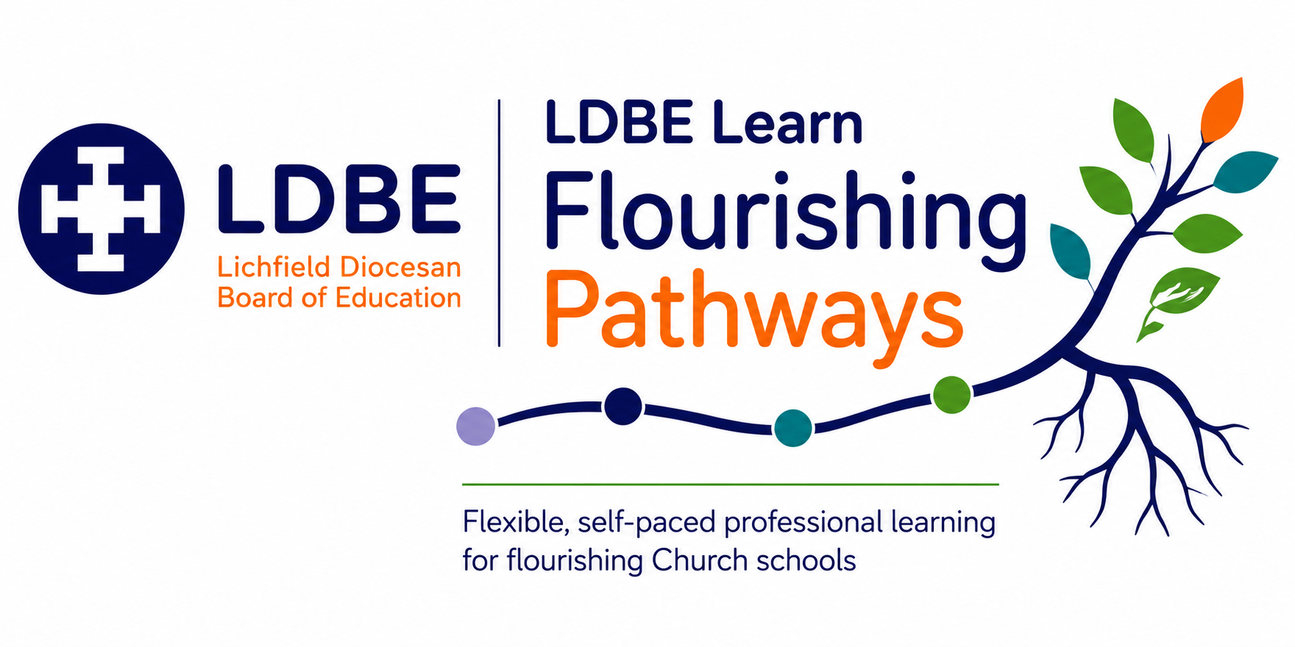

The importance of reflection
Professional learning is most powerful when we intentionally make sense of what we have learned and consider how it might influence our leadership and practice. Throughout this pathway, you will be invited to pause and respond to reflective questions. Taking time to write down your thinking can help deepen understanding, connect new learning with your own context and identify meaningful next steps.
As you reflect, you may find it helpful to use Driscoll's simple model of reflective practice. It provides a helpful structure for considering not only what you have learned, but also how that learning might shape your Church school's ongoing journey.
Driscoll's Reflective Model | Prompt
What? | What have I learned? What does this tell me about our school's current practice in collective worship?
So what? | Why does this matter? What difference is collective worship making to pupils and the whole school community? Is it enabling the flourishing of pupils and adults?
Now what? | What action might we take? How could this influence leadership, decision-making and the lived experience of pupils, adults and the wider community?

The SIAMS Framework reminds us that Church schools come in many different shapes and sizes. There is no one-size-fits-all approach to leadership or school improvement in collective worship. Instead, each school's context, together with its theologically rooted Christian vision, shapes the decisions it makes and the impact it seeks to have. As you complete your reflections, consider not only what you have learned, but how this learning could enhance your school’s practice in collective worship.
There are no right or wrong answers. These reflections are for you. They are intended to support thoughtful professional learning, deepen your understanding and help you identify purposeful next steps. If you choose to record your reflections throughout the pathway, they may also provide a helpful foundation when completing the end-of-module reflection and evaluation required for certification.

Lesson 1: Flourishing Reflection
Reflection Question
- Reflect on the thought that life is made up of moments of sadness and struggle, and moments of joy and celebration. How has this been true for your own life?

- How have moments of sadness and moments of joy been part of your school's journey?

- How have collective worship and the school's vision and values navigated these moments?

- What do you think could be the impact of praising God in the midst of sadness, and in joyful times?

Lesson 3: A Recap of Collective Worship: Legalities and Background Knowledge
Reflection Question
- Which of the above aims of collective worship are strengths in your school?

- Which of them need further development?

- What examples could you give in your school of how collective worship is enabling pupils and adults to flourish?

Lesson 4: Collective Worship and Spiritual Development
Reflection Questions
- How would you define spiritual flourishing?

- Does your school have a way of talking about spirituality that everyone understands?

- How is this used in collective worship and is it helping pupils and adults to flourish?

Lesson 5: Planning a Year in the Life of Collective Worship
Reflection Question s
How do you currently plan a year of collective worship?

How might this now be enhanced considering:
•Christian calendar
•Biblical themes
•Use of the outdoors
•Eucharist
•Other events in the life of the school?

How might these different elements contribute to spiritual flourishing?

Lesson 6: Planning a Week in the Life of Collective Worship
Reflection Questions
- What does your weekly approach to collective worship look like?

- Can you identify many/ most/ some of the elements we have discussed?

- Is there anything missing from your weekly collective worship that you would like to now include?

Lesson 7: Planning a Day in the Life of Collective Worship
Reflection Questions
- What structure does daily collective worship take in your school?

- How does this enable it to be inclusive, invitational and inspiring?

- How could structure contribute to both familiarity and creativity within worship?

Lesson 8: Children as Leaders
Reflections Questions
- What opportunities do children in your school currently get to plan and lead worship?

- How might these opportunities be enhanced?

- How might leading worship contribute to children's spiritual development?

Lesson 9: Monitoring and Evaluating Collective Worship
Reflection Question
- How is Collective Worship currently monitored within your school?

- How does monitoring and evaluation contribute to the further spiritual flourishing of pupils and adults?

Lesson 10: Collective Worship Policy
Reflection Questions
- What does your collective worship policy currently look like? Are you and other staff and governors familiar with it?

- How can you ensure it is up to date with the latest guidance?

- How is the policy contributing to the spiritual flourishing of children and adults?

