
Come follow Christ in the footsteps of St Chad Come follow Christ in the footsteps of St Chad Come follow Christ in the footsteps of St Chad Come follow Christ in the footsteps of St Chad Come follow Christ in the footsteps of St Chad Come follow Christ in the footsteps of St Chad Come follow Christ in the footsteps of St Chad Come
LDBE Learn: Flourishing Pathways
An Introduction to Collective Worship
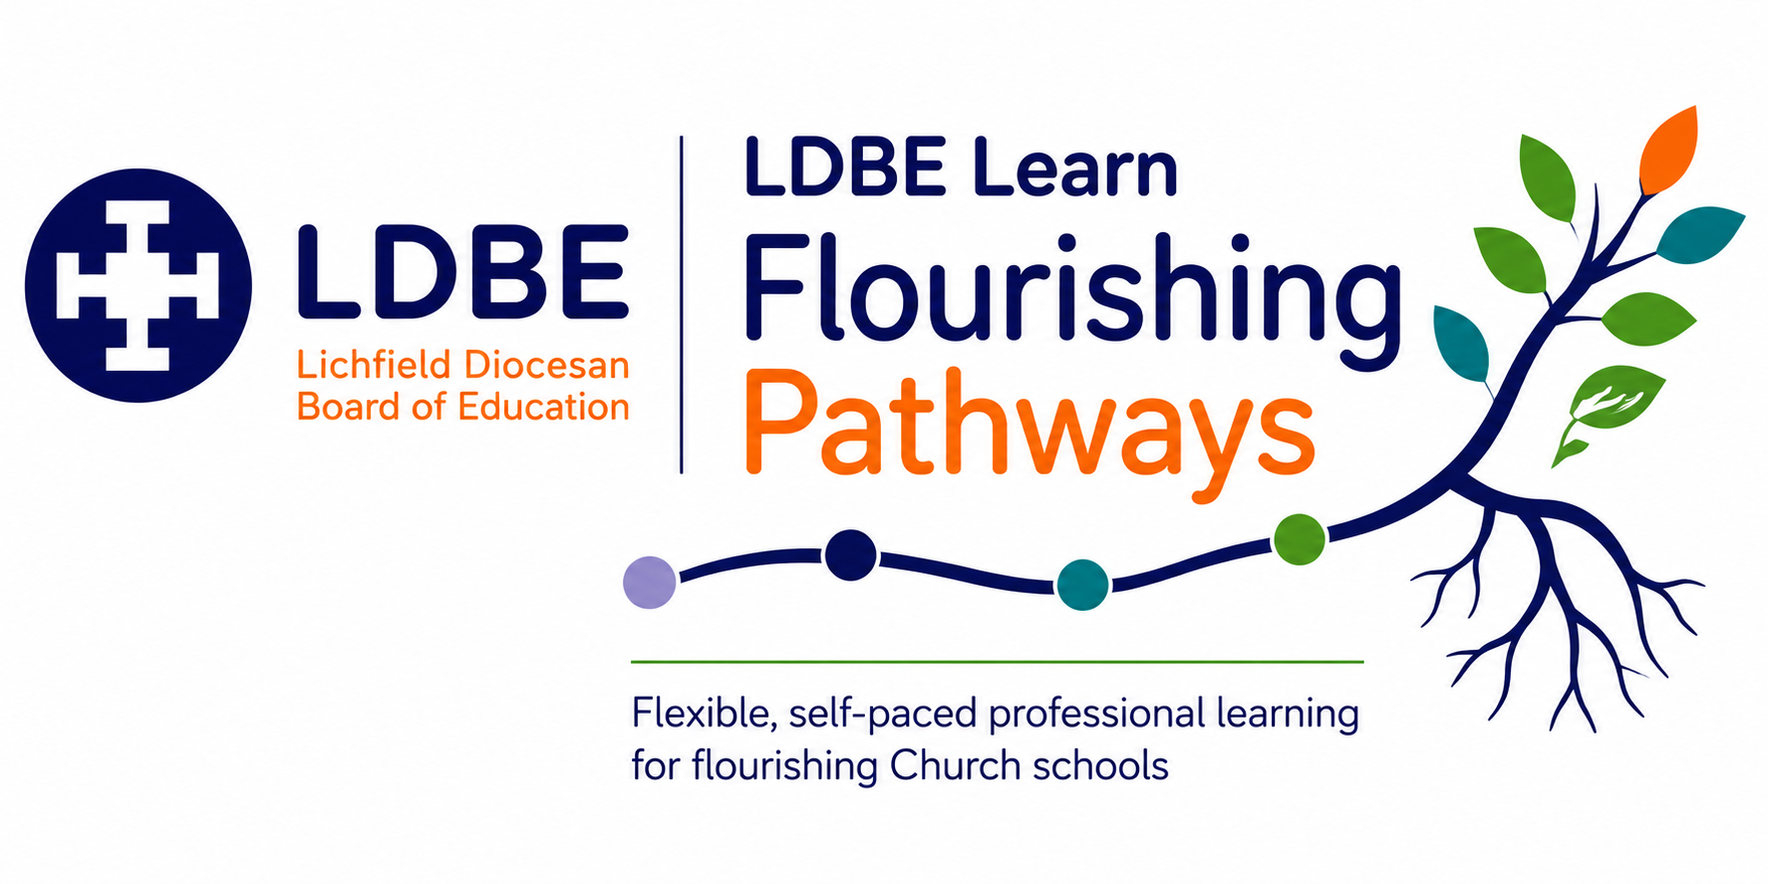

The importance of reflection
Professional learning is most powerful when we intentionally make sense of what we have learned and consider how it might influence our leadership and practice. Throughout this pathway, you will be invited to pause and respond to reflective questions. Taking time to write down your thinking can help deepen understanding, connect new learning with your own context and identify meaningful next steps.
As you reflect, you may find it helpful to use Driscoll's simple model of reflective practice. It provides a helpful structure for considering not only what you have learned, but also how that learning might shape your Church school's ongoing journey.
Driscoll's Reflective Model | Prompt
What? | What have I learned? What does this tell me about our school's Collective Worship and current practice?
So what? | Why does this matter? How does current practice influence pupils’ and adults’ opportunities to grow spiritually?
Now what? | What action might we take? How could practice in Collective Worship be enhanced in light of what has been learned?

The SIAMS Framework reminds us that Church schools come in many different shapes and sizes. There is no one-size-fits-all approach to leadership or school improvement in Collective Worship. Instead, each school's context, together with its theologically rooted Christian vision, shapes the decisions it makes and the impact it seeks to have. As you complete your reflections, consider not only what you have learned, but how this learning could enhance your practice in Collective Worship.
There are no right or wrong answers. These reflections are for you. They are intended to support thoughtful professional learning, deepen your understanding and help you identify purposeful next steps. If you choose to record your reflections throughout the pathway, they may also provide a helpful foundation when completing the end-of-module reflection and evaluation required for certification.

Lesson 1: Flourishing Reflection
Reflection Questions:
- What do you consider to be sources of wisdom?

- How is wisdom different from knowledge?

- How do we as humans deepen our wisdom?

- How could Christian worship contribute to this?

Lesson 3: Collective Worship: History, Legalities and Background Knowledge
Reflection Questions:
- Think back to your own experiences of collective worship/ assembly in school- if you had them. What do you remember?

- Are your memories positive or negative, or a mixture?

- Think about RE and Collective worship in your school. In what ways are they similar? How are they different?

- Does this reflect what you have learned about Collective Worship so far in this course?

Lesson 4: What is Collective Worship?
Reflection Questions:
- What do you think of the 'warm fires, open doors' analogy for collective worship?

- Do you think this describes collective worship in your school? Why or why not?

Lesson 5: Church of England Guidelines for Collective Worship
Reflection Questions:
- Which of the above aims for collective worship are strengths in your school? Which could be developed further?

- Collective Worship is 'the unique heartbeat of the school and is offered as part of a wider opportunity for pupils and adults to encounter faith by engaging in conversations about God, both as individuals and together.'
How true do you think this is of worship in your school and classroom at the moment? How might it become more so?

Lesson 6: Three Essential Ingredients for Collective Worship
Reflection Questions:
- How does your school currently explore vision and values in collective worship? How might this be enhanced?

- In what ways does your collective worship contribute to pupils' and adults' spiritual development?

- Which elements of Anglican worship are present in your school's collective worship? How do they contribute to spiritual development?

Lesson 7: A Suggested Structure for Collective Worship
Reflection Questions:
Gathering:
How do you gather children and adults together for collective worship?

In what ways is this marked out as a special and different time?

Engaging:
What is the main content of the 'engage' part of worship at your school?

How is the content inclusive, invitational and inspirational?

How does Bible and Christian teaching inform the content?

Are children and adults engaged and inspired during worship? How could this be improved further?

Responding:
How is the community invited to respond in worship in your school?

Are there opportunities for reflection and prayer?

How do you think these contribute to spiritual flourishing?

Sending:
How are children and adults 'sent out' from collective worship in your school, whether that is whole school or class worship?

Is there a sense that worship has changed and transformed us?

How might we encourage this sense of transformation?

Structure as a Whole:
Does worship in your school and class have a recognisable and familiar structure?

Which of the areas Gathering, Engaging, Responding, Sending are currently being
done well?

Which of these do you think could be further enhanced?

Lesson 8: Children as Leaders of Collective Worship
Reflection Questions:
How might you encourage children in their leadership of collective worship?

Of which of the above opportunities could you make better use?

Lesson 8: Children as Leaders of Collective Worship
Reflection Questions:
How might you encourage children in their leadership of collective worship?

Of which of the above opportunities could you make better use?

