
Come follow Christ in the footsteps of St Chad Come follow Christ in the footsteps of St Chad Come follow Christ in the footsteps of St Chad Come follow Christ in the footsteps of St Chad Come follow Christ in the footsteps of St Chad Come follow Christ in the footsteps of St Chad Come follow Christ in the footsteps of St Chad Come
LDBE Learn: Flourishing Pathways
Developing High Quality RE
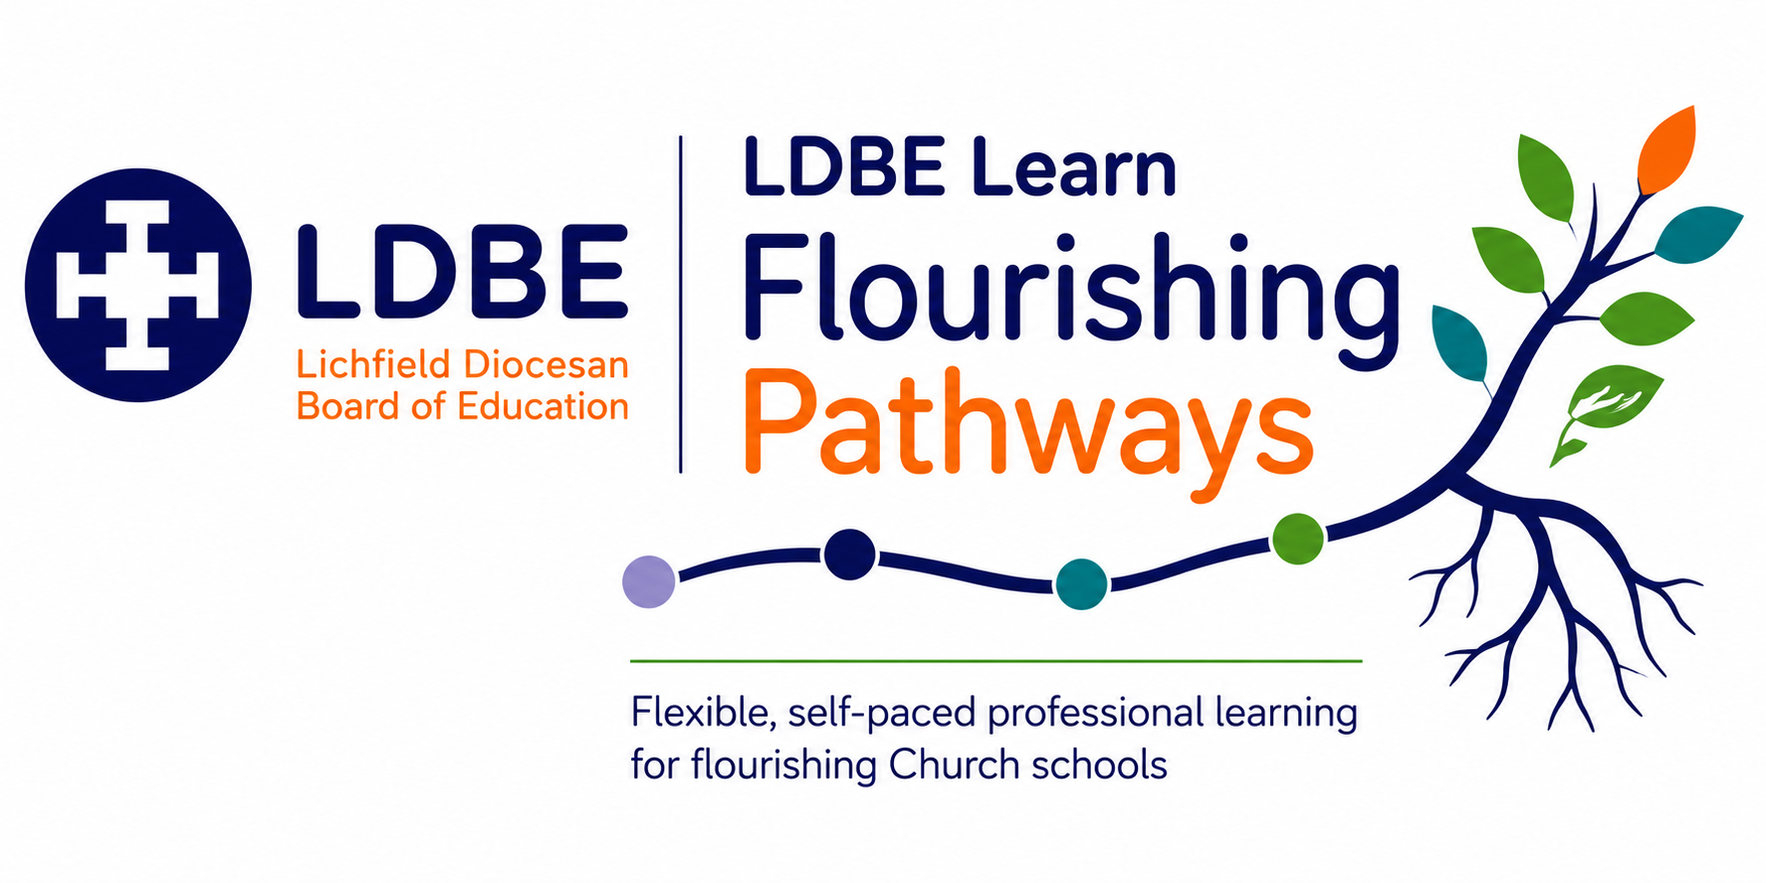

The importance of reflection
Professional learning is most powerful when we intentionally make sense of what we have learned and consider how it might influence our leadership and practice. Throughout this pathway, you will be invited to pause and respond to reflective questions. Taking time to write down your thinking can help deepen understanding, connect new learning with your own context and identify meaningful next steps.
As you reflect, you may find it helpful to use Driscoll's simple model of reflective practice. It provides a helpful structure for considering not only what you have learned, but also how that learning might shape your Church school's ongoing journey.
Driscoll's Reflective Model | Prompt
What? | What have I learned? What does this tell me about our school's RE curriculum and current practice?
So what? | Why does this matter? Does my teaching build knowledge about religious and non-religious teaching? Does it develop ways to learn about these traditions using theology, human/social sciences and philosophy? Are there opportunities for pupils to reflect on their own personal beliefs? Is RE creative and engaging? What difference is this making to pupils?
Now what? | What action might we take? How could this influence leadership, decision-making and the lived experience of pupils, adults and the wider community?

The SIAMS Framework reminds us that Church schools come in many different shapes and sizes. There is no one-size-fits-all approach to leadership or school improvement in RE. Instead, each school's context, together with its theologically rooted Christian vision, shapes the decisions it makes and the impact it seeks to have. As you complete your reflections, consider not only what you have learned, but how this learning could enhance your practice in RE.
There are no right or wrong answers. These reflections are for you. They are intended to support thoughtful professional learning, deepen your understanding and help you identify purposeful next steps. If you choose to record your reflections throughout the pathway, they may also provide a helpful foundation when completing the end-of-module reflection and evaluation required for certification.

Module: Initial Reflections
Reflection Question
How does your own worldview influence your teaching of RE?

What difference does RE make to children flourishing in your setting?

How well does your RE curriculum provide opportunities for children to understand themselves and others?

Module: Legal Requirements for RE
Reflection Question
How does your current practice meet the legal requirements for RE?

Is sufficient time and priority given to the subject?

Are there any changes you need to make to current practice?

Module: Statement of Entitlement for RE (CE Schools)
Reflection Question
How does your current practice meet the requirements for of the Statement of Entitlement for RE?

What are the strengths of the RE taught in your classroom?

Are there any changes you need to make to your current classroom practice?

Module: Developing 3 Types of Knowledge in RE
Reflection Question
Reflect on your current classroom practice in RE across a unit of learning:
- Does your current practice build knowledge about a variety of religious and non-religious traditions?
- Does it explore beliefs and practices and where they came from?
- Does it consider the impact of these beliefs on the believer?
- Are there opportunities to ask and engage with 'big questions'?

Module: Ways of Knowing
Reflection Question
Think about the last unit you taught in RE:
How did you include a balance of theology, human and social science and philosophy?

Module: Recognising Complexity
Reflection Question
Think about the last unit you planned and taught in RE:
- Did your teaching resources include authentic voices and real-world examples from a range of people?
- Did you use careful language such as “some”, “many” and “most” rather than making universal statements?
- Were pupils encouraged to recognise that individuals within the same worldview may interpret beliefs and traditions differently?

Think about the units you have taught this year:
- Was diversity explored within Christianity, Islam, Judaism, Hindu traditions, Sikhi, Buddhism and non-religious worldviews, rather than only between them?

Module: Learning Sequences
Reflection Question
Think about the last unit you planned and taught in RE.
How well did your teaching sequence build knowledge and understanding?

How well did your learning activities match the learning intention?

Module: Example Activities
Reflection Question
How might you enhance your current practice? Have you seen any activities you might wish to try?

Module: Artefacts
Reflection Question
How effective is your use of artefacts in RE? Consider how often they are used. Consider the questions used to support reflection.

Module: Art
Reflection Question
How effective is your use of artefacts in RE? Consider how often they are used. Consider the questions used to support reflection.

Module: Assessment
Reflection Question
- How does assessment inform teaching and future planning?

- How do you know what pupils know, understand and can do?

- How do you identify gaps and misconceptions in pupils’ learning?

- How does assessment help pupils make progress in their substantive and disciplinary knowledge?

- What evidence shows that your approach to assessment is having an impact?

Module: RE 360
Reflection Question
Reflect on own practice:
Use the 360 tool or reflection questions in your reflection journal.

