Dementia-Friendly

School Certificate
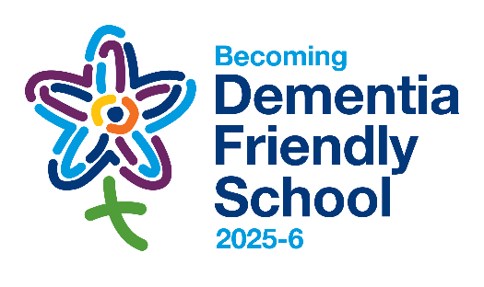

[school name]

This Action Plan for the year ahead entitles the school(s) to use the “Becoming Dementia Friendly School” logo for this academic year.
Action Plan

Your local Dementia-Friendly School Lead is: [add name]
Your Diocese of Lichfield dementia-friendly contacts are: [add name of your CDA] and Sarah Thorpe
Your Action Plan was approved by [add name of Head/Executive Head and name of Dementia-Friendly School Lead, if different] in [add month & year]

Date: [add month & year]
Our shared Vision in the Diocese of Lichfield is of partnering with others in seeking the common good, working for justice as a people of hope. Thank you for your actions to become a more dementia-friendly school at the heart of your community.
………………………………………………
The Rt Revd Dr Michael Ipgrave OBE, 99th Bishop of Lichfield




Notes

The Diocese of Lichfield has been working to take action on dementia through our dementia-friendly churches network since 2015 and, from the 2022/3 academic year, this has now been extended to dementia-friendly schools. As such, we authorise the use of our “Becoming Dementia Friendly School” logo, when church schools or schools with a strong church connection agree to a three-point Action Plan for the academic year. We want dementia awareness to become part of school life and we want our schools to be places where people affected by dementia are welcomed, understood, respected and supported.
- Actions: The actions need to be specific, realistic and achievable. They can be small steps forward: they are steps that you can and will take in the year ahead. We can share with you examples of possible actions – and it is sensible to discuss possible actions early on with your Christian Distinctiveness Adviser. This Certificate records the agreed three-point Action Plan. You can commit to more actions if you wish – but it is better to deliver on three points than to commit to more and not deliver.
- School/Academy Approval: The Action Plan can be either for an individual school or for a group of schools. Approval is given by a person/body that can speak for all schools covered by the Action Plan e.g. the Head / Executive Head.
- Sign off, Signature by +Michael and Display: Every Certificate, when agreed, is shared by Sarah Thorpe (Dementia-Friendly Church Enabler) with Bishop Michael, Bishop of Lichfield, who personally signs every completed Certificate. Bishop Michael is proud to be part of a Diocese that takes dementia-friendly churches and schools seriously. Signed Certificates are sent out from the Bishop’s Office. Please display your signed Certificate(s) in your school(s). For a group of schools, there will be a Certificate to display in each participating school.
- Dementia-Friendly School Contact Name and Renewal: These are the people who will be contacted to review/renew the Action Plan for the start of the next academic year. We hope and expect then to confirm completion of these actions, in readiness to sign up to three more actions, entitling you to use the logo, with a new date stamp, for the next academic year.
 | HEAD/EXECUTIVE HEAD | DEMENTIA-FRIENDLY SCHOOL LEAD (if different)
NAME:
EMAIL:
PHONE:
SCHOOL ADDRESS:
Certificate format last updated: July 2025

