Dementia-Friendly

School Certificate

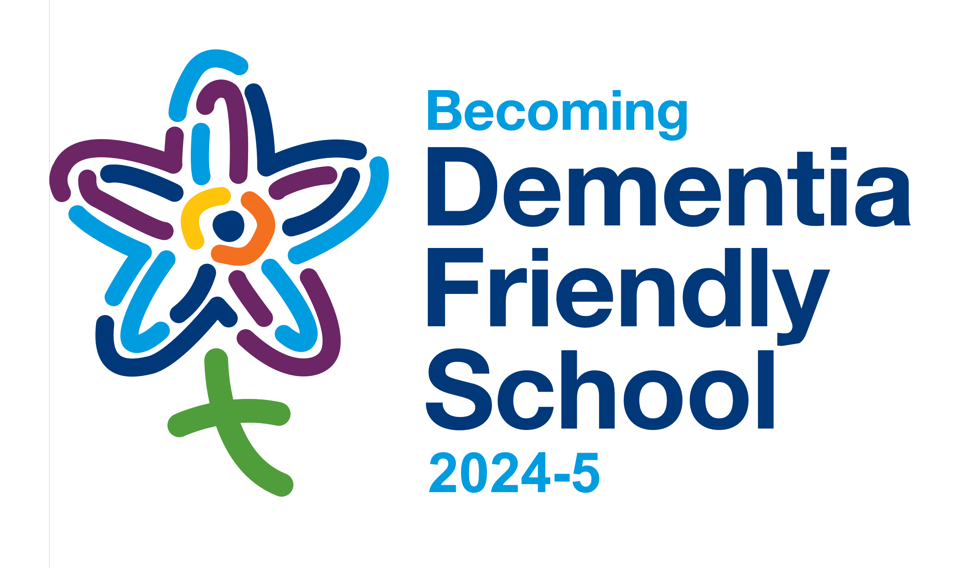**Church of England Primary School**

Thank you for committing to the following Action Plan: this entitles you to use the “Becoming Dementia Friendly School” logo for this academic year. At the end of the year, we will review the Action Plan together and discuss an appropriate Action Plan for the next academic year.

**ACTION PLAN:**

1. Appoint a dementia friendly schools coordinator and hold an initial staff meeting as an introduction for staff.
2. Hold a worship as an introduction for the pupils.

**Your Dementia-Friendly School Lead is:**

**Your Diocese of Lichfield dementia-friendly contacts are:** Lynsay Jennings or Alex Wolvers and Sarah Thorpe

**Your Action Plan was approved by:**

**DATE: NOVEMBER 2024**

**Our shared vision is of schools that partner with others in seeking common good, working for justice as people of hope. Thank you for your actions to become a more dementia-friendly school at the heart of your community.**

**……………………………………...…………………………………………………..**

**The Rt Revd Dr Michael Ipgrave OBE, 99th Bishop of Lichfield**

 

**Following Christ in the footsteps of St Chad**

**PLEASE DISPLAY THIS CERTIFICATE IN YOUR SCHOOL,**

**WHEN IT HAS BEEN COMPLETED AND SIGNED**

The Diocese of Lichfield has been working to take action on dementia through our dementia-friendly churches network since 2015 and, from the 2022/3 academic year, this has been extended to dementia-friendly schools. The Diocesan focus is on improving inclusion and quality of life for people with dementia, staying in step as patterns change, recognising the heart and soul connections that are so important as dementia advances. As such, it is able to authorise the use of our “Becoming Dementia Friendly School” logo when church schools or other schools with a strong church connection agree to a three-point Action Plan for the academic year. This supports schools that want dementia awareness to become part of school life, so that we name and face dementia together. It supports schools which want to welcome, understand, respect and support people affected by dementia – both someone with a diagnosis and their family/carers. It supports schools which want:

* OUR CHILDREN to be aware of dementia and understand to how to stay in step as patterns change through advancing dementia.
* OUR CHILDREN’S FAMILIES affected by dementia to be welcomed, understood, respected, and supported – connecting with school and attending school events; and
* OUR STAFF affected by dementia to be understood, respected, and supported – including staff who are supporting family members with dementia, either locally or further afield.

These notes are to assist in completion of the Certificate.

1. **SCHOOLS/ACADEMIES:** The Action Plan can either be for an individual school or for a group of schools. It is the choice of the schools involved, but agreement needs to be reached with a person or body that can speak for all schools covered by the Action Plan. The Certificate records who has given the approval and the date on which it was given. For a group of schools, we can provide one copy of the certificate to display in each participating school.
2. **ACTIONS:** The actions need to be specific, realistic, and achievable. They can be small steps forwards, as no action is too small, but they must be steps that you can and will take in this academic year. We can share with you examples of possible actions. This Certificate records the agreed three-point Action Plan for this year. You can commit to more actions if you wish – but it is better to deliver on three points than to commit to more and not deliver: you can always take further action points into the next academic year!
3. **DURATION OF CERTIFICATE AND RENEWAL:** Once agreed, the Certificate entitles you to use the logo for this academic year. At the end of the year, we will review/renew the Action Plan. Then, we are looking for confirmation that this year’s actions have been completed and readiness to sign up to three more actions, to entitle you to use the logo with a new date stamp for the next academic year.
4. **DEMENTIA-FRIENDY SCHOOL CONTACT NAME:**  Please specify the name of the person who is your Head / Executive Head and (if different) your Dementia-Friendly School Lead. These are the people who will be contacted to review/renew the Action Plan for the start of the next academic year.

|  |  |  |
| --- | --- | --- |
|  | HEAD/EXECUTIVE HEAD | DEMENTIA-FRIENDLY SCHOOL LEAD (if different) |
| NAME: |  |  |
| EMAIL: |  |  |
| PHONE: |  |  |
| SCHOOL ADDRESS: |  | |

1. **DIOCESE OF LICHFIELD APPROVAL:**

This Certificate names (overleaf) the person from the Diocese of Lichfield who approved it. For approval, for more information, or for help in finalising the Action Plan, please contact any of the following:

* Your school’s Christian Distinctiveness Adviser; or
* Alex Wolvers, Mission in Schools Enabler and Christian Distinctiveness Adviser

[alex.wolvers@lichfield.anglican.org](mailto:alex.wolvers@lichfield.anglican.org) 07948 077004; or

* Sarah Thorpe, Dementia-Friendly Church Enabler, Diocese of Lichfield

[sarah.thorpe@lichfield.anglican.org](mailto:sarah.thorpe@lichfield.anglican.org) 0798 224 8949