DEMENTIA-FRIENDLY SCHOOLS

EXPLANATORY NOTES

From the academic year 2022/3, the Diocese of Lichfield is inviting church schools and other schools with a strong church connection within the diocese to join our Dementia-Friendly Schools Network. This builds on the Dementia-Friendly Churches Network, through which the Diocese of Lichfield has been taking action on dementia since 2013.

These Explanatory Notes set out:

1. The aim of the Dementia-Friendly Schools Network
2. A brief explanation of what dementia is
3. An introduction to the three-stage process
4. Certificate and logo
5. Possible Certificate actions
6. Role of the local coordinator/contact
7. Resources to support next steps
8. Dementia Friendly Schools Support Team
9. **What is the aim of our Dementia-Friendly Schools Network?**

We want dementia awareness to become part of school life, so that we name and face dementia together. We want to be a school which welcomes, understands, respects, and supports people affected by dementia – both someone with a diagnosis and their family/carers.

We want:

• ALL IN OUR SCHOOL COMMUNITY (pupils, staff, and families) to be aware of dementia and to understand how to stay in step as patterns change through advancing dementia.

• ALL IN OUR SCHOOL COMMUNITY (pupils, staff, and families) affected by dementia to be welcomed, understood, respected, and supported.

1. **What is dementia?**

Dementia is an umbrella term for a range of progressive conditions that affect the brain. The [Dementia Research UK website explains](https://www.alzheimersresearchuk.org/kids/juniors/what-is-dementia/): “Our brains are amazing. They work hard to store memories. They help us to make sense of the world. They control everything we think, feel, say and do. Our brains make us who we are. Like all parts of the body, brains sometimes become ill. There are illnesses that stop a person's brain from working properly. When a person has one of these illnesses, their brain starts to have problems doing all the jobs it has to do. The person may start to have problems with remembering, thinking, speaking or seeing what or where things are. They might say or do things that seem strange to us. They may find it more difficult to do everyday things. They may not seem like the same person they used to be. Doctors use the word dementia to describe these different problems.”

1. **What is the Three-Stage Process offered by the Network?**

The Diocese of Lichfield has been working to take action on dementia through its dementia-friendly churches network since 2013 and, from 2022 onwards, this has been extended to dementia-friendly schools. Our network offers a three-stage process:

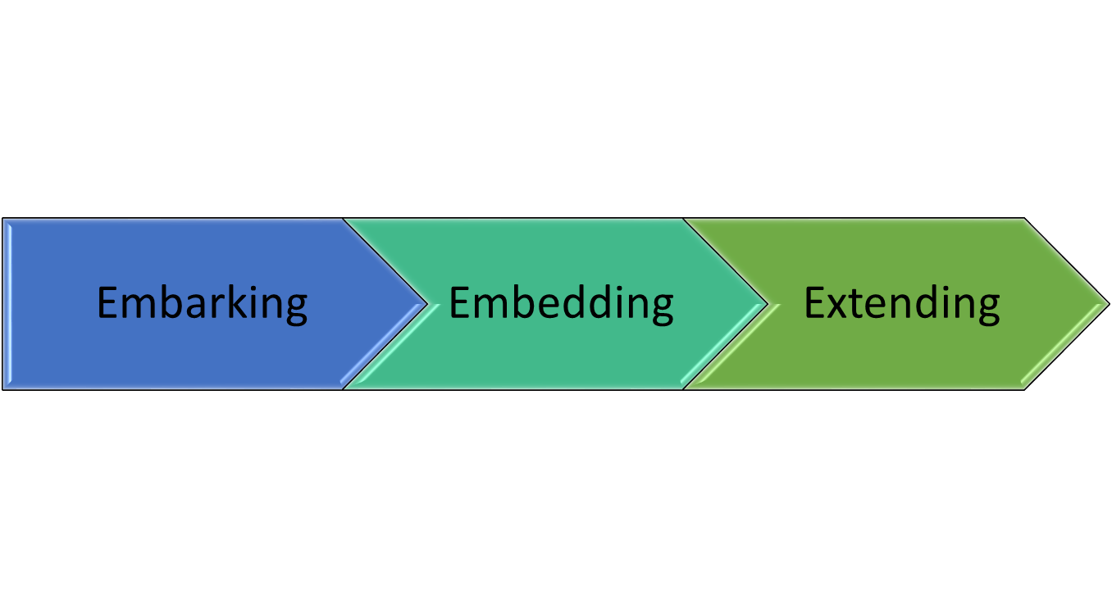

* Introductory session for staff
* First steps on raising awareness with children

* Agreeing the Dementia-Friendly Schools Certificate action points
* Agreeing to an annual review and renewal with further actions planned
* Developing wider community connections

1. **What is the Dementia-Friendly Schools Certificate and logo?**

Dementia-Friendly School Certificates are offered to church schools or other schools with a strong church connection that agree to a three-point Action Plan for the academic year. This authorises the school to use the “Becoming Dementia Friendly School” logo for the academic year.

The Certificate and logo recognise that we are “Becoming Dementia Friendly School” – that we are taking action on dementia. It’s not a destination, it’s a direction of travel. So, it doesn’t mean that “we’ve got everything right”, but it does mean that we are taking action and we are willing to learn and change together. The Certificate sets out three actions on dementia that are planned for this academic year – and the expectation is that the Certificate will be renewed ready for the start of the new year, setting out further actions to take forward.

1. **Possible Actions to Include in a School’s Certificate**

* Hold an initial staff meeting as an introduction for staff
* Hold a worship as an introduction for the pupils
* Appoint a Dementia-Friendly Schools coordinator
* Appoint pupil Dementia- Friendly Schools champions
* Write to parents about becoming a more dementia-friendly school
* Begin to use the Dementia-Friendly Schools logo
* Set up a prayer space with a dementia focus
* Invite parents and carers to a pupil led worship, explaining the journey that the school is on
* Have a dementia-friendly noticeboard and dementia leaflets in school
* Make a Memory Box or prayer cards to share within the wider community
* Partner with the local church to either encourage them to become dementia-friendly or to work on a project together
* Use the [Alzheimer’s Society teaching resources](https://www.alzheimers.org.uk/get-involved/dementia-friendly-communities/dementia-teaching-resources/schools) as part of either a courageous action drop down day, RE lessons, PSHE lessons or SMSC lessons
* Use the [Dementia UK resources](https://www.dementiauk.org/get-support/resources/children/) to help answer some of the pupils’ difficult questions around dementia
* Review our school building and signage for dementia-friendliness
* Hold a [fundraising activity](https://www.dementiauk.org/get-involved/events-and-fundraising/do-your-own-fundraising/school-fundraising-ideas/a-z-of-fundraising-for-children/) for a dementia charity and to share information on dementia
* Get copies of Wendy Mitchell’s books “Somebody that I used to know” and “What I wish people knew about dementia” to share in school, to open up conversations about dementia
* Make links with local homes or centres that work alongside those living with dementia

NB Music is a great way to make intergenerational links

* Consider setting up or supporting a Forget-Me-Not Café that would provide support for people living with dementia
* Involve pupils in agreeing next steps for going forward
* Involve pupils writing articles for local papers or Parish magazines

1. **Local Coordinator or Contact**

It will be helpful to appoint someone as the Dementia-Friendly School Coordinator/contact. The contact is not an expert on dementia but is:

* COORDINATING ACTION: Agreeing actions for the Dementia-Friendly School Certificate and ensuring those are implemented, through coordinating others in school who want to be involved in taking action on dementia together. This could be done with the support of the school’s CDA (Christian Distinctiveness Adviser) or alongside the local church.
* MAKING CONTACTS: Connecting with the local and wider community in order to identify local need and also possible partners (e.g. the local church or community group).
* SHARING INFORMATION: Sharing information they find out about local groups and resources available for people living with dementia and their families/carers and, where relevant, signposting on to something locally.
* SOMEONE TO SPEAK TO: Listening to people across the school community who have concerns about memory loss or dementia, or who are affected by dementia.
* WHERE APPROPRIATE, PRAYING FOR PEOPLE AFFECTED BY DEMENTIA: During worship time, in class reflection time, or even in their own prayers remembering people living with dementia and their families/carers: this is an important part of the scheme.

1. **Resources to Support Next Steps**

Alongside these Introductory Notes, the following resources are available on

The Lichfield Diocesan Board of Education webiste: <https://www.ldbe.co.uk/becoming-dementia-friendly-schools/>:

1. Dementia-Friendly Schools Staff Introduction PowerPoint with two documents to print out and share with all staff who participate in this session:
   * 8-page handout for staff
   * Action on Dementia Cards

*to involve all staff, as the school embarks on becoming a more dementia-friendly school.*

*NOTE: The PowerPoint, 8-page Handout and Action on Dementia Cards are in a password-protected area of the website: please contact the Dementia-Friendly Schools Support Team for access to this material.*

1. Dementia-Friendly Schools Leaflet for the Whole School Community

*to use on the website or with a letter to parents, communicating about embarking on becoming a more dementia-friendly school*

1. Picture Reflection Worship for Pupils on Dementia – Boats, Staying Afloat

*to use an introductory worship focus, embarking on becoming a more dementia-friendly school*

1. Dementia-Friendly Schools Certificate Format

*to see the format, when deciding on three actions that will be appropriate for our school for this academic year*

1. Memory Box Instructions for Schools

*to use if making Memory Boxes for people affected by dementia*

1. Dementia Reflection Space

*to use if creating a reflection space focusing on dementia*

1. Boats and Staying Afloat – Dementia-Friendly Worship

*to use or adapt if sharing dementia-friendly worship with people affected by dementia in the local community e.g., in a residential care home*

1. **Dementia Friendly Schools Support Team:**

For more information on the Dementia-Friendly Schools network or for support or to sign up to a Dementia-Friendly School Certificate, please speak to your CDA or to someone from our Support Team.

Sarah Thorpe – Dementia-Friendly Church Enabler

Email: [sarah.thorpe@lichfield.anglican.org](mailto:sarah.thorpe@lichfield.anglican.org?subject=Dementia-Friendly%20Schools)

Alex Wolvers – Mission Enabler for Schools

Email: [alex.wolvers@lichfield.anglican.org](mailto:alex.wolvers@lichfield.anglican.org?subject=Dementia-Friendly%20Schools)