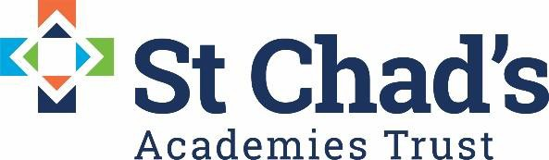

Payroll & Pensions officer required: St Chad’s Academies Trust (central office), Birchills CE Community Academy, Farringdon Street, Walsall, WS2 8NF
Salary: £25,000 - £30,000 (starting salary based on experience and pro-rata based on hours worked) + pension
Contract: 0.5 FTE, Permanent
Start Date: 7 March 2022 (earlier if possible)
All Saints National Academy, High Street, Bloxwich, Walsall,WS3 3LP

St. Chad’s Academies Trust is transforming the futures of young children in our Church of England academies across the West Midlands. The Trust which formed in 2014 comprises of 20 (first, middle and primary) academies, working in partnership with seven local authorities.

The Trust currently employs 1,133 employees, operating one payroll system under one PAYE reference. Given the geographical position of the Trust we work with three Local Government Pension Schemes and the Teachers Pension scheme.

Following the implementation of our new payroll system Cintra IQ in April 2020, we are looking to expand the Trust’s offer to our academies and are offering this exciting opportunity to join the Trust as a 0.5 FTE Payroll & Pensions Officer, who will be responsible for supporting the central function and academy business managers across the Trust with all payroll and pension queries, as the primary point of contact.

We are looking for an experienced, resourceful officer who will bring knowledge, experience, yet welcome new challenges and opportunities that the post provides. Working closely with the Director of Operations you will support the drive to secure further improvements, manage effective and efficient payroll and pensions processing and share an enthusiasm to develop, train and support across the Trust.

As a Trust we are committed to work/life balance, continual personal development opportunities and health and wellbeing. The position attracts a pension scheme (Church Workers Pension Scheme). A full and considered tailored induction and transition programme is in place to ensure your employment starts productively, welcoming you to the team.

The successful candidate will have experience of working within a payroll and pensions environment and be able to demonstrate transferable skills to drive effective support to our academies and service improvements and initiatives.

We are looking for candidates who will:

- Deliver a customer service of a consistently high standard to the academies of St Chad’s.
- Have an ability to proactively promote/ influence service improvements, compliance with audit, financial regulations and payroll & pensions legislation
- Have a willingness to actively participate in the development of the service, coaching, mentoring and development of others, creating a development climate
- Work independently and as a team member, demonstrating active participation in team meetings and promote the ethos of the Trust through collaborative working across multiple disciplines.
- Promote and model the Christian values and ethos of the Trust.

We welcome and encourage informal discussions about the role expectations of this post so if you are interested, please contact the DoO, Zoe Heath on zoe.heath@stchads.uk or 07496 722397 should you wish to discuss the position further.

For further information and an application pack please contact Chloe Norton (chloe.norton@stchads.uk)
A letter of application, referencing the person specification, should be submitted with the completed application form.

Please can you return all completed applications electronically to chloe.norton@stchads.uk Executive Assistant, by the timeline provided.

Closing date for applications: | Close of business Wednesday January 26th 2022
Shortlisting: | Thursday January 27th 2022
Interviews: | Thursday February 3rd 2022

Please can you return all completed applications to Chloe Norton on the above contact details, thank you.

The Trust is committed to safeguarding and promoting the welfare of children and young people/ vulnerable adults and we expect all staff and volunteers to share this commitment.

The post is subject to an enhanced DBS disclosure check along with other relevant pre-employment checks.

St Chad’s Academies Trust is committed and working towards equal opportunity in employment.

We look forward to hearing from you!

