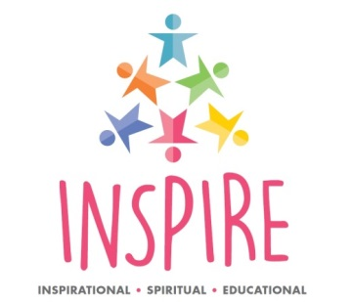
5th – 16th June 2023
22nd May –26th May 2023

Application Form 2023
What does it ‘Mean to be Human’?
Join us at Lichfield Cathedral and be INSPIRED for the day through interactive, inspirational, spiritual, reflective & deep learning.
Join the team from the Diocesan Board of Education and the Cathedral Education Team to engage in high quality learning experiences including:
- Reflecting with WISDOM around the question of what it means to be human
- Engaging in the art of the cathedral as a means of expressing HOPE
- Experiencing the use and science of music to express COMMUNITY
- Considering the importance of DIGNITY and responsibility in being human
Inspire will also be a great opportunity to:
- Experience the awe and wonder of Lichfield Cathedral
- Meet with Christians and discover how their faith influences their lives.
- Meet with other schools and share experiences.
- Reflect on some of the big questions facing us today.

School / Academy
Address
Contact
email address
Telephone number
Number of pupils and Year Group
If wishing to attend on the same day as another school/academy please give details
Please indicate if any of the above dates are not convenient
Signature and Date of application
Application forms should be returned to Paula Lloyd,
Paula.lloyd@lichfield.anglican.org
by Friday 21st October 2022

