14 December 2020

Dear Colleagues

I am writing on behalf of the Diocesan Board of Education, (DBE), as the Autumn Term ends. It has been the most extraordinary term, and indeed year. No doubt this will be recorded as one of the most challenging times in our education system.

On behalf of the DBE, I would like to thank you all for your dedication and hard work though these difficult days. What is amazing is that our schools have remained open and our students have continued to access the rich and creative curriculum which you provide.

The nurture and support you have given the students are to be commended. This pandemic has bought so many challenges, and in particularly the need to address the mental health and well-being of both students and adults. You have worked so hard to enable the students to flourish and have supported each other thought this difficult journey.

I would like to thank all staff at our schools and academies. Our cleaning teams, our cooks, our site managers, and office staff. Together, you have worked tirelessly for our students and their communities.
I would also like to all the leadership teams and CEO’s who have shown determination and vision for our schools during these unprecedented times.

We are all leaders in this journey. Whether you are a cook, a teacher, a cleaner, a teaching assistant, a member of the admin team or indeed the headteacher. You each in turn, lead your department, your colleagues, your key stages, and your own teams forward, to ensure that our students have the best possible opportunities. Without each of you, our schools could not continue to flourish.

I do not know what 2021 will bring. However, there is hope. Hope with the new vaccine. Hope that we have come so far on this journey in 2020 and can continue to grow together in fellowship. Hope that our wonderful students will continue to thrive and achieve great things. Hope that in 2021 all our families will be together again.

On behalf of the DBE, I would like to thank you all for your commitment, energy and hard work thought these difficult months. I hope that this Christmas brings rest and peace to you and your families.

I wish you every blessing and look forward to seeing you all in 2021.

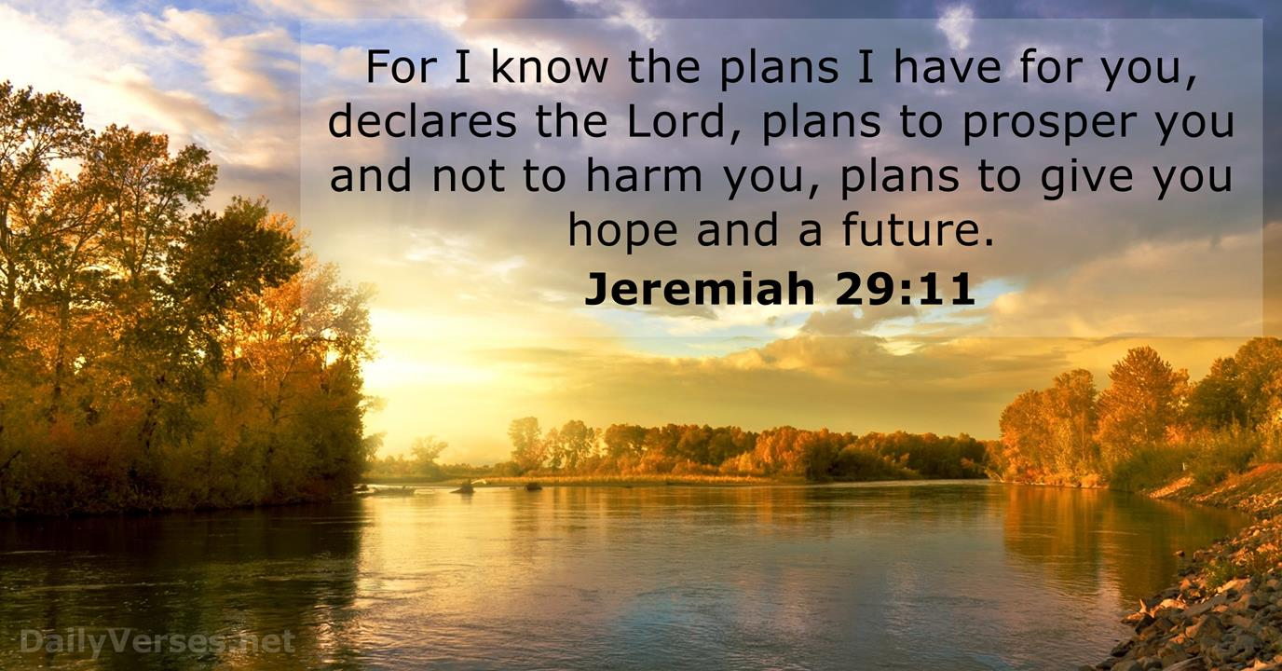

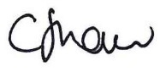

Claire Shaw
Diocesan director of Education

