What do Muslims believe?
Lesson Theme | Challenges
- Why is the name Allah so important to Muslims?  If possible watch:  https://www.youtube.com/watch?v=PDxKxnVZtgo  A ten minute introduction to Islam | Think:  Who is the most important person to you?  How do you show respect to them?  For Muslims the most important person is God – the Arabic name for God is Allah.  Islam began in the part of the world called Arabia. Can you find Arabia on a map?  The language called Arabic is very important to Muslims. In Arabic the word for God is Allah. Muslims believe that there is no God but Allah.  Look at the Arabic designs below that show the name of Allah. This is one way that Muslims show their respect to Allah.  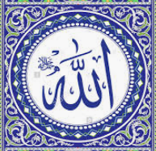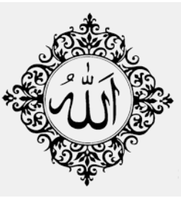  Key Challenge:  Create your own Islamic tile – you may want to use these designs as examples. Can you write the name Allah in Arabic as part of your design?  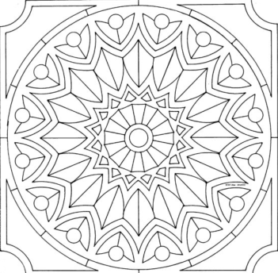  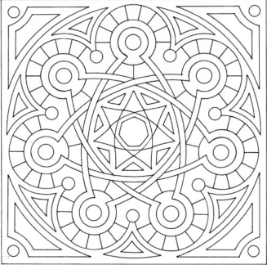  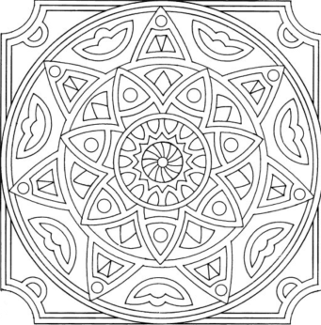
- Why is the prophet Mohammad (pbuh) so important to Muslims? | The Prophet Muhammad (pbuh) was a merchant born in the city of Mecca. Muhammad was respected as he was a wise and fair businessman. Tradition says Muhammad escaped the busy city during the month of Ramadan and went to the mountains by himself to think. Muslims believe Allah chose Muhammad to be his Prophet because he was a fair and wise man and because he was concerned for the people. They believe the Prophet Muhammad (pbuh) was chosen to tell the people there was only one God. This happened when Muhammad was 40 years old, when an angel appeared and revealed the first verses of the Qur’an to him.  If possible watch the film about the 'Prophet and the Ants' and the story of 'The Crying Camel', showing that no matter how small or large animals are they are all important to God and need to be cared for.  https://www.bbc.co.uk/bitesize/clips/z9tqb82  Or read the story, perhaps someone can help you…  It was very hot day. The people who lived in the city of Medina were trying to find somewhere to keep cool. There were many beautiful gardens in the city with tall, shady trees where people came to sit and find shade. They talked. They sipped refreshing drinks. They told stories and they laughed.  The Prophet Muhammad was walking in one of the gardens. He loved to walk under the trees where it was green and cool. He liked to think quietly as he walked. He smiled at the people he knew as he walked along.  While he was walking, Prophet Muhammad heard a strange noise. It sounded like someone crying. It sounded like someone howling. It sounded like someone was very upset. As he came closer to the crying and howling, the Prophet could see it was not a sad person at all. It was a sad camel.  Muhammad felt very sorry for the camel. It was tied to a post, out in the sunshine. It was very hot, and looked very thirsty. Tears were running down the camel’s cheeks and its fur was very wet. No one seemed to notice the camel’s howls. Muhammad stroked the camel, and it became calmer. After a while the howls became grunts and the grunts became snorts of pleasure. The tears stopped running down the camel’s cheeks. He knew Muhammad was his friend.  Muhammad became angry. He strode along the pathways calling, “Who owns this camel?” At last a voice said, “I do,” and a man stepped out from under the shade of the biggest tree in the garden.  Muhammad looked at the man. He was not hot. He was not thirsty. He was not thinking about his camel. Muhammad spoke quietly. As Muhammad spoke, the camel owner’s head began to droop. He realised what he had done. Muhammad reminded him that the camel was one of Allah’s creatures. The animal worked hard for the man, carrying heavy loads and travelling to places far away. Muhammad reminded the man that he should take great care of the camel in return for its hard work. The camel owner felt very bad. He had been cool, comfortable and happy while the camel was hot, bothered and upset. His behaviour had even upset the Prophet Muhammad. He was so ashamed. From that day on he looked after his animals with great care, and always made sure they had enough to eat and drink the camel never cried again.  Key Challenge:  The Prophet was kind to animals.  Make a list of different animals, and different ways to be kind to them?  Muslims believe Allah made the whole world and all the creatures in the world, so caring for animals pleases God.  Draw your favourite animal and colour it beautifully. Choose 3 words to say how we can care for this animal. Write the words onto their picture. (E.g. ‘food, water, stroking, safety, gentleness, kindness, taking for a walk, cleaning out their house, never being cruel…’)
- Why is the Qur’an important to Muslims?  If possible watch this clip about the Qur’an https://www.bbc.co.uk/bitesize/clips/z4fgkqt | The Qur’an is the holy book of Islam. The Qur’an is a book in the Arabic language that Muslims believe to be the actual words of Allah. In the Qur’an Allah tells Muslims how they should worship him and also how they should behave towards each other. The words that angel Jibrael gave Muhammed were written down and these make the book the Qur’an.  Muslims take great care when handling the Qur’an as they treat it with respect. It should be covered, kept on a high shelf and put on a stand when read. Hands should be washed before touching it.  What does this show about its importance for a Muslim?  Key Challenge:  - Design an instruction sheet to explain how a Qur’an should be treated  - Design a bookmark to be used either in a Qur’an or in your favourite book. (You may want to use Arabic patterns on the bookmark).
- Why is prayer so important to Muslims?  If possible watch this clip https://www.bbc.co.uk/bitesize/clips/z4gkq6f | Prayer is an important part of a Muslim’s life. Prayer takes place in a mosque but it can also take place in any clean place. Salat is one of the 5 pillars of Islam.  The Qur’an teaches that believers should offer salat five times a day; at dawn, noon, late afternoon, dusk and after dark. Prayer involves the whole body, and set movements called Rak’ah help focus on Allah.  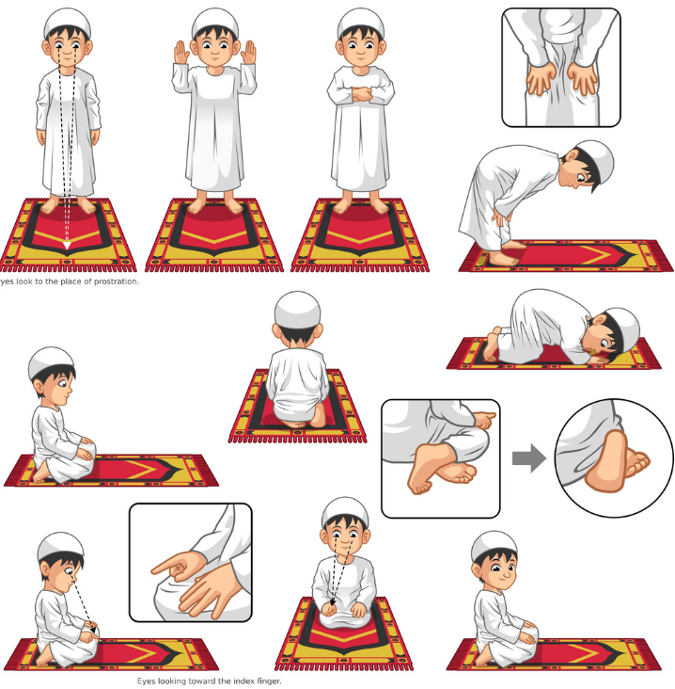  Key Challenge:  Design and make a prayer mat. This may be out of paper or even fabric  