How can Muslim and Christian Aid make a difference?
Lesson Theme | Challenges
- What is a charity? | What do you think of when you hear the word charity?  A charity is an organisation that aims to help someone or something especially in a time of crisis.  Do you recognise any of these charity logos?  Which charity do they belong to?  If you don’t know perhaps ask someone in your family if they do know.  Have you seen them before?  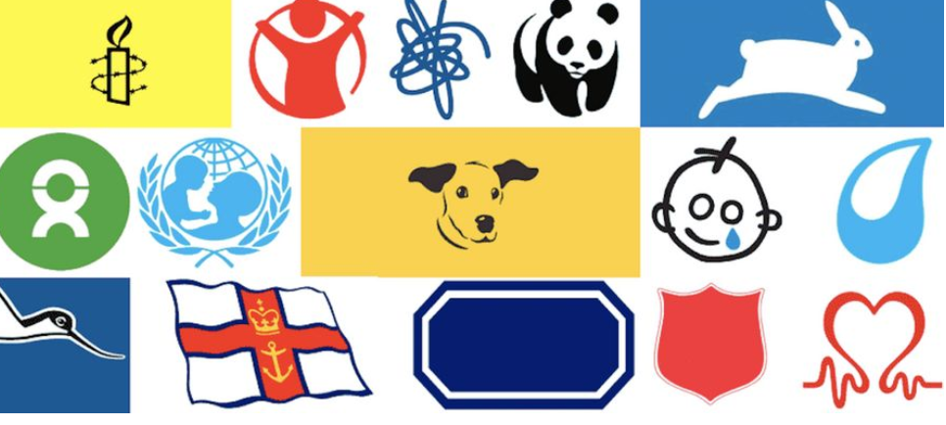  Key Challenge:  If you were to set up a charity who or what would the charity help?  Design a logo to go with your charity.
- What does Christian Aid do? | If you can, watch this short clip about Christian Aid:  https://www.christianaid.org.uk/schools/exploring-christian-aid-school  Christian Aid works with people living in poverty, no matter what their faith is or if they have none. It’s called Christian Aid because it was started by Christians who believed that the Bible teaches us to care for others.  Read the story of the Good Samaritan from the Bible (Luke 10:25-37) or use this summary:  One day a Jewish man was walking down a dangerous, desert road when he was attacked by robbers. The robbers beat him up, took all his clothes and left him for dead. A little later a priest walked down the same road. He saw the man lying there but he crossed over and walked past on the other side. Soon after, another very religious man walked down the road. He was Jewish like the man who’d been attacked. He also saw him lying in the road, but he also crossed over and walked past on the other side. After a while, a third man walked down the road. He was from a different place and a different religion to the man who’d been attacked. He was a Samaritan, and the Samaritans and Jews hated each other. When he saw the man lying in the road he went over to him. He bandaged the man’s wounds and put him on a donkey. He took him to a hotel and cared for him. Then he paid the bill and said to the hotel owner that he would cover all the costs for the man to be looked after until he returned.  Many Christians today see this teaching as a reason to use their lives to make life better for other people, and Christian Aid helps many Christians to put their faith into action and to help others.  Key Challenge:  - Think about what questions might you ask the Good Samaritan if you were able to meet him?  - Create a cartoon strip that retells the story of the Good Samaritan – use the last frame to explain how this story is an inspiration for Christian Aid.
- Muslim Aid | 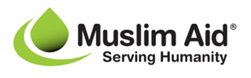  If you can, watch these short clips as introductions to Muslim Aid  https://www.muslimaid.org/about-us/our-values/  https://www.youtube.com/watch?v=RCCcwCcEvac  To Muslims all over the world it is important to help the community to create peace and harmony. Sadaqah covers all kinds of good deeds and involves putting other people first. Muslims also feel it is their duty to give money to charity. Zakah is one of the Five Pillars of Islam, and every adult Muslim who can afford it must donate a portion of their wealth to charity each year.  Muslim Aid was established in the UK in 1985 by community leaders from 17 Islamic organisations in response to the drought in the Horn of Africa. They are a faith-based British international charity that provides help to people who are victims of natural disasters or conflict or suffering from poverty, hunger, disease, illiteracy, discrimination, homelessness, debt, unemployment, injustice, deprivation or lack of skills and economic opportunities.  They develop long-term development projects aimed at providing sustainable living for poor communities and survivors of natural disasters as well as providing emergency relief. They give special emphasis to education and improving child and women health. They work in all parts of the globe Compassion and justice (Ru’ufun and ‘Adl) in all of our actions;  The Holy Qur’an describes a ‘godly’ person as someone: “giving a rightful share of their wealth to the beggar and the deprived” (51:19); while Prophet Muhammad (peace and blessings be upon him) reminds us that: “Every good act is charity; and the person who guides others to a good act is as the one who did it; and, assuredly, God loves the act of aiding the distressed!” (al Bayhaqi). The Prophet also says that “Love for humanity what you love for yourself!” (al-Bukhari).  “Whosoever saves a life, it is as if they have saved the lives of all humankind” (Qur’an 5:32)”.  The ethos of Muslim Aid is rooted in these teachings; a belief that providing relief and aid to others is central to one’s humanity. This can, and is, performed by those of all faiths and none.  Key Challenge:  Imagine that you are on the board of Muslim Aid – you have been given a grant of money and it is your job to decide how best Muslim Aid can spend it. Based on what you know about the organisation – how are you going to suggest Muslim Aid will spend it? Create a poster/booklet/advertisement illustrating the work that you plan to do with Muslim Aid
- Climate action challenge | Many faith charities see the climate crisis is one of the most critical issues of our time.  Key Challenge:  Use your creative skills to develop a ‘think piece’ on the beauty of the natural world and the importance of climate justice? This could be a written story or poem, a photograph or a piece of art.  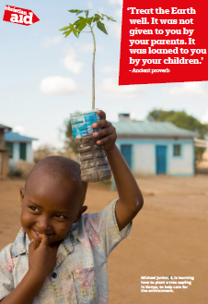  You may want to use this ancient proverb and poster as an inspiration:  ‘Treat the Earth well.  It was not given to you by your parents.  It was loaned to you by your children.’  - Ancient proverb

