Thanksgiving
Weekly bible focus:  Luke 1: 46-56 Mary praises God  Luke 2: 8 -20 Shepherds hear about Jesus  Matthew 2: Wise Men visit Jesus   |  | Reflection ideas for the classroom or outdoor area
Monday  Windows  Windows are for looking out onto God’s world and being inspired by its wonders. | Gathering  Once everyone is calm and the space is set up ready for worship you may want to start by lighting a candle.  Light the candle with these words: As we come together, we light this candle. If you are Christian, you may think the light is like Jesus, shining out everywhere. If you believe in God, you may think the light symbolises the presence of God in the world. If you are not sure about your beliefs, the flickering light may make you wonder about the existence of God. If you don’t believe in God, the light may make you consider what meaning there is in the world. Or the candle may have a particular meaning for you today.  Saying / signing a greeting.  Examples:  This is the day that the Lord has made.  Let us rejoice and be glad in it.  Come on everyone! Clap your hands!  Shout to God with joyful praise!  The Lord is with us  Let us praise his name together  Grace, mercy and peace be with you  and also with you.  The grace of our Lord Jesus Christ, the love of God and the fellowship of the Holy Spirit be with you  and also with you.  We have gathered here today to think about ‘Thankfulness’  Engage  Read or retell dramatically the Nativity story from Luke 2. You could use puppets and/or a sensory box    Or watch:  https://www.youtube.com/watch?v=L5m2GE6DFeM  Explain:  Explain that Christmas is a time when many Christians thank God that Jesus came to earth to show and tell people how to live.  Going deeper  Get children to think about thankfulness in relation to the Christmas story. What ‘thank you’ prayers and sentences might people in the story (Mary, Joseph, shepherds, angels) have said at different moments?  Respond  Please listen to the words of this prayer.  After each line you might like to say the words  ‘We give you thanks and praise.’  For Jesus, God’s amazing gift to the world,  All: We give you thanks and praise.  For all that Jesus has done for us,  All: We give you thanks and praise.  For giving us all we that we have,  All: We give you thanks and praise.  Amen.  Sending/Blessing  “Sending” is the completion of the worship. When your worship in the hall comes to a conclusion there is literally a “sending”, as people exit and go back to their classrooms—how you follow the same pattern in the classroom will depend on how you prepared and gathered for worship.  Blessing examples:  We go into the world to walk in God's light, to rejoice in God's love and to reflect God's glory.  Amen  Go in peace to love and serve the Lord.  In the name of Christ. Amen.  Go in peace,  We go in peace  Go in joy  We go in joy  Go in love  We go in love  Amen.  May the light of Christ our Lord shine in all our hearts.  Amen. | Christmas Thanks  Equipment:  Christmas Tree.  Red paper baubles, hole punched.  Pens to write on baubles.  String to hang baubles.  Suggested Instructions: Christmas is a time where we see family and friends; where we think about the year that has just gone by and the year to come. Take a moment to think of three things you can be thankful for that have happened since last Christmas. It might be passing an exam, getting into another school, winning a sporting event. Write the three things you are thankful for onto a Christmas bauble and hang it on the tree.  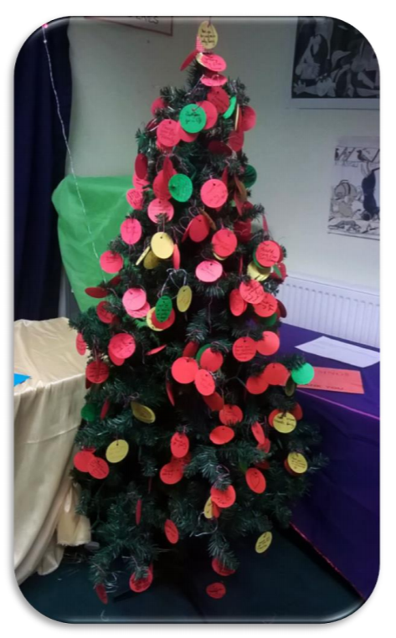  Jesus’ Gifts – Being Thankful  Equipment: Play dough, protective sheeting, a table and chairs.  Set-up: Cover the table with protective sheeting and put the play dough on top.  Suggested Instructions:  When the Wise Men found Jesus, they offered him gifts of gold, frankincense, and myrrh. What ‘gifts’ do you have? (Not just things, but people, skills, memories, anything really.) What are you thankful for? If you want to, you can make a model of something you would like to say thank you for.  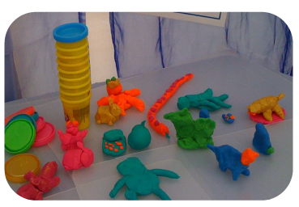  Links to worship songs:  Born is the King  https://www.youtube.com/watch?v=EnMBUjCPaZ0  Christmas Medley  https://www.youtube.com/watch?v=H0iFgc5GjwA
Tuesday  Mirrors  Mirrors are for looking into and reflecting upon things, either alone or together. Mirrors often help us to see things more clearly. | Gathering  As above  Engaging  Bethlehemian Rhapsody  https://www.youtube.com/watch?v=pW1pbuyGlQ0  Modern retelling of the nativity using music Bohemian Rhapsody  Responding  Remind children of the ‘thank you’ prayers and sentences might people in the story (Mary, Joseph, shepherds, angels) might have said at different moments? Make a paper chain of these ‘thank you’ words as part of class Christmas decorations (use big links, and supported writing and talk to enable deeper thinking; some pupils may choose/need to show their ideas with pictures). Use red and green paper to make this chain  Sending  As above
Wednesday  Doors  Doors are for walking through in order to then act or respond in some way; it might mean moving on, making choices, doing something creative or purposeful in response. | Gathering  As above  Engaging  How do people show gratitude at Christmas? What examples of being thankful were in the Christmas story? Discuss whether children have anything to be thankful for at Christmas this year.  You could show pictures of the things that are taken for granted that others may not have.  Responding  Make another paper chain(use two different colours, maybe blue and purple this time) of all the ‘thank yous’ the pupils can think of that they need to say this Christmas: to family, friends, teachers, dinner supervisors and so on, for all that makes Christmas a special time of year.  Or create a gratitude jar/ tree where children add all the things/people they are thankful for  Sending  As above
Thursday –  Meditation   | Use the Meditation resource alongside the Spiritual Encounters – bible based meditation teacher’s pack: http://www.ldbe.co.uk/about/guidance-resources/worship-and-meditation/  (This can be adapted for use with all ages)  You may want to use the following reflection:  Be Thankful  Be thankful that you don’t already have everything you desire.  If you did, what would there be to look forward to?  Be thankful when you don’t know something,  for it gives you the opportunity to learn.  Be thankful for the difficult times.  During those times you grow.  Be thankful for your limitations,  because they give you opportunities for improvement.  Be thankful for each new challenge,  because it will build your strength and character.  Be thankful for your mistakes.  They will teach you valuable lessons.  Be thankful when you’re tired and weary,  because it means you’ve made a difference.  It’s easy to be thankful for the good things.  A life of rich fulfilment comes to those who  are also thankful for the setbacks.  Gratitude can turn a negative into a positive.  Find a way to be thankful for your troubles,  and they can become your blessings
Friday –  Celebration   | Take this time to celebrate what has happened during the week – you may want to give out awards. If possible, join the bubbles using Zoom or Teams so that the whole school can come together in a time of celebration.  Remember that this should also be a time of worship and celebration so begin with a gathering, include a prayer, a blessing, and a song of celebration.

