Host of Angels and the Shepherds
Weekly bible focus:  Luke 2:8-20   |  | Reflection ideas for the classroom or outdoor area
Monday  Windows  Windows are for looking out onto God’s world and being inspired by its wonders. | Gathering  Once everyone is calm and the space is set up ready for worship you may want to start by lighting a candle and saying / signing a greeting.  Examples:  The grace of our Lord Jesus Christ,  the love of God,  and the fellowship of the Holy Spirit  be with you  and also with you  Grace, mercy and peace  from God our Father  and the Lord Jesus Christ  be with you  and also, with you.  Lord, open our lips  and we shall praise your name.  This is the day that the Lord has made.  Let us rejoice and be glad in it.  We meet in the name of God:  God the Father,  God the Son,  God the Spirit:  God is one.  Let us worship God:  Father, Son and Holy Spirit.  Engage  If the Queen planned to announce that there would be a new King, who would she tell first?  Share your ideas and look at some of the people that she might announce the news to first.  Read  Luke 2:8-20  ⁸ And there were shepherds living out in the fields near by, keeping watch over their flocks at night. ⁹ An angel of the Lord appeared to them, and the glory of the Lord shone around them, and they were terrified. ¹⁰ But the angel said to them, ‘Do not be afraid. I bring you good news that will cause great joy for all the people. ¹¹ Today in the town of David a Saviour has been born to you; he is the Messiah, the Lord. ¹² This will be a sign to you: you will find a baby wrapped in cloths and lying in a manger.’  ¹³ Suddenly a great company of the heavenly host appeared with the angel, praising God and saying,  ¹⁴ ‘Glory to God in the highest heaven,  and on earth peace to those on whom his favour rests.’  ¹⁵ When the angels had left them and gone into heaven, the shepherds said to one another, ‘Let’s go to Bethlehem and see this thing that has happened, which the Lord has told us about.’  ¹⁶ So they hurried off and found Mary and Joseph, and the baby, who was lying in the manger. ¹⁷ When they had seen him, they spread the word concerning what had been told them about this child, ¹⁸ and all who heard it were amazed at what the shepherds said to them. ¹⁹ But Mary treasured up all these things and pondered them in her heart. ²⁰ The shepherds returned, glorifying and praising God for all the things they had heard and seen, which were just as they had been told.  Or watch:  https://www.youtube.com/watch?v=sGak3d7HOck  Explain:  Shepherds were not important people in society at the time that Jesus was born.  In fact, they were not just ordinary, they were the lowest of the low!  They spent all of their time with smelly sheep and, as a result, were not popular with others.  So, why did God choose a bunch of shepherds to be the first group of people to hear about his son’s birth?  Why do you think we can be encouraged that God chose the shepherds to hear the good news first?  What does this tell us about God?  Respond  Reflect and consider God’s choice of people to be the first to hear the news about the birth of his son. We know that the shepherds were not considered important.  Think about the people in our nation and our world who are not considered important. (Link to World Map activity above). Remember them in your prayers.  Our Father, in heaven,  Holy is your name.  Your Kingdom come,  Your will be done on earth, as it is in heaven.  Give us this day our daily bread,  And forgive us our sins,  As we forgive those who sin against us,  And lead us not into temptation,  But deliver us from evil.  Amen.  Sending/Blessing  “Sending” is the completion of the worship. When your worship in the hall comes to a conclusion there is literally a “sending”, as people exit and go back to their classrooms—how you follow the same pattern in the classroom will depend on how you prepared and gathered for worship.  Blessing examples:  May God’s blessing surround us today  Amen  Go in peace to love and serve the Lord.  In the name of Christ.  Amen  May the joy of the angels, the eagerness of the shepherds, the perseverance of the wise men, the obedience of Joseph and Mary and the peace of the Christ-child be yours this Christmas; and the blessing of God Almighty, the Father, the Son and the Holy Spirit, be among you and remain with you always. Amen. | 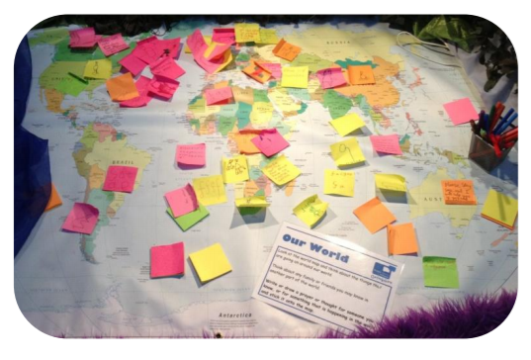  Shepherds on the Hill  World Map  Equipment: Felt tip pens, post-it notes, world map, cushions.  Set-up: Put the world map on the floor and place the cushions, pens and Post-its around it.  Suggested Instructions: Think about how God chose to share the news about the birth of Jesus with shepherds first, people who weren’t considered important at that time. Think about people in our world that might not be considered important. If you want to, you can write a thought or prayer for them onto a Post-it note and stick it onto the map.  Links to worship songs:  Angels we have heard on high  https://www.youtube.com/watch?v=VutfWYmJSwg&list=PLz2u9XXowozCWhD-TmvhkVOp1mwXqlAgi&index=7  O What a Glorious Night  https://www.youtube.com/watch?v=6aGLV5CfoTU  Sent from above  https://www.youtube.com/watch?v=tep-97o2kL4  Like A Candle Flame  https://www.youtube.com/watch?v=TGAXlGBB10M  The Lord’s My Shepherd  https://www.youtube.com/watch?v=upRoR7ej9Ns  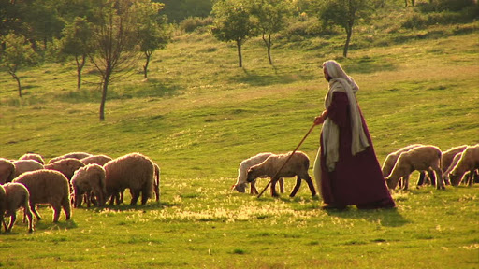    
Tuesday  Mirrors  Mirrors are for looking into and reflecting upon things, either alone or together. Mirrors often help us to see things more clearly. | Gathering  As above  Engaging  John 10:14-15  The Good Shepherd  ¹⁴ “I am the good shepherd. I know my sheep, and my sheep know me, ¹⁵ just as the Father knows me, and I know the Father. I give my life for the sheep.  Psalm 23:1-4  The Lord is my shepherd.  I have everything I need.  ² He gives me rest in green pastures.  He leads me to calm water.  ³ He gives me new strength.  For the good of his name,  he leads me on paths that are right.  ⁴ Even if I walk  through a very dark valley,  I will not be afraid  because you are with me.  Your rod and your shepherd’s staff comfort me.  Isn’t it interesting that the shepherd is important in other parts of the Bible too?  King David, in his Psalm, wrote about God being like a shepherd to him.  Jesus, as an adult, spoke about being the Good Shepherd.  Think: What does a shepherd do? Why do you think David and Jesus used the picture of a shepherd? What does it tell us about God/Jesus?  Why do you think we might need a shepherd?  Responding  Think about times when you might need a Shepherd to guide and protect you.  Who can you turn to in these times?  Take some time to pause and reflect.  Sending  As above
Wednesday  Doors  Doors are for walking through in order to then act or respond in some way; it might mean moving on, making choices, doing something creative or purposeful in response. | Gathering  As above  Engaging  Re-read the part of the passage that focuses on the host of angels.  ⁹ An angel of the Lord appeared to them, and the glory of the Lord shone around them, and they were terrified. ¹⁰ But the angel said to them, ‘Do not be afraid. I bring you good news that will cause great joy for all the people.  ¹³ Suddenly a great company of the heavenly host appeared with the angel, praising God and saying,  ¹⁴ ‘Glory to God in the highest heaven,  and on earth peace to those on whom his favour rests.’  Can you imagine a better way to receive joyful good news?!  Just imagine, you are minding your own business, taking care of your sheep and suddenly an incredible choir of angels appears with a message of hope and joy! How would it feel? What would it sound like?  https://www.youtube.com/watch?v=NlrMzbdP2X0  Responding  What do you think of when someone mentions ‘news’? At the moment, the news seems to be full of very worrying stories.  It is so uplifting when we hear good news. Think back to the daily news updates we had on Captain Tom and his fundraising walk – it lifted everyone’s spirits and we were all excited to hear how much money he had raised for the NHS.  https://www.goodgoodgood.co/goodnewspaper  https://thehappynewspaper.com/  See goodnews_movement on social media.  Could you set up a good news station in your classroom? Encourage everyone to share their good news and watch how it brings joy and uplifts everyone.  Sending  As above
Thursday –  Meditation   | Use the Meditation resource alongside the Spiritual Encounters – bible based meditation teacher’s pack: http://www.ldbe.co.uk/about/guidance-resources/worship-and-meditation/  (This can be adapted for use with all ages)  You may want to use the following reflection:
Friday –  Celebration   | Take this time to celebrate what has happened during the week – you may want to give out awards. If possible join the bubbles using Zoom or Teams so that the whole school can come together in a time of celebration.  Remember that this should also be a time of worship and celebration so begin with a gathering, include a prayer, a blessing, and a song of celebration.

