Gabriel & Mary
Weekly bible focus:  Luke 1: 26-38   |  | Reflection ideas for the classroom or outdoor area
Monday  Windows  Windows are for looking out onto God’s world and being inspired by its wonders. | Gathering  Once everyone is calm and the space is set up ready for worship you may want to start by lighting a candle and saying / signing a greeting.  Examples:  Christ the light of the world is here  Lord Jesus shine on us.  Grace, mercy and peace be with you  and also with you.  Lord, open our lips  and we shall praise your name.  This is the day that the Lord has made.  Let us rejoice and be glad in it.  The Lord is with us  Let us praise his name together.  Engage  Read Luke 1:26-38  ²⁶ In the sixth month of Elizabeth’s pregnancy, God sent the angel Gabriel to Nazareth, a town in Galilee, ²⁷ to a virgin pledged to be married to a man named Joseph, a descendant of David. The virgin’s name was Mary. ²⁸ The angel went to her and said, “Greetings, you who are highly favoured! The Lord is with you.”  ²⁹ Mary was greatly troubled at his words and wondered what kind of greeting this might be. ³⁰ But the angel said to her, “Do not be afraid, Mary; you have found favour with God. ³¹ You will conceive and give birth to a son, and you are to call him Jesus. ³² He will be great and will be called the Son of the Most High. The Lord God will give him the throne of his father David, ³³ and he will reign over Jacob’s descendants forever; his kingdom will never end.”  ³⁵ The angel answered, “The Holy Spirit will come on you, and the power of the Most High will overshadow you. So the holy one to be born will be called^{[b]} the Son of God.  ³⁸ “I am the Lord’s servant,” Mary answered. “May your word to me be fulfilled.” Then the angel left her.  You could also watch:  https://www.youtube.com/watch?v=KT_cHi8QJMw&t=6s  Explain:  This part of the Christmas story, where the angel Gabriel visits Mary, is often called ‘The Annunciation’. Gabriel arrives to make an important announcement to Mary about her future.  How do you think Mary felt?  How would you have gone about telling someone that they were about to become the mother of God’s son?  ‘Do not be afraid!’ – this seems to be the standard opening line for angels! Do you think we portray angels accurately? Look at some different paintings of angels and see if you agree with the artist’s ideas.  Going deeper:  After Gabriel had made his announcement to Mary, she went to visit her cousin Elizabeth. Elizabeth was also expecting a baby and that baby would grow up to be John the Baptist.  What do you think Mary said to Elizabeth about her news?  Do you think she was panicking? Worried? Excited?  Mary Praises God  This part of the Bible is sometimes called The Magnificat. It is said and even sung in churches. See if you can work out Mary’s feelings from the words she says.  ⁴⁶ Then Mary said,  “My soul praises the Lord;  ⁴⁷ my heart is happy because God is my Saviour.  ⁴⁸ I am not important, but God has shown his care for me, his servant girl.  From now on, all people will say that I am blessed,  ⁴⁹ because the Powerful One has done great things for me.  His name is holy.  ⁵⁰ God will always give mercy  to those who worship him.  ⁵¹ God’s arm is strong.  He scatters the people who are proud  and think great things about themselves.  ⁵² God brings down rulers from their thrones,  and he raises up the humble.  ⁵³ God fills the hungry with good things,  but he sends the rich away with nothing.  ⁵⁴ God has helped his people Israel who serve him.  He gave them his mercy.  ⁵⁵ God has done what he promised to our ancestors,  to Abraham and to his children forever.”  Respond  Encourage the pupils to respond with their own prayers first and then if appropriate use the Lord’s prayer.  Our Father, in heaven,  Holy is your name.  Your Kingdom come,  Your will be done on earth, as it is in heaven.  Give us this day our daily bread,  And forgive us our sins,  As we forgive those who sin against us,  And lead us not into temptation,  But deliver us from evil.  Amen.  Sending/Blessing  “Sending” is the completion of the worship. When your worship in the hall comes to a conclusion there is literally a “sending”, as people exit and go back to their classrooms—how you follow the same pattern in the classroom will depend on how you prepared and gathered for worship.  Blessing examples:  We go into the world to walk in God's light, to rejoice in God's love and to reflect God's glory.  Amen  The Lord bless us and watch over us, the Lord make his face shine upon us and be gracious to us, the Lord look kindly on us and give us peace. Amen  May the light of Christ our Lord shine in all our hearts.  Amen. | 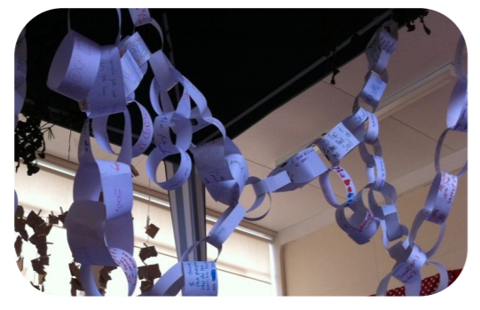  Hopes & Dreams  Equipment: Paper strips, felt tip pens, sticky tape & scissors or a stapler. Print-out of the conversation between the angel and Mary.  Set-up: Start a few paper chains off, perhaps inside a gazebo, and place the rest of the equipment close by.  Suggested Instructions: Read the conversation between Mary and the angel Gabriel. Think about what the angel said, ‘nothing is impossible with God.’ Think about your hopes and dreams, however impossible they may feel. If you want to, you can write or draw them onto strips of paper, and then add them to the paper chain.  Links to worship songs:  Angels we have heard on high  https://www.youtube.com/watch?v=VutfWYmJSwg&list=PLz2u9XXowozCWhD-TmvhkVOp1mwXqlAgi&index=7  O What a Glorious Night  https://www.youtube.com/watch?v=6aGLV5CfoTU  Sent from above  https://www.youtube.com/watch?v=tep-97o2kL4  Like A Candle Flame  https://www.youtube.com/watch?v=TGAXlGBB10M  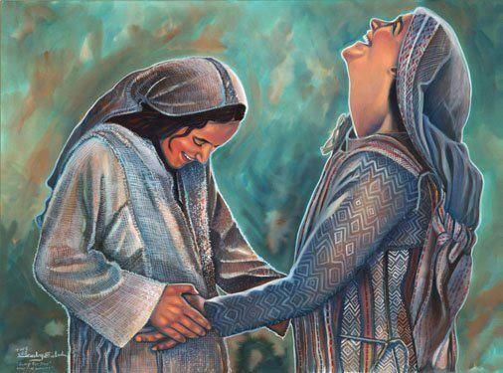    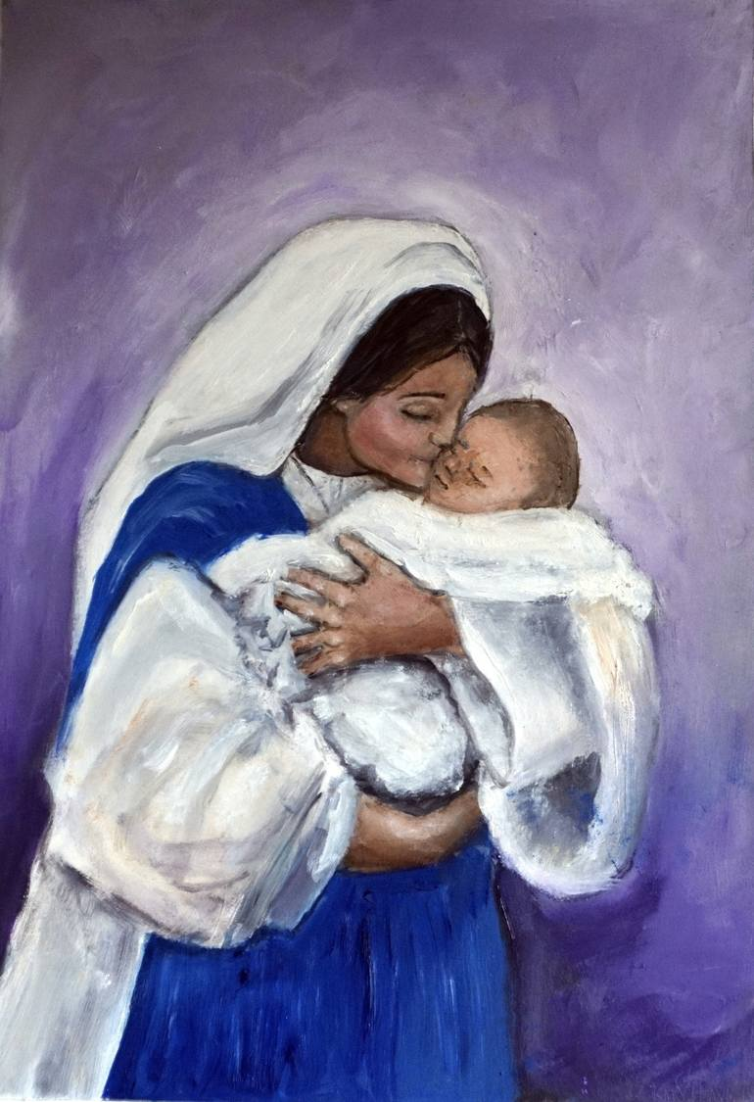  
Tuesday  Mirrors  Mirrors are for looking into and reflecting upon things, either alone or together. Mirrors often help us to see things more clearly. | Gathering  As above  Engaging  We will be thinking today about the qualities in a person that God might use…  Remember ‘The Magnificat’ from worship yesterday?  What type of person do you think Mary was? Did God choose a rich and powerful woman to be the mother of his son? Can you find some clues in Mary’s song of praise that tell us what she was like?  Responding  Have you ever doubted that you have got the ability to achieve everything you want to? Mary was young and from a humble background. God saw her heart and used her in the most incredible way.  What are your hopes and dreams? Think and reflect on them now.  Sending  As above
Wednesday  Doors  Doors are for walking through in order to then act or respond in some way; it might mean moving on, making choices, doing something creative or purposeful in response. | Gathering  As above  Engaging  Mary Did You Know?  Listen to the song by Pentatonix https://www.youtube.com/watch?v=cZVjXsf_7aI  Could Mary have possibly fully understood the impact that her baby was going to have on the world?  Listen to the words of the song.  What else would you tell Mary about who her son would grow up to be? What would he do? How would he impact the world? Do you think she would be amazed to know that we are still talking about him today?  Responding  Think about the people who have helped you so far in your life. Your family, friends, teachers… Do they know how they have helped you? Do they know the impact they have had on you? Maybe you could tell them.  Perhaps someone has been a good friend to you and made you feel cared for…why don’t you tell them?  Perhaps a teacher has helped give you more confidence in your learning…why don’t you tell them?  Perhaps someone in your family has made you feel loved and secure…why don’t you tell them?  Ask them…did you know?
Thursday –  Meditation   | Use the Meditation resource alongside the Spiritual Encounters – bible based meditation teacher’s pack: http://www.ldbe.co.uk/about/guidance-resources/worship-and-meditation/  (This can be adapted for use with all ages)  You may want to use the following reflection:
Friday –  Celebration   | Take this time to celebrate what has happened during the week – you may want to give out awards. If possible join the bubbles using Zoom or Teams so that the whole school can come together in a time of celebration.  Remember that this should also be a time of worship and celebration so begin with a gathering, include a prayer, a blessing, and a song of celebration.

