ADVENT

Advent

Background for teachers
For many Christians unfamiliar with the liturgical year, there may be some confusion surrounding the meaning of the Advent season. Some people may know that the Advent season focuses on expectation and think that it serves as an anticipation of Christ’s birth in the season leading up to Christmas. This is part of the story, but there’s more to Advent.

The word “Advent” is derived from the Latin word adventus, meaning “coming,” which is a translation of the Greek word parousia. Scholars believe that during the 4th and 5th centuries in Spain and Gaul, Advent was a season of preparation for the baptism of new Christians at the January feast of Epiphany, the celebration of God’s incarnation represented by the visit of the Magi to the baby Jesus (Matthew 2:1), his baptism in the Jordan River by John the Baptist (John 1:29), and his first miracle at Cana (John 2:1). During this season of preparation, Christians would spend 40 days in penance, prayer, and fasting to prepare for this celebration; originally, there was little connection between Advent and Christmas.

By the 6th century, however, Roman Christians had tied Advent to the coming of Christ. But the “coming” they had in mind was not Christ’s first coming in the manger in Bethlehem, but his second coming in the clouds as the judge of the world. It was not until the Middle Ages that the Advent season was explicitly linked to Christ’s first coming at Christmas.

Media Clip:
https://www.bbc.co.uk/teach/class-clips-video/religious-studies-KS2-christmas/z4xcjhv
We hear about the symbolism of the advent wreath, which represents Jesus as the light of the world, and the advent calendar, which is about marking this important time.
Advent Wreath
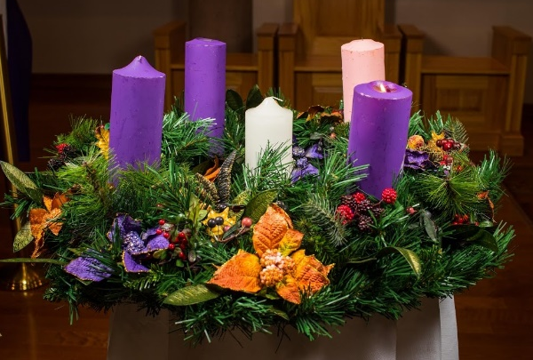
The Advent wreath first appeared in Germany in 1839. A Lutheran minister working at a mission for children created a wreath out of the wheel of a cart. He placed twenty small red candles and four large white candles inside the ring. The red candles were lit on weekdays and the four white candles were lit on Sundays.

Eventually, the Advent wreath was created out of evergreens, symbolizing everlasting life in the midst of winter and death. The circle reminds us of God’s unending love and the eternal life He makes possible. Advent candles are often nestled in the evergreen wreath. Additional decorations, like holly and berries, are sometimes added. Their red colour points ahead to Jesus’ sacrifice and death. Pinecones can symbolize the new life that Jesus brings through His resurrection. Families begin lighting a candle on the fourth Sunday before Christmas, and they light another candle each subsequent Sunday.

There are several traditions about the meaning or theme of each candle. The most utilised in Anglican tradition is:

Advent 1 The Patriarchs  ‘The Patriarchs’ can naturally focus on Abraham, our father in faith, and David, the ancestor in whose city Jesus was born. | Advent 2 The Prophets  ‘The Prophets’ gives an opportunity to reflect on the way the birth of the Messiah was ‘foretold’
Advent 3 John the Baptist  John, who proclaimed the Saviour. | Advent 4 The Virgin Mary  Mary, who bore him in her womb
The (optional) fifth candle represents light and purity and is called "Christ’s candle." It is placed in the middle and is lit on Christmas Day.
A further tradition is below:

The first candle symbolises hope and is called the "Prophet’s Candle." The prophets of the Old Testament, especially Isaiah, waited in hope for the Messiah’s arrival. | The second candle represents faith and is called "Bethlehem’s Candle." Micah had foretold that the Messiah would be born in Bethlehem, which is also the birthplace of King David.
The third candle symbolises joy and is called the "Shepherd’s Candle." To the shepherd’s great joy, the angels announced that Jesus came for humble, unimportant people like them, too. In liturgy, the colour rose signifies joy. | The fourth candle represents peace and is called the "Angel’s Candle." The angels announced that Jesus came to bring peace--He came to bring people close to God and to each other again.
The (optional) fifth candle represents light and purity and is called "Christ’s candle." It is placed in the middle and is lit on Christmas Day.

- Create an advent wreath
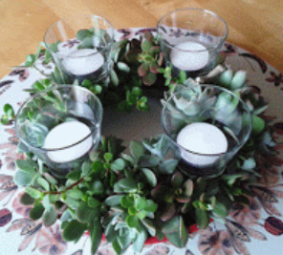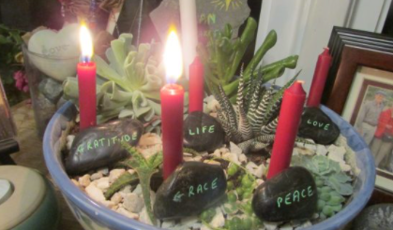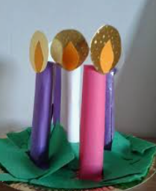

- Look at reading associated with each of the candles. E.g. For the ‘Prophet Candle’, look at some of the Old Testament prophecies and allow children to consider what these prophecies meant.
- Look at how John the Baptist prepared the way for Jesus. Pupils to write a message asking people to prepare for the coming of Jesus using modern means e.g. E-mail, blog, Twitter, rap, etc.

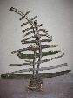
Jesse Tree
A Jesse Tree is a way of preparing for Advent by journeying through the stories on Jesus’s family tree. Each day of Advent, read a Bible story about someone on Jesus’s family tree and hang an ornament symbolising the story on your Jesse Tree. As you decorate your tree, you’ll see how God prepared for Jesus to be born through many generations.

https://www.faithward.org/jesse-tree/jesse-tree-symbols-and-bible-stories/
Follow the link for a complete list of Jesse Tree Bible symbols and the Bible stories that they represent. Because the length of Advent varies, you may not use all the Jesse Tree symbols and Bible stories in the set each year. There are enough symbols here to cover each day between November 27 and December 25.
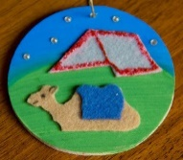
Bible stories could be a daily focus with decorations hung on the Jesse tree (this could be a Christmas tree or bare branches. Pupils could create their own decorations.

Revealing Jesus
Jesus is all over the Bible, concealed in the Old Testament and revealed in the New Testament. In the Old Testament there are many pointers towards Jesus.
Explore some of the hints and prophecies about Jesus:
- Look at some of the Old Testament characters and explore how they might point towards Jesus – look for similarities/hints in the stories
  - Noah (Genesis 6-9)– a righteous man who obeyed God so was saved along with his whole family. Jesus was a more righteous man than Noah and Christians believe that those who follow Jesus are saved too. The rainbow was a sign of God’s promise, today it is the cross.
  - Abraham and Isaac (Genesis 22)– Abraham was asked to sacrifice his much-loved son, Isaac.
  - Joseph (Genesis 37-50)
          - Joseph’s dreams revealed he would achieve high status and as a result bring blessing to others. Jesus was born to rule and because of this many others would find salvation.
          - Joseph was sold for 20 pieces of silver (the going price of a slave). Jesus was sold for 30 pieces of silver (the going price of a slave).
          - Joseph was tempted by Potiphar’s wife. Jesus was tempted by the devil.
          - Joseph forgave his brothers and saved them even after they sinned against him and tried to harm him. Jesus forgave those who crucified him.
  - Moses (Exodus 3, 14, 32)– Moses rescued the Israelites who were slaves, but they complained about their lives and began to worship other gods. God was angry and wanted to destroy them but Moses pleaded with God to be wiped out in their place.
  - David (1 Samuel 17; Psalm 22)– David was born in Bethlehem as was Jesus. Davis was anointed to be king of Israel. Jesus was called King of the Jews at his crucifixion. Psalm 22 is a prophecy about the death of Jesus. Where do the students see Jesus in this Psalm? Use gospels Matthew 27: 41-43, John 19:28, Luke 23:34

- Explore some of the prophecies. Have they been fulfilled?
- The Messiah will be born in Bethlehem Micah 5: 2-5a
- He will be King Isaiah 9: 6-7; Daniel 7:13-14; Zechariah 9:9
- He will be a descendant of David/Family Lineage Samuel 7: 12-16; Psalm 132:11; Jeremiah 23:5-6; Jeremiah 33:15; Isaiah 11:1; Numbers 24:17
- He will be born of a Virgin Isaiah 7:14
- He will be a priest Zechariah 6:11-13, Psalm 110:4
- He will be Lord Psalm 110:1
- He will be God Isaiah 9:6, Jeremiah 23:6
- He will bring salvation Isaiah 49:6, Zechariah 9:9
- He will atone for sins Isaiah 53:4-6, Isaiah 53:7-8, Isaiah 53: 10-12
- He will heal the sick/preach the good news Isaiah 61:1, Isaiah 35:5-6
- He will teach in parables Psalm 78:2
- He will be a liht to the Gentiles Isaiah 42:6, Isaiah 49:6
- He will enter Jerusalem riding a donkey Zechariah 9:9
- He will be rejected/mocked/suffer and die Isaiah 53:1-3, Psalm 118:22, Psalm 22:7-8, Psalm22: 16-18, Psalm 22:30
- He will be betrayed by a friend Psalm 41:9
- He will be betrayed for 30 pieces of silver Zechariah 11:12
- He will be beaten, mocked and spat upon Isaiah 50:6
- His bones will not be broken Psalm 34: 19-20
- He will be raised from the dead Isaiah 53: 8-12, Psalm 16:10, Psalm 49:15
- He will ascend to heaven Psalm 68:18

Advent Calendar
- Interactive Advent Calendar from CAFOD. Each day has a Biblical reflection and an action.

Reverse Advent Calendar
Reverse advent calendars work by you filling them every day with items of food or clothing that can then be taken to a food bank or charity in order to help those less fortunate that are struggling at Christmas time. It more importantly teaches the importance of helping others and seeing the bigger picture at Christmas.

