Resources from Blackburn Diocese Board of Education Team
www.bdeducation.org.uk

A brand new video resource, ‘Off the Shelf’ is designed to be used as collective worship in schools and at home with themes specifically relevant at this time. There are also ‘Off the Shelf’ picture posts and an RE resource is being created alongside that and will be available soon. Each of these resources asks big questions and challenges the viewer to reflect and make a response. Available on our Facebook page and website.
As well as that the Children’s and Youth teams in the diocese have produced some fantastic resources, click on the links below to check those out: (ctrl & click to follow the links)
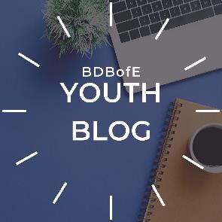
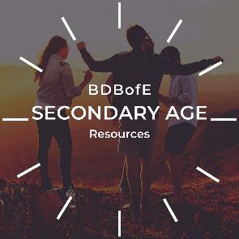
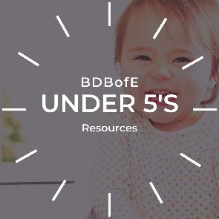

The team have been working hard to adapt many of the church focused resource to being home focused and for parents to use with their children and young people. The best way of keeping up with the new resources and those being adapted is through their Social Media pages, the links for which are below. (ctrl & click to follow the links)

Jesus Himself faced cataclysmic threats. Herod was always out to kill him. I love his advice when living under that threat: “Do not worry about tomorrow, for tomorrow will worry about itself. Each day has enough evil of its own” (Matt 6.34). May our Good Father give His peace and wisdom to parents and children at this time.

Bishop Jill, 26.3.20

