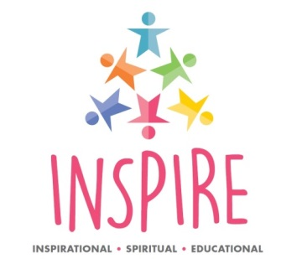
Year 6 1st-5th June 2020
Year 8 8th-12th June 2020
Year 4 18th–22nd May 2020

Application Form 2020
What does it ‘Mean to be Human’?
Join us at Lichfield Cathedral and be INSPIRED for the day through interactive, inspirational, spiritual, reflective & deep learning.
Join the team from the Diocesan Board of Education and the Cathedral Education Team to engage in high quality learning experiences including:
- Reflecting with WISDOM around the question of what it means to be human
- Engaging in the art of the cathedral as a means of expressing HOPE
- Experiencing the use and science of music to express COMMUNITY
- Considering the importance of DIGNITY and responsibility in being human
Inspire will also be a great opportunity to:
- Experience the awe and wonder of Lichfield Cathedral
- Meet with Christians and discover how their faith influences their lives.
- Meet with other schools and share experiences.
- Reflect on some of the big questions facing us today.

School / Academy
Address
Contact
email address
Telephone number
Number of pupils and Year Group
If wishing to attend on the same day as another school/academy please give details
Signature and Date of application
Application forms should be returned to Paula Lloyd, LDBE
1 Three Spires House, Station Road, Lichfield. WS13 6HX Paula.lloyd@lichfield.anglican.org
by Friday 25th October 2019

