Mission – a scheme of work

Welcome
Our diocesan motto calls us to: Come follow Christ in the footsteps of St Chad. Chad is known as a humble man, with a peaceful and servant heart who came to Mercia in order to build bridges of trust, kindness and service across the barriers which divided both his own society and also the wider world.
In this scheme of work we are encouraging our pupils to also follow in Chad’s footsteps and to become courageous advocates – recognising injustice, identifying the causes and acting accordingly by serving the common good.

Using the Scheme of Work
Although you are obviously free to use the scheme of work however you feel fits best with your school we do have some ideas on how it could be used:
- As part of a creative curriculum approach to teaching and learning
- As transition work for years 4, 6 and 8
- A RE focused week
- An end of term, post SATS, year 6 focus project

Church of England Vision for Education
The Church of England’s vision for education: ‘Deeply Christian - Serving the Common Good’ has Jesus' promise of 'life in all its fullness' at its heart. It is about ‘educating the whole person’, what the 1988 Education Reform Act sees as physical and intellectual development united with spiritual, moral, social and cultural development.
In line with this vision the scheme encourages all to work for the common good of the whole community. This is all underpinned by the four key SIAMS strands of ‘Wisdom, Hope, Community and Dignity,’
Wisdom – good schools foster an enthusiasm for both learning and life but enthusiasm without wisdom is a dangerous thing. In our schools we want to see children and young people who are enthusiastic about learning but who have wisdom to know what to do with that knowledge in order to best serve each other and the world that we all share.
Hope – it is easy to look at the world we live in and see things as ‘hopeless.’ Yet the Christian gospel is one of hope. Good schools encourage their pupils to live lives of hope and aspiration where the individual understands what it means to have a unique calling on their life – a calling that includes: ‘to act justly and to love mercy and to walk humbly with your God.’ (Micah 6)
Community - We are only persons with each other: our humanity is ‘cohumanity’, inextricably involved with others, utterly relational, both in our humanity and our shared life on a finite planet. If those others are of ultimate worth then we are each called to responsibility towards them and to contribute responsibly to our communities. The good life is ‘with and for others in just institutions’ (Paul Ricoeur). So education needs to have a core focus on relationships and commitments, participation in communities and institutions, and the qualities of character that enable people to flourish together (taken from the Church of England’s Vision for Education)
Dignity - Human dignity, the ultimate worth of each person, is central to the Christian faith and is at the heart of all good schools. The recognition of another’s worth must always lead to positive action, this is especially relevant in times of need – inaction is never an option. (Luke 10: 25-37)

Core SIAMS Links
Within the new SIAMS framework, which came into effect from the Autumn Term 2018, the strand, “Character development: hope, aspiration and courageous advocacy,” assesses:
- How well does the school community connect their charitable activities to their vision and associated values? Do leaders provide opportunities for all pupils to engage in social action and understand how they can challenge injustice?

This scheme of work will go a long way in helping to address this aspect of the SIAMS framework as we work together to encourage our young people to aspire to be the best that they can be, living as global citizens and addressing the needs of others.

Organisations that are mentioned in this document:
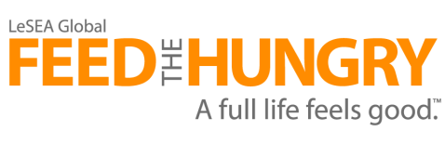
Feed the Hungry does exactly what its name suggests. Over 172,000 children are now receiving hot, nutritious meals every day in 21 countries around the globe, as of December 2017 through Feed the Hungry. Children are supported through the support outreach programme Every Child, Every Day and its partner agency Life Rice.
In addition to emergency relief efforts that bring aid to people caught in the grip of natural disaster, war, and endemic poverty, Feed the Hungry provides nutritional security to some of the most vulnerable children in the world. Through Every Child, Every Day centres in twenty-one nations, thousands of children receive a hot meal prepared daily by a network of volunteers. The guarantee of a daily meal gives these boys and girls a chance to get a primary education and gives them hope for a better, brighter future. And since these meals are delivered through local church partners the children also receive spiritual nourishment to help them grow in Christ.
Feed the Hungry directly oversees the entire relief process to make sure all contributions get into the hands of those who need it most—when they need it most. Before distributing food, they secure guarantees from government agencies, giving them the right to distribute food directly through local churches who know the people—and the need—in their communities. Under their direction and leadership, food is distributed as intended. Even more important, Christ is shared with hurting people who need to hear of His love!
The Jo Cox Foundation, as an MP, Jo didn't believe any issue was so intractable that it had to be left on the 'too difficult pile'. The foundation believes ‘in working together with individuals and organisations that share the commitment to a fairer, kinder and more tolerant world.’
They ‘seek to amplify the voices of all those who believe that compassion, understanding and optimism are signs of strength and not weakness.’
The Foundation exists to guide people towards those who are working on the things Jo was passionate about. This includes people who know that it is not enough just to talk about what can make communities stronger or to complain about injustice, indifference or cruelty. In this sense the Foundation works as a catalyst for change.
Place of Welcome is a growing network of hospitality run by local community groups who want to make sure that everyone in their area has a place to go for a friendly face, a cup of tea and conversation. The guiding principles for all Places of Welcome:
Place: An accessible and hospitable building
People: Open to the local community and staffed by volunteers
Presence: A place where people actively listen to one another
Provision: Offering free refreshments
Participation: Recognising that every person coming to a Place of Welcome will bring talents, experiences and skills that they might be willing to share locally.
To find our more, visit: http://www.placesofwelcome.org/

Mission – Lower Key Stage 2

Key Bible passage - Luke 10:25-37, The Good Samaritan
²⁵ Then a teacher of the law stood up. He was trying to test Jesus. He said, “Teacher, what must I do to get life forever?”
²⁶ Jesus said to him, “What is written in the law? What do you read there?”
²⁷ The man answered, “Love the Lord your God. Love him with all your heart, all your soul, all your strength, and all your mind.” Also, “You must love your neighbour as you love yourself.”
²⁸ Jesus said to him, “Your answer is right. Do this and you will have life forever.”
²⁹ But the man wanted to show that the way he was living was right. So he said to Jesus, “And who is my neighbour?”
³⁰ To answer this question, Jesus said, “A man was going down the road from Jerusalem to Jericho. Some robbers attacked him. They tore off his clothes and beat him. Then they left him lying there, almost dead. ³¹ It happened that a Jewish priest was going down that road. When the priest saw the man, he walked by on the other side of the road. ³² Next, a Levite came there. He went over and looked at the man. Then he walked by on the other side of the road. ³³ Then a Samaritan traveling down the road came to where the hurt man was lying. He saw the man and felt very sorry for him. ³⁴ The Samaritan went to him and poured olive oil and wine on his wounds and bandaged them. He put the hurt man on his own donkey and took him to an inn. At the inn, the Samaritan took care of him. ³⁵ The next day, the Samaritan brought out two silver coins and gave them to the innkeeper. The Samaritan said, ‘Take care of this man. If you spend more money on him, I will pay it back to you when I come again.’”
³⁶ Then Jesus said, “Which one of these three men do you think was a neighbour to the man who was attacked by the robbers?”
³⁷ The teacher of the law answered, “The one who helped him.”
Jesus said to him, “Then go and do the same thing he did!”

Resources:
BBC Bitesize: https://www.bbc.co.uk/education/clips/zfk8mp3
RE:quest: http://request.org.uk/restart/2015/06/30/story-time-the-good-samaritan/

Aims:
- Wisdom - To discuss what Jesus meant by the commandment ‘Love your neighbour.’
- Hope – To discover ways that we can inspire others to offer acts of love into seemingly hopeless situations. And in doing this raise the aspiration for our own lives.
- Community – To work as a community to offer acts of love to ‘our neighbours.’
- Dignity – To recognise the many factors in the world that can work to destroy a person’s sense of dignity. To identify ways that our acts of love can help to restore that dignity.

Step into the text – Wisdom

You could begin by thinking about what it means to ‘love.’ What does love look like?’ Look at and discuss some typical images of people showing love –giving flowers, hugging, helping or laughing together… Ask the pupils if they think any of the images represent the love that Jesus was talking about here. Consider what it means to ‘love our neighbours.’ (Note in the original translation the phrase can be translated to read ‘do acts of love towards your neighbour’).
Have the pupils design or find an image that they think best demonstrates the type of love/kindness that Jesus was teaching about.
Discuss a time when they carried out an act of kindness towards someone else – how did they feel? How did the other person feel?
Discuss a time when someone did an act of kindness towards them – ask the same questions.
Discuss the point of why it was so radical for the time that the hero of Jesus’ story was a Samaritan. In order to do this first look at what we know about the characters but also remember that Jews and his audience were all Jews.

Priest
- Regarded highly by the people
- Jewish religious leaders
- Jewish political leaders
- Worked in the temple
- Thought themselves above anyone else
- Lived be strict rules
- Trained in law
- Would have nothing to do with Samaritans

Levite -
- Were considered highly in Jewish society
- Worked in the temple
- Served as religious guards
- Organised the temple music
- They arrested Jesus
- They cleaned the temple
- They prepared the sacrifices in the temple
- Would have nothing to do with Samaritans

Samaritans
- Known as enemies of the Jews
- Had no dealings with the Jews
- Neighbours to the Jews

Split the class into three groups. Have the following questions written on a large piece of paper:
- From the parable, what do you think the main lesson was that Jesus was teaching his audience?
- What is the main lesson we can take from the parable for our own lives?
- How are we to treat others – even those who we would not naturally be friends with?
Pass the questions around the groups – giving each group time to discuss each question and record their answers. They can star any answer that has already been written and that they agree strongly with.

Leading from this activity the pupils could create a story with an unexpected hero in it – this could then be acted out, turned into a cartoon, presented as a book or turned into a story-telling session.

Feed the Hungry – Hope
Leading on from the work around the parable of the Good Samaritan, the question to answer now is, ‘Who is my neighbour?’
The organisation ‘Feed the Hungry’ https://feedthehungry.org.uk/ lives by the principle that anyone who is in need is ‘my neighbour.’ But before you find out more about their work see how much you know about some of the countries where they work.
Cut out the cards and see if the children can match them back into their sets.
Sri Lanka | Kenya | China | Haiti
Flag: | Flag: | Flag: | Flag:
Say ‘hello’:  Ayubowan | Say ‘hello’:  Jambo | Say ‘hello’:  Ni hao | Say ‘hello’:  Bonjou
Capital city:  Sri Jayawardenepura Kotte | Capital city:  Nairobi | Capital city:  Bei Jing | Capital city:  Port-au-Prince
Traditional art: | Traditional art: | Traditional art: | Traditional art:

From the list below, research in some depth one of the countries, in which Feed the Hungry work. You could decide to look at just one country for the whole class or allow groups to choose their own.
1. BURKINA FASO  2. BURUNDI  3. CAMBODIA  4. CHINA  5. HAITI  6. KENYA  7. LESOTHO | 8. LIBERIA  9. MALAWI  10. MONGOLIA  11. NICARAGUA  12. NORTH KOREA  13. PHILIPPINES  14. SRI LANKA | 15. SOUTH SUDAN  16. THAILAND  17. UGANDA  18. UNITED STATES  19. ZAMBIA  20. ZIMBABWE
For an electronic map of the countries use the link below. https://fusiontables.googleusercontent.com/embedviz?q=select+col1+from+18BNdW6t9SBtpUaaw6YrfueEemLA444-c7PVydPvx&viz=MAP&h=false&lat=11.313061007447791&lng=-160.69008914999995&t=1&z=2&l=col1&y=1&tmplt=1&hml=TWO_COL_LAT_LNG .
Using geography and general research skills, find out key facts about the country then think of creative ways to present the findings. This could include pupils producing their own set of cards for the country and putting them together to create a class card game.
Questions for research could include:
- Where is it on a map?
- What is the weather like around the year?
- What crops grow there?
- Do the majority of people in this country have access to the essentials to life?
- What do most people eat in the country? Is there a regular supply of this food?
- What are the main problems the country face? What could be some solutions to these problems?
- What is the country famous for?
- What are the levels of poverty in the country?
Find out the type of work that Feed the Hungry are doing in particular countries to bring hope to what appears to be a hopeless situation. https://feedthehungry.org.uk/our-impact/field-reports/
Or watch the film: https://www.youtube.com/watch?v=uKgQBPkezck
For other clips visit: https://www.youtube.com/user/feedthehungryuk
(To find out more about the organisation and the work that they do visit https://feedthehungry.org.uk/lessons/ – the PowerPoint and script are useful resources for this).
Record your findings in a creative way that will inspire others to find out more about the work of Feed the Hungry and the needs there are in so many countries around the world. You may want to:
- Try using Aurasma (https://www.youtube.com/watch?v=T_yzHNLhZGk) as a fun and creative way to bring your report to life.

- 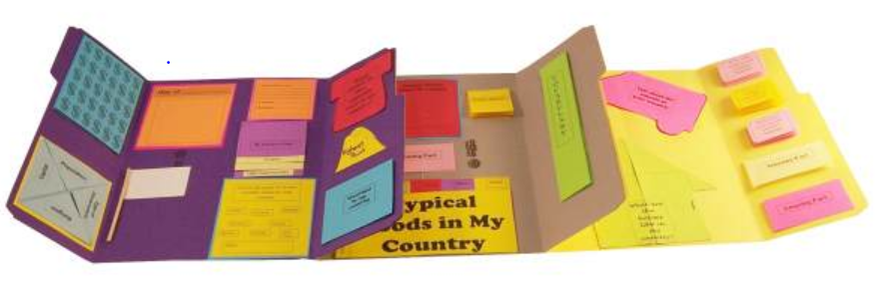 Or more traditionally - get creative with a lap book.

- Pupils could create a shoebox diorama of a famous landmark in the country or a place of interest that you have learnt about.

- A model or poster could be created that compared and contrasted your local area with the country that is being studied. Allow the pupils the time to discuss the advantages and disadvantages of both areas.
Consider whether your research has caused you to aspire to make a difference– why or why not?
What is the main thing you and your school could do to help bring hope to others around the world?

Feed the Hungry – Dignity
As you have been exploring, the main message of the parable of the Good Samaritan is, to ‘love your neighbour.’ And by neighbour, this literally means anyone and everyone but especially those in need. You have also looked at how Feed the Hungry is trying to fulfil this commandment in the work that it is doing. The question now is how can you follow the same example and ‘love your neighbour,’ and in doing so help people to be treated with the dignity and respect they deserve.

Joining the work of ‘Feed the Hungry’

Your school may or may not be in the position where raising money for ‘Feed the Hungry’ is appropriate. Whether fund raising is an option or not, the children could still become ‘courageous advocates’ by raising the profile of the organisation or simply making people aware of the urgent need to tackle the issue of poverty and hunger around the world. This could be done in a number of different ways:

Include prayers for the countries and work of Feed the Hungry or set up a prayer focus area in your school https://feedthehungry.org.uk/act/pray/

Allow the pupils to plan and lead a worship / assembly on the research they have done. There are ideas to help here https://feedthehungry.org.uk/lessons/

Invite a speaker in from Feed the Hungry. For more details contact Rachel Bird: rachel@feedthehungry.org.uk

Encourage the pupils to write letters to your local MP, newspaper, radio or BBC news explaining the work they have done and asking for their help in tackling the issues of poverty and hunger.

Arrange for a display of the pupil’s work to be put up either in the school or a local community building (e.g. church, library, and village/town hall). If appropriate the pupils could act as guides for this.

If it was appropriate for the pupils to raise money for ‘Feed the Hungry’ there is a downloadable fundraising pack that can be used to help with ideas https://feedthehungry.org.uk/schoolsfundraisingpack/ and also advertising posters etc. https://feedthehungry.org.uk/downloadables/

Dignity item collections and Kindness Kits for children (https://feedthehungry.org.uk/kindnesskit/ ) As well as food, Feed the Hungry are also involved in the distribution of essential ‘dignity’ items and Kindness Kits. For more information about these two different ways of showing you care please follow the link above or see the leaflets below:

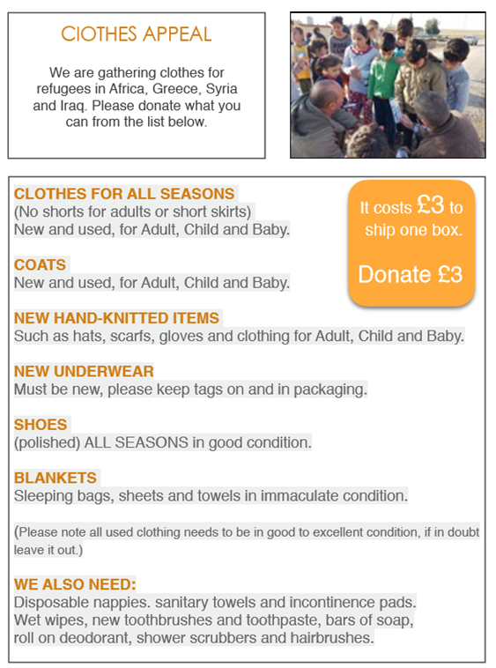

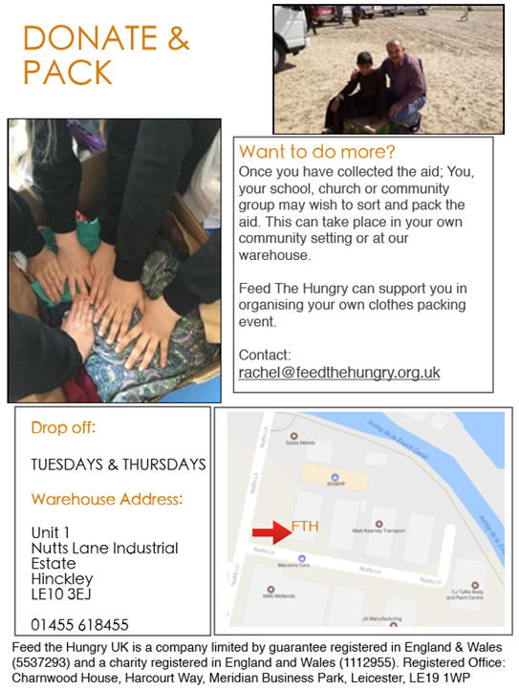

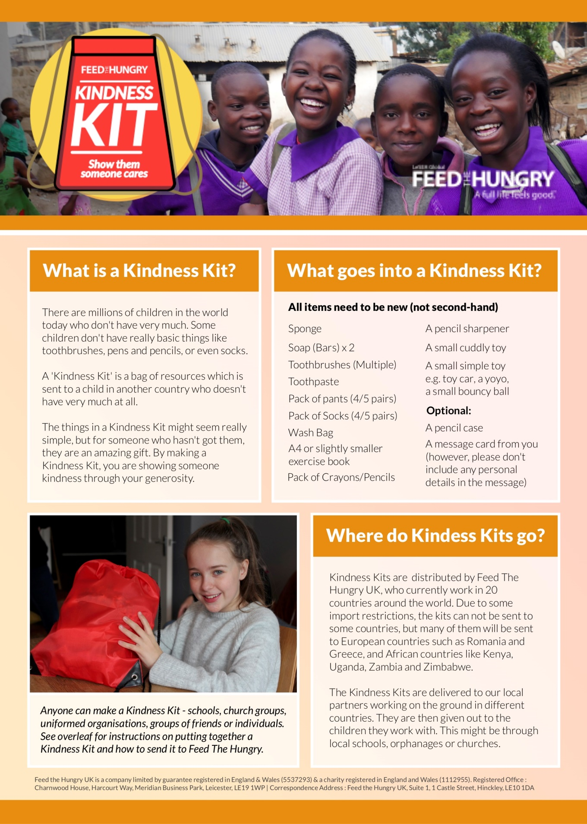

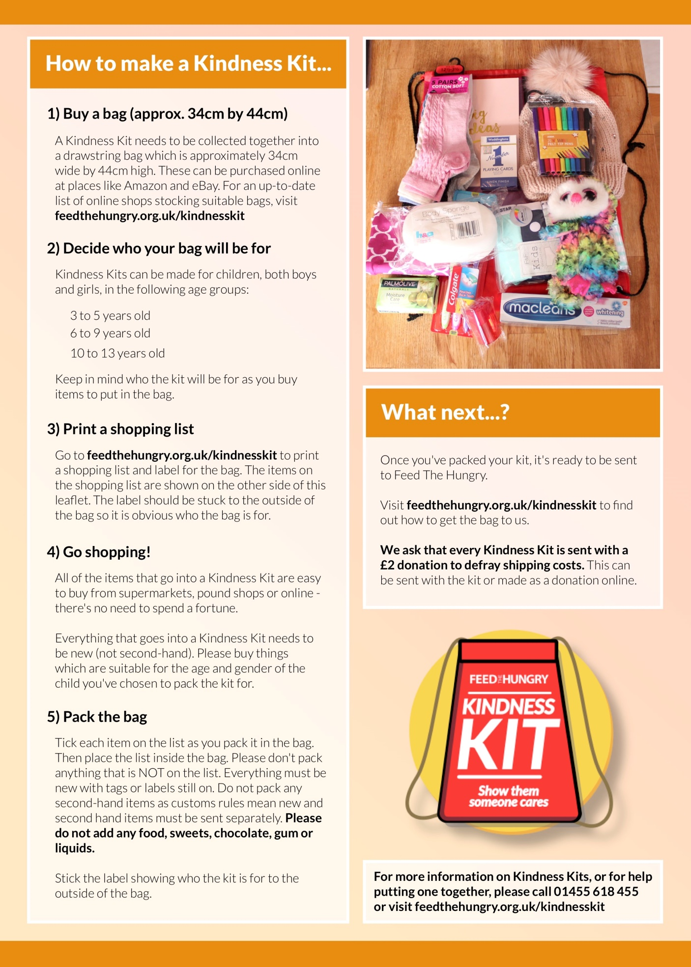

The Big Community Food Pack - Hands-on international aid work, UK
This would be a challenge for a group of schools to take on alongside their local churches and community.
Feed the Hungry are hosting food packings events around the UK. They are looking for individuals and teams to come and join in this awe inspiring project to help those in need in some of the poorest countries. As part of the work that Feed the Hungry does, they need to make up food packages that are then shipped out to their partner schools all around the world, as you can imagine this is no small venture. One way that you can help with this is to organise a food pack. For an idea of what this may look like visit: https://www.youtube.com/watch?v=uKgQBPkezck
If you wanted to take on this amazing challenge then you would need to work closely with Feed the Hungry who would bring along the food, equipment and transport. For your part you would need to raise £1950, this would cover the cost of food for 10,000 meals and provide the volunteer packers. We appreciate this is a massive commitment on your part but if you do want to know more please contact Paul on: foodpack@feedthehungry.org.uk
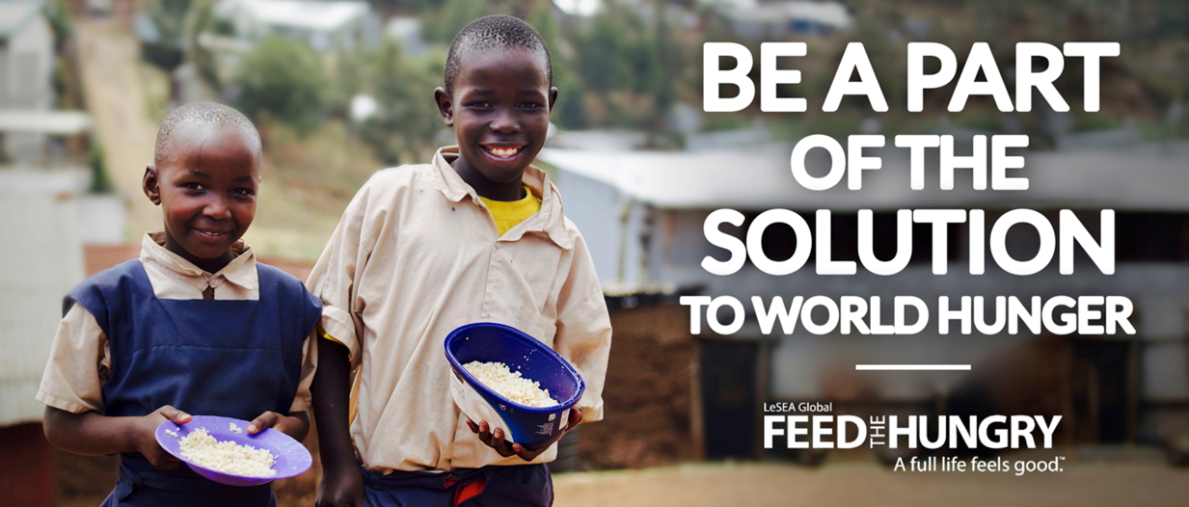
What is the main thing that you and your school could do to ensure that all people around the world, including in your local community, are treated with the dignity and respect they deserve?

Jo Cox Foundation – Community
‘Love your neighbour…’
So far we have looked at the issue of what it means to ‘love our neighbours’ in regards to those in need around the world and yet even in the local community there will be those who are in need. The ‘Jo Cox Foundation’ has been set up to champion the causes that Jo was passionate about. One of the main issues they are focusing on is loneliness. The Foundation is continuing the work of the Loneliness Commission that Jo established to bring about a step change in the public policy response to the UK's loneliness crisis. The Foundation has been working to highlight the issue of loneliness amongst different groups and encouraging ways that communities can come together to tackle this issue. https://www.jocoxfoundation.org/the-issues
Leading on from the work based around the parable of the ‘Good Samaritan,’ the pupils could work on organising an event that brings the local community together. This could be an event that focuses on one particular group or on the community as a whole. The pupils could be involved in every aspect of the organisation – costing, amounts needed, invitations, catering, hosting, decorations,
- Beat the Streets – organise a walk around your local area that could end at your school where people could be offered drinks and cakes / soup.
- Organise a Street Party – this could be in your school grounds
- A tea dance – if you have a particularly elderly population the pupils could organise a traditional tea dance for them.
- Around the world in 80 dishes – If your school is in a multi-cultural area you could organise cooking demonstrations from various cultures or have a food carnival where people can come along to taste the food. This could also lead on to producing a recipe book that you sell as a fund raiser.
- Organise a Community Quiz – money raised could also go towards a local community project.
- Local Community Fair– This would run almost like a careers fair but to advertise local organisations / groups. This could include anything from Cubs/ Scouts, football clubs, U3A groups, ‘knit and natter’ groups to the local health workers or counsellors. This could be a way for people to get to know what is happening in their community.
- A craft morning – have a wide range of craft activities available for people to have a go at. If there are local groups or individuals that are able to help with this ask them to get involved. This could be a great opportunity for people to find a new hobby or even to be encouraged to set up new local groups if there is an obvious need.

Places of Welcome – Community
‘Love your neighbour’
Hospitality is at the heart of Christian community and is one of the main ways to show love and concern for our neighbours whilst tackling the ever increasing problem of loneliness. This “social epidemic” is an issue that the Jo Cox foundation has strived hard to combat. The final report of the Jo Cox Loneliness Commission found that nine million adults in the UK are often or always lonely and that loneliness is as harmful to health as obesity or smoking 15 cigarettes a day.
Places of Welcome is a growing network of hospitality run by local community groups who want to make sure that everyone in their area has a place to go for a friendly face, a cup of tea and a conversation if and when they need it.
The primary aim of the Places of Welcome network is that “Every neighbourhood has places where all people feel safe to belong, connect and contribute.” http://www.placesofwelcome.org/

By establishing your school as a ‘Place of Welcome’ you would be creating stronger community links as well as ensuring a safe place for the wider school community to meet. If possible, a ‘Place of Welcome’ could be established directly in your school. To begin with this may be something simple that operates a couple of times a term and is open to parents, carers or family members at the beginning or the end of the day. If you do not have the means to facilitate this within your school maybe your local church or community centre would be willing to partner with you on it. Where appropriate this could be linked with an open clinic with the community nurse or health worker.
Older pupils could be actively involved in welcoming people and helping to provide the refreshments and possibly even entertainment.

Cross Curriculum Links
Year 4
English
- reading books that are structured in different ways and reading for a range of purposes discussing words and phrases that capture the reader’s interest and imagination
- asking questions to improve their understanding of a text
- identifying main ideas drawn from more than 1 paragraph and summarising these
- identifying how language, structure, and presentation contribute to meaning
- retrieve and record information from non-fiction plan their writing by:
- discussing writing similar to that which they are planning to write in order to understand and learn from its structure, vocabulary and grammar
- discussing and recording ideas
- draft and write by:
- composing and rehearsing sentences orally (including dialogue), progressively building a varied and rich vocabulary and an increasing range of sentence structures English appendix 2
- organising paragraphs around a theme
- in non-narrative material, using simple organisational devices [for example, headings and sub-headings]
- evaluate and edit by:
- assessing the effectiveness of their own and others’ writing and suggesting improvements
- proofread for spelling and punctuation errors
- read their own writing aloud to a group or the whole class, using appropriate intonation and controlling the tone and volume so that the meaning is clear

Maths
- solve simple measure and money problems involving fractions and decimals to 2 decimal places
- estimate, compare and calculate different measures, including money in pounds and pence
Science
- gathering, recording, classifying and presenting data in a variety of ways to help in answering questions
- recording findings using simple scientific language, drawings, labelled diagrams, keys, bar charts, and tables
- identifying differences, similarities or changes related to simple scientific ideas and processes
- recognise that environments can change and that this can sometimes pose dangers to living things
Art and Design
- to create sketch books to record their observations and use them to review and revisit ideas
- explore traditional art from the countries you have been looking at – by using the same style produce a piece of work that highlights the work that you have been doing
Geography
- locate the world’s countries
- physical geography, including: climate zones, biomes and vegetation belts, rivers, mountains, volcanoes and earthquakes, and the water cycle
- human geography, including: types of settlement and land use, economic activity including trade links, and the distribution of natural resources including energy, food, minerals and water use maps, atlases, globes and digital/computer mapping to locate countries and describe features studied

Mission – Upper Key Stage 2

Key Bible passage - Matthew 25:34-46 The Sheep and the Goats
³⁴ “Then the King will say to the good people on his right, ‘Come. My Father has given you his blessing. Come and receive the kingdom God has prepared for you since the world was made. ³⁵ I was hungry, and you gave me food. I was thirsty, and you gave me something to drink. I was alone and away from home, and you invited me into your house. ³⁶ I was without clothes, and you gave me something to wear. I was sick, and you cared for me. I was in prison, and you visited me.’
³⁷ “Then the good people will answer, ‘Lord, when did we see you hungry and give you food? When did we see you thirsty and give you something to drink? ³⁸ When did we see you alone and away from home and invite you into our house? When did we see you without clothes and give you something to wear? ³⁹ When did we see you sick or in prison and care for you?’
⁴⁰ “Then the King will answer, ‘I tell you the truth. Anything you did for any of my people here, you also did for me.’
⁴¹ “Then the King will say to those on his left, ‘Go away from me. God has said that you will be punished. Go into the fire that burns forever. That fire was prepared for the devil and his helpers. ⁴² I was hungry, and you gave me nothing to eat. I was thirsty, and you gave me nothing to drink. ⁴³ I was alone and away from home, and you did not invite me into your house. I was without clothes, and you gave me nothing to wear. I was sick and in prison, and you did not care for me.’
⁴⁴ “Then those people will answer, ‘Lord, when did we see you hungry or thirsty? When did we see you alone and away from home? Or when did we see you without clothes or sick or in prison? When did we see these things and not help you?’
⁴⁵ “Then the King will answer, ‘I tell you the truth. Anything you refused to do for any of my people here, you refused to do for me.’

Resources:
You tube: https://www.youtube.com/watch?v=iWSkdx-XwWY animated retelling of the parable

Aims:
- Wisdom - To discuss what Jesus meant by the statement, ‘I tell you the truth. Anything you did for any of my people here, you also did for me.’ And the implications of this on how we may decide to live.
- Hope – To discover ways that we can inspire others to offer acts of love and hope to all people, regardless of their background or their ability to return the favour. And in doing this raise the aspiration for our own lives.
- Community – To work as a community to reach out to the needs of those around us.
- Dignity – To recognise the many factors in the world that can work to destroy a person’s sense of dignity. To identify ways that our acts of love can help to restore that dignity in a sustainable way.

Step into the text – Wisdom

The Bible passage talks about acts of kindness and love that people have offered to others, ‘I was hungry, and you gave me food. I was thirsty, and you gave me something to drink. I was alone and away from home, and you invited me into your house. I was without clothes, and you gave me something to wear. I was sick, and you cared for me. I was in prison, and you visited me.’
You may want to begin by thinking about acts of kindness that the pupils have offered to others. What motivated them? How did it make them feel? How did it make the recipient feel?
Discuss whether they (or someone they were with) have ever done an act of kindness for a complete stranger? What was the motivation there? Was it different from before? What were the emotions involved – were they different?
From this parable ask the questions: What must have been going on at the time for Jesus to have told this parable? How do you think people were behaving towards one another? Looking at the parable, does Jesus take the treatment of others seriously? Why do you think this? In light of this parable, what do you think we can learn about how we should treat others?
Knowing what the right thing to do isn’t always easy. We have to make hundreds of decisions each day about how we should behave and the things that we should say but do we always think about how they could impact others. Play the ‘The Sheep and Goat Scenario Debate’ as a fun way of thinking about the choices we make:
- Your friend asks if they can borrow your new colouring pencils – they are new and some you haven’t even used yet. What would you do?
- You are running late for school and when you arrive everyone else has already gone in. As you come to the school gates you find £5 on the pavement. No-one is there to see you pick it up.
- You are in such a rush that you forget to give the £5 in! Later that day, when the whole school is in worship, there is a message given out that a boy from one of the younger classes has lost some money and is really upset. What would you do now?
- A new pupil has started in your class. At break time they are all on their own, you go up and ask if they want to join your group of friends. They say that they are OK and walk off. They look really sad and lonely. What would you do?
- It is a special PE lesson and you have been chosen to be the team captain and what is more, you get to choice who is on your team. What would you do?
- A wing mirror from a car that was parked outside your school was broken last night and you know who has done it. The following day you find out that someone has got the blame for the broken mirror and they are in real trouble but you know it wasn’t them. What would you do?
Conclusion – watch the film and think about how ‘being a sheep’ can have a massive impact on those around you.
https://www.youtube.com/watch?v=PT-HBl2TVtI This is a short film that demonstrates the positive impact one person can have by showing kindness to another person.

Feed the Hungry – Hope
In the parable both the ‘sheep’ and the ‘goats’ were faced with the same situations and they both had choices to make – to help or not to help. This is not always an easy choice to make – in giving to someone else it could mean that you have to go without something that you want. What’s more, if we are going to be honest, it is not always easy to know the best way to help either.
Consider how deciding to give money to someone in need could be a difficult decision to make. Order the statements below with those that you think are most relevant at the top.
It is always important to give to those in need. | It is better to give to organisations rather than to individuals. | If I was in need I would want someone to help me.
You should never feel pressured to give to charity. | You should never give money to someone you don’t know. | It is better to give food or clothes than money.
There are too many people in need – I can’t make a difference. | It is governments that should be helping not ordinary people. | Working together we can make a big difference.

The organisation ‘Feed the Hungry’ https://feedthehungry.org.uk/ lives by the principle that we should do all that we can to help others – whether that means your best friend or a stranger in need. However even an organisation like Feed the Hungry can be faced with the decision on what the best way to help is. Is it best to deal with the immediate need, in a quick and effective way or is it best to find a sustainable solution?

Sustainable Farming – sustainable hope for the future
There is a saying, ‘If you give a man a fish, you feed him for a day. If you teach a man to fish you feed him for life.’ Discuss why this would be a good model for solving some of the issues that face the poorest countries and giving them hope for the future.
Feed the Hungry recognises that to simply send food is only a short term solution to a much bigger problem and so they are working with local people to develop a sustainable solution. To find out more about this work visit:
https://www.youtube.com/watch?v=CDKHlvsBjcQ
https://www.youtube.com/watch?v=WGJWrkkJncM
https://www.youtube.com/watch?v=FR2Q9pVGxFU
https://www.youtube.com/watch?v=PCRqNfUXdTQ
https://www.youtube.com/watch?v=fcBQobJBUKE

Sustainable Farming Board Game
Use this game to discuss the problems that face many poor countries and the hope that projects like the one set up by Tebuho Mulala in Zambia offer: https://feedthehungry.org.uk/zambia/
54  Hope | Floods come. Go back 2 | 52 | 51 | You can afford medicine Move on 2 | 49
48 | 47 | Able to sell some of your crops Move on 4 | 45 | 44 | Outbreak of diarrhoea. Go back 2
37 | Volunteers help at the school. Move on 3 | 39 | 40 | 41 | 42
36 | 35 | 34 | Civil unrest breaks out. Go back 2 | 32 | 31
Farm food feeds the school Move on 2 | 26 | 27 | 28 | 29 | Crops fail. Go back 2
24 | 23 | 22 | Buy a well for your village. Move on 4 | 20 | 19
13 | 14 | Set up a village farm. Move on 2 | 16 | 17 | No clean water in the schoolhttps://kidsgardening.org/about-us/. Go back 2
12 | Make money from pigs. Move on 2 | 10 | 9 | Too hungry to learn. Go back 2 | 7
1  start | 2 | 3 | Famine has hit. Go back 2 | 5 | 6

Feed the Hungry – Dignity
As you have been exploring, the main message of the parable of the ‘Sheep and Goats’ is the importance of loving and serving others. You have also looked at how Feed the Hungry is trying to fulfil this in the work that it is doing. The question now is how can you follow the same example and ‘love and serve those that you meet – restoring hope and dignity to all?’

Joining the work of ‘Feed the Hungry’

If it was appropriate for the pupils to raise money for ‘Feed the Hungry’ there is a downloadable fundraising pack that can be used to help with ideas https://feedthehungry.org.uk/schoolsfundraisingpack/ and also advertising posters etc. https://feedthehungry.org.uk/downloadables/ . However your school may not be in the position where raising money for ‘Feed the Hungry’ is appropriate yet the children could still become ‘courageous advocates’ by raising the profile of the organisation or simply making people aware of the urgent need to tackle the issue of poverty and hunger around the world. For ideas on how this can be done please see the scheme of work for Lower Key Stage 2.

School Garden
In order for the pupils to gain a better understanding of the issues that the farmers face you could set up a school garden with the aim of selling the produce or supplying the school kitchen or even become part of the ‘Community Fridge Network.’ https://www.hubbub.org.uk/Event/community-fridge-network
The pupils could plan which crops to grow, work out when they would need to be planted and which ones are likely to make more of a profit. They will also need to learn about the hard work it takes to maintain the garden and how to cope when things go wrong.
For ideas for your garden visit:
https://www.nsalg.org.uk/growing-advice/how-to-plan-an-allotment/design-a-childrens-allotment/
There are more ideas here, even if you only have space for a window sill garden:
https://schoolgardening.rhs.org.uk/school-stories?stype=&regionID=&region=&ageGrpID=undefined&ageGrp=&storyTypeID=&storyType=&page=1
https://kidsgardening.org/about-us/

Jo Cox Foundation – Community
In the parable of the ‘Sheep and Goats’ each group had a choice to make on how they should respond to the situations they witnessed. The cost of doing nothing was great, the hungry were not fed, the homeless and naked were not helped and the prisoners were not visited. There was also a cost on the goats – they paid the price for doing nothing.
Before her death Jo Cox was working, with colleagues, on a paper called, ‘The Cost of Doing Nothing.’ The paper calls for a commitment on the part of governments to increase support for the protection of civilians in conflict and to prevent mass atrocities. To read the finished paper visit: https://policyexchange.org.uk/wp-content/uploads/2017/01/Intervention-01-17_v8.pdf
2018 will mark the centenary celebrations for the end of World War 1. WW1 was known as the war to end all wars but sadly this was not the case – according to the UN’s most recent figures there are now an, ‘Unprecedented 65 million people displaced by war and persecution.’ When faced with such statistics we are challenged on whether we, like the goats, will decide to do nothing, but who would pay the cost of that? Or, like Jo Cox, will we as a community have the heart of the sheep and decide to do something about the terrible situation facing so many in the world today.
For a video and background information on the refugee crisis from the BBC Newsround website visit: http://www.bbc.co.uk/newsround/34262108

Unicef School Pack

https://www.unicef.org.uk/rights-respecting-schools/resources/refugee-crisis-europe/
This new free teaching resource allows you to explore the refugee and migrant crisis with children and young people at school. The comprehensive pack can be particularly helpful if you are planning something in your school to mark World Refugee Day on or around the 20th June. The education pack is aimed at teachers and contains learning activities that can help children in primary and secondary schools (from 7 years old upwards) make sense of the refugee crisis, with a focus on children and their rights.

World Vision Community Action Plan
Here are five meaningful activities that can help your pupils make a big impact on the Syrian refugee crisis. Take your pick and choose an activity to do, or make it a challenge to do all five.
Visit: https://www.worldvision.org/refugees-news-stories/how-your-kids-can-help-syrian-refugees
Any fundraising could be linked with a street party to celebrate the centenary of the end of WW1.
Places of Welcome – Community
Then the King will answer, ‘I tell you the truth. Anything you did for any of my people here, you also did for me.’
Hospitality is at the heart of Christian community and is one of the main ways to show love and concern for our fellow human beings whilst tackling the ever increasing problem of loneliness. This “social epidemic” is an issue that the Jo Cox foundation has strived hard to combat. The final report of the Jo Cox Loneliness Commission found that nine million adults in the UK are often or always lonely and that loneliness is as harmful to health as obesity or smoking 15 cigarettes a day.
Places of Welcome is a growing network of hospitality run by local community groups who want to make sure that everyone in their area has a place to go for a friendly face, a cup of tea and a conversation if and when they need it.
The primary aim of the Places of Welcome network is that “Every neighbourhood has places where all people feel safe to belong, connect and contribute.” http://www.placesofwelcome.org/

By establishing your school as a ‘Place of Welcome’ you would be creating stronger community links as well as ensuring a safe place for the wider school community to meet. If possible, a ‘Place of Welcome’ could be established directly in your school. To begin with this may be something simple that operates a couple of times a term and is open to parents, carers or family members at the beginning or the end of the day. If you do not have the means to facilitate this within your school maybe your local church or community centre would be willing to partner with you on it. Where appropriate this could be linked with an open clinic with the community nurse or health worker.
Older pupils could be actively involved in welcoming people and helping to provide the refreshments and possibly even entertainment.

Cross Curriculum Links
Year 6
English
- reading books that are structured in different ways and reading for a range of purposes
- identifying and discussing themes and conventions in and across a wide range of writing
- asking questions to improve their understanding
- summarising the main ideas drawn from more than 1 paragraph, identifying key details that support the main ideas
- distinguish between statements of fact and opinion
- retrieve, record and present information from non-fiction
- explain and discuss their understanding of what they have read, including through formal presentations and debates, maintaining a focus on the topic and using notes where necessary
- provide reasoned justifications for their views identifying the audience for and purpose of the writing, selecting the appropriate form and using other similar writing as models for their own
- noting and developing initial ideas, drawing on reading and research where necessary
- using a wide range of devices to build cohesion within and across paragraphs
- using further organisational and presentational devices to structure text and to guide the reader [for example, headings, bullet points, underlining]

Maths
- solve number and practical problems that involve all elements of the statutory requirements
- solve addition and subtraction multi-step problems in contexts, deciding which operations and methods to use and why
- solve problems involving addition, subtraction, multiplication and division
- solve problems involving the calculation of percentages [for example, of measures and such as 15% of 360] and the use of percentages for comparison
- solve problems involving the calculation and conversion of units of measure, using decimal notation up to 3 decimal places where appropriate
- and construct pie charts and line graphs and use these to solve problems
- calculate and interpret the mean as an average

Science
- recording data and results of increasing complexity using scientific diagrams and labels, classification keys, tables, scatter graphs, bar and line graphs
- reporting and presenting findings from enquiries, including conclusions, causal relationships and explanations of and a degree of trust in results, in oral and written forms such as displays and other presentations
- identifying scientific evidence that has been used to support or refute ideas or arguments
- recognise the impact of diet, exercise, drugs and lifestyle on the way their bodies function
- identify how animals and plants are adapted to suit their environment in different ways and that adaptation may lead to evolution

Art and Design
- to create sketch books to record their observations and use them to review and revisit ideas
- explore traditional art and produce an informative art piece that reflects the same style
Geography
- locate the world’s countries, using maps to focus on - concentrating on their environmental regions, key physical and human characteristics, countries, and major cities
- physical geography, including: climate zones, biomes and vegetation belts, rivers, mountains, volcanoes and earthquakes, and the water cycle
- human geography, including: types of settlement and land use, economic activity including trade links, and the distribution of natural resources including energy, food, minerals and water use maps, atlases, globes and digital/computer mapping to locate countries and describe features studied
h

Mission – Key Stage 3

Key Bible passages on the theme of Justice:

Micah 6:6-8
With what shall I come before the Lord
and bow down before the exalted God?
Shall I come before him with burnt offerings,
with calves a year old?
⁷ Will the Lord be pleased with thousands of rams,
with ten thousand rivers of oil?
Shall I offer my firstborn for my transgression,
the fruit of my body for the sin of my soul?
⁸ He has shown you, O mortal, what is good.
And what does the Lord require of you?
To act justly and to love mercy
and to walk humbly with your God.

Psalm 146: 7-9
God upholds the cause of the oppressed
and gives food to the hungry.
The Lord sets prisoners free,
⁸ the Lord gives sight to the blind,
the Lord lifts up those who are bowed down,
the Lord loves the righteous.
⁹ The Lord watches over the foreigner
and sustains the fatherless and the widow,
but he frustrates the ways of the wicked.

Proverbs 31:8-9
Speak up for those who cannot speak for themselves,
for the rights of all who are destitute.
⁹ Speak up and judge fairly;
defend the rights of the poor and needy and remember their misery no more.
Jeremiah 22:3 This is what the Lord says: Do what is just and right. Rescue from the hand of the oppressor the one who has been robbed. Do no wrong or violence to the foreigner, the fatherless or the widow, and do not shed innocent blood in this place.

Resources:
The Bible Project: https://thebibleproject.com/explore/justice/ (an overview of the theme of justice in the Bible)
The Bible Project: https://thebibleproject.com/explore/psalms/ (an overview of the book of Psalms)
The Bible Project: https://thebibleproject.com/explore/proverbs/ (an overview of the book of Proverbs)
The Bible Project: https://thebibleproject.com/explore/jeremiah/ (an overview of the book of Jeremiah)
The Bible Project: https://thebibleproject.com/explore/micah/ (an introduction to the book of Micah)

Aims:
- Wisdom - To discuss what, according to the Bible verses above, are the kingdom values that God would want us to live by (e.g. justice, righteousness, equality, love and mercy).
- Hope – To discover ways that we can inspire others to look beyond hopeless situations. Living lives as courageous advocates, anchored in kingdom values and raising the aspiration for our own lives and others.
- Community – To work as a community to fight against injustice and promote mercy whilst walking humbly with God.
- Dignity – To identify and challenge those injustices that can easily enslave people and lead to a loss of dignity, respect and hope.

Step into the text – Wisdom
In this programme you will begin by looking in general at kingdom values for living. You will then go onto look specifically at the issues of justice and injustice and the impact they can have on individuals, the local community and the worldwide community. You will be discussing how injustice can destroy both hope and dignity and at the same time break down communities. And yet on the flip side of this you will be discussing how true justice can restore hope and dignity and bring together communities.

Kingdom Values
In groups look at the key Bible passages above. Pick out key words or phrases that talk about the kingdom values that God wants us to live by. Once this is done have available a selection of newspapers or news articles. Highlight those where the values you have identified are being demonstrated and those where people are acting contrary to what God is calling for.
From this discuss the following:
Does our world live by kingdom values? Why do you think this? What are the consequences of this? In the Lord’s prayer we say ‘Your Kingdom come on earth as it is in heaven.’ If this was to be fulfilled what would our school, local community, country and world look like?’
Create a piece of art, song or creative writing entitled, ‘Your Kingdom Come.’
Justice
Using the Bible passages above as a guide and linking with Matthew 5:13 -16, ask what pupils understand by the word justice.

This easy demonstration is a fun way to explain justice and injustice: Materials: Clear drinking glass filled with one cup of water, fresh egg, ¼ cup salt, a permanent marker, and tablespoon
Carefully place the egg in the glass of water. Tell the students that the egg represents someone who is not being treated justly. Sinking to the bottom represents how someone in this circumstance may well feel- sad, depressed, defeated, without hope or dignity, and unloved.
Remove the egg from the water and set it aside. One tablespoon at a time, add salt to the water. As you stir in each spoonful, explain that the salt represents different ways to act justly. For example: following the rules when playing a game, taking turns and sharing, treating others with honesty and respect, and taking action to help someone being treated unfairly. After you have added all of the salt, put the egg back in the water. The egg will now float. Explain that this is like a person being supported with kindness, justice, and “held up” by the justice, dignity, hope and the community of others. (Adapted from a 10-Minute Life Lesson, by Jaime Miller)
The Collins dictionary defines justice as: ‘fairness in the way that people are treated,’ ‘the quality of being reasonable, fair, or right.’

The struggle for justice:

Are there any people you associate with the struggle for justice? (E.g. Ghandi. Martin Luther King Jr, Rosa Parkes, Amelia Pankhurst…)
Have the pupils research the lives of one of these people. What motivated them to fight against injustice?

The kingdom value of justice:
In summary, look at what the Bible says about justice, you could start by watching the Bible Project film https://thebibleproject.com/explore/justice/. The aim of this is to see what God’s view of justice and injustice is and what the Bible teaches about how we should behave in this matter.
Get creative... Imagine that God is creating a Justice League hero. Based on the Bible passages - What would this hero fight for? What would their job entail? What would their logo and slogan be? What would they ensure would happen in the world? Create this Justice League hero – give them an appropriate name and write a job description for them.
When they have completed this task highlight that God’s ultimate hero is Jesus:
Jesus’ mission is captured in a single vision with two dimensions. His hope for a restored humanity envisions well‐being for people who are spiritually poor and people who are socially poor... Jesus lives right and makes life right with others. In Jesus’ code, to love is to be just. To be just is to love. And when we claim to follow Jesus, we are disciples of justice. Jesus’ mission on earth in his time is our mission on earth in our time - the Bible calls for all of us to ‘act justly, love mercy and walk humbly with our God,’ it is not simply left to the ‘heroes of the faith to fulfil this in the here and now. (Adapted from the opening statement of the Salvation Army’s International and Social Justice Commission).
Making the struggle your own – courageous advocacy:
Have there been occasions when individuals in the group have stood up for justice?
Identify local, national or international issues of injustice (e.g. lack of affordable housing, the need for so many to use Food Banks, the level of homelessness in many of our cities, the inequality of pay in many jobs, the plight of refugees…). Encourage the pupils to consider how they can help tackle these issues with the talents they have. They could be raising the awareness of issues through worship/assemblies, public meetings or concerts, debates, writing letters to MPs, corporations, local news stations or newspapers or setting up social media campaigns.

Feed the Hungry – Hope and Aspiration
Before you begin the following section it would be useful to introduce the work of Feed the Hungry. To find out more about the organisation and the work that they do visit https://feedthehungry.org.uk/lessons/ – the PowerPoint and script are useful resources for this.
It is widely accepted that injustice and poverty are closely linked, with one feeding the other, and both leading to situations of hopelessness.
Quotes about injustice and poverty:
“Like slavery and apartheid, poverty is not natural. It is man-made and it can be overcome and eradicated by the actions of human beings.” Nelson Mandella
"Poverty is the worst form of violence." Mahatma Ghandi
“Poverty is like punishment for a crime you didn't commit.” Eli Khamarov
“Women do two thirds of the world's work. Yet they earn only one tenth of the world's income and own less than one percent of the world's property. They are among the poorest of the world's poor.” Barber B. Conable, Jr.
“In a country well governed, poverty is something to be ashamed of. In a country badly governed, wealth is something to be ashamed of.” Confucius
“The poverty of our century is unlike that of any other. It is not, as poverty was before, the result of natural scarcity, but of a set of priorities imposed upon the rest of the world by the rich. Consequently, the modern poor are not pitied...but written off as trash.” John Berger
“If the misery of the poor be caused not by the laws of nature, but by our institutions, great is our sin.” Charles Darwin
“I use to pray that God would feed the hungry or do this or that, but now I pray that he will guide me to do whatever I am supposed to do, what I can do. I use to pray for answers, but now I’m praying for strength. I use to believe that prayer changes things but now I know that prayer changes us and we change things.” - Mother Teresa
“Poverty often deprives a man of all spirit and virtue; it is hard for an empty bag to stand upright” Benjamin Franklin
Discussion
Have a selection of these quotes (or others if you wish) on large pieces of paper. Have the class working in groups, pass the papers around the groups allowing them time to discuss and comment on each quote:
- ‘What do you think is meant by this quote?’
- ‘Do you know of any examples where this is true?’
- ‘What is your response to this quote?’
- ‘From the Bible passages you have looked at – what would God’s response be to these quotes?’
Extension work could be for each group to take a quote and research around it with the result of then creating a presentation inspired by that quote (this could take the form of a piece of drama, a song, artwork, PowerPoint etc.).
Basti Life https://www.tear.org.au/resources/basti-life
The aim of this activity is to give the pupils a deeper understanding of the seemingly hopeless situation facing many of the people that Feed the Hungry are working with on a daily basis.
As part of this immersive activity the pupils are split into families who become paper-bag makers for survival and have to contend with unfair shopkeepers, debt collectors, and other hazards of slum life. It also explores the issues of poverty and injustice as well as the possibilities of positive social change through community development work in a Basti.
All that you need for this activity is downloadable on the website above, it does take some planning and setting up but it is well worth it as the children get a first-hand experience of what it is like to live in a poverty trap. You can adapt it to fit your circumstances.
The alternative to running this yourself is to contact Empathy Action http://www.empathyaction.org/simulation/ who will come and run a simulation for you.
Feed the Hungry, as an organisation recognises the devastating impact poverty can have on the lives of the most vulnerable people. Their aim is to combat this injustice and restore hope to what appears to be hopeless situations. They are a group of people who have chosen to live their lives by the biblical principles that were discussed earlier.
Research the type of work Feed the Hungry are involved in by reading their field reports: https://feedthehungry.org.uk/our-impact/field-reports/
Or watch the films: https://www.youtube.com/watch?v=YgPj5ZwHggE
https://feedthehungry.org.uk/zambia/

For other clips visit: https://www.youtube.com/user/feedthehungryuk
(To find out more about the organisation and the work that they do visit https://feedthehungry.org.uk/lessons/ – the PowerPoint and script are useful
OR alternatively invite a speaker in from Feed the Hungry. For more details contact Rachel Bird: rachel@feedthehungry.org.uk
Record your findings in a creative way that will inspire others to find out more about the work of Feed the Hungry and the needs there are in so many countries around the world. You may want to:
- Make a film promoting the work of ‘Feed the Hungry,’ including your Basti Life experience if appropriate, this could be shown at a parent’s evening or in a whole school worship / assembly.
- In groups focus on one particular country where Feed the Hungry works and create a presentation based on that country:
1. BURKINA FASO  2. BURUNDI  3. CAMBODIA  4. CHINA  5. HAITI  6. KENYA  7. LESOTHO | 8. LIBERIA  9. MALAWI  10. MONGOLIA  11. NICARAGUA  12. NORTH KOREA  13. PHILIPPINES  14. SRI LANKA | 15. SOUTH SUDAN  16. THAILAND  17. UGANDA  18. UNITED STATES  19. ZAMBIA  20. ZIMBABWE
For an electronic map of the countries use the link below. https://fusiontables.googleusercontent.com/embedviz?q=select+col1+from+18BNdW6t9SBtpUaaw6YrfueEemLA444-c7PVydPvx&viz=MAP&h=false&lat=11.313061007447791&lng=-160.69008914999995&t=1&z=2&l=col1&y=1&tmplt=1&hml=TWO_COL_LAT_LNG .
Consider whether your research has caused you to aspire to make a difference in our world – why or why not?
What is the main thing you and your school could do to help bring hope to others around the world? What does your school do already?
Could you join with other local organisations to expand the impact that you have (e.g. The church, businesses, rotary clubs, scouts, guides etc.) and maybe consider organising, ‘A Big Community Food Pack?’
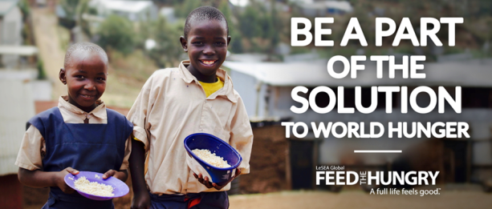
Feed the Hungry are hosting food packings events around the UK. They are looking for individuals and teams to come and join in this awe inspiring project to help those in need in some of the poorest countries. As part of the work that Feed the Hungry does, they need to make up food packages that are then shipped out to their partner schools all around the world, as you can imagine this is no small venture. One way that you can help with this is to organise a food pack.
For an idea of what this may look like visit: https://www.youtube.com/watch?v=uKgQBPkezck
If you wanted to take on this amazing challenge then you would need to work closely with Feed the Hungry who would bring along the food, equipment and transport. For your part you would need to raise £1950, this would cover the cost of food for 10,000 meals and provide the volunteer packers. We appreciate this is a massive commitment on your part but if you do want to know more please contact Paul on: foodpack@feedthehungry.org.uk

Feed the Hungry – Dignity and Respect
As you have seen, God’s kingdom is one of justice, righteousness, hope, and love – where the needs of all are met. You have also looked at how Feed the Hungry is working towards establishing these kingdom values here on earth. The question now is, ‘How does the work of Feed the Hungry, in helping to tackle the issue of poverty, link with people having the dignity and respect they deserve and what part can we play in this?’

Facts about Hunger and Poverty!
- 11% of the world’s population suffer from hunger.
- 766 million people, 45,385 million of them children, 46 million lived on less than $1.90 a day in 2013.
- Poor nutrition causes 45% of the deaths among children under age 5.
- Close to 156 million children are stunted, a result of undernutrition and infection.
- In 1990, only 12 countries in Africa were facing food crises, of which only four were in protracted crises. Twenty years later, a total of 24 countries were experiencing food crises, with 19 in crisis for eight or more of the previous ten years.
- Sixty-six million primary school-age children attend classes hungry across the developing world, with 23 million in Africa alone.
- WFP calculates that US$3.2 billion is needed per year to reach all 66 million hungry school-age children.
- Unless the world tackles deprivation today, 167 million children will live in extreme poverty by 2030, and 69 million children under age 5 will die of preventable causes.

Exploring the vital need for a good diet
This is linked with the Key Stage 3 Science.
The aim of this section is for the pupils to gain a fuller understanding of the impact that poverty and leading on from that, severe hunger and malnutrition can have on a person:
“Fundamentally, poverty is a denial of choices and opportunities, a violation of human dignity. It means lack of basic capacity to participate effectively in society. It means not having enough to feed and clothe a family, not having a school or clinic to go to, not having the land on which to grow one’s food or a job to earn one’s living, not having access to credit. It means insecurity, powerlessness and exclusion of individuals, households and communities. It means susceptibility to violence, and it often implies living on marginal or fragile environments, without access to clean water or sanitation” (UN Statement, June 1998 – signed by the heads of all UN agencies)
Malnutrition
BBC Bitesize Science - Nutrition, digestion and excretion https://www.bbc.co.uk/education/topics/zf339j6/resources/2 include a series of clips on the ‘Science behind carbohydrates, protein, fats, vitamins and minerals and hydrations.’ These can be used as a basis to explain the importance of a good, balanced diet.

Questions to ask leading from this:
What can the people in the film do because of the food that they eat or the water that they drink?
What becomes harder if we don’t have the right food? How do we feel if we have missed a meal? What would happen if this continued day after day? Would we be able to do sport, to think properly, to work well or to study hard? Would we be able to fight off diseases?

Encourage the pupils to keep a food diary for a week or simply think back over the last couple of days to remember what they have drunk and eaten. Alternatively you could use the school menu for a week as the basis of your discussion – what food groups have made up the diet? How do they work in your body? What do they help your body to do? Is there anything lacking in the diet?

Now consider how a lack of a good diet would impact your emotional, as well as physical, wellbeing and how this could lead to a breaking down of dignity and respect. To help think about this further watch these clips that show lives and diets that are in stark contrast to the healthy diets and ways of lives that you have been looking at:

https://www.youtube.com/watch?v=-E2fq2RFT3Q – this is a very powerful film but does have some upsetting images and so you would need to consider carefully how you would use it.
https://www.youtube.com/watch?v=lUer_ZA4sJs&t=7s – a UNICEF film about world hunger
https://www.youtube.com/watch?v=4WHkA82e9Hk&t=1s – a UNICEF looking at those who are surviving by living on grass.

Turn your learning into action - look up some recipes that offer a balanced diet that contains a healthy balance of protein, carbohydrates, vitamins and minerals. If the facilities are available pupils could prepare a healthy meal to share with others. This could be turned into a team based ‘Master Chef’ challenge that could then be linked to an awareness and fund raising event for ‘Feed the Hungry’.

For other ideas on how to raise money for ‘Feed the Hungry’ there is a downloadable fundraising pack that can be used to help with ideas https://feedthehungry.org.uk/schoolsfundraisingpack/ and also advertising posters etc. https://feedthehungry.org.uk/downloadables/

Or for further ways that your school can join in with the work of feed the hungry please see the lower key stage 2 scheme of work. This includes, amongst other things, instructions for a clothes appeals and putting together kindness kits.

Jo Cox Foundation, the White Helmets – Community
The ‘Jo Cox Foundation’ has been set up to champion the causes that Jo was passionate about. One of the main issues they are focusing on is the worsening situation in Syria. The Foundation has taken up Jo's work to galvanise the support of the public and decision makers for the protection of Syrian civilians. Since its inception, the Foundation has been working closely with MPs and organisations to push for more sustained engagement amongst parliamentarians on the Syrian conflict. In the days following Jo's death over 40,000 people generously donated over £1.5 million to the Jo Cox Fund. This money is being used to support work in Yorkshire, across the UK and in Syria with the White Helmets community project.
The White Helmets have used the grant to purchase eight ambulances which are now operational in Syria. They are also using our support to set up a 'Hero Fund'. This is supporting the families of over 150 White Helmets who have lost their lives carrying out life-saving humanitarian work in Syria.

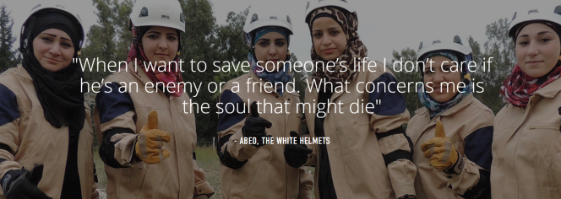
UNARMED AND NEUTRAL – from the news that comes out of Syria we can often see the civilians there as helpless victims, but as a community they are far more than that. The White Helmets are a community of volunteers whose aim is to save people on all sides of the conflict - pledging commitment to the principles of “Humanity, Solidarity, Impartiality” as outlined by the International Civil Defence Organisation. This pledge guides every response, every action, every life saved - so that in a time of destruction, all Syrians have the hope of a lifeline.
The White Helmets mostly deal with the aftermath of government air attacks. Yet they have risked sniper fire to rescue bodies of government soldiers to give them a proper burial.
Bakers, tailors, engineers, pharmacists, painters, carpenters, students and many more, the White Helmets are volunteers from all walks of life. Many have paid the ultimate price for their compassion - 204 have been killed while saving others.
To find out more about their work visit: https://www.whitehelmets.org/en
The story of the White Helmets community group would be a good inspirational starting point for a whole school collective worship. This would link with further possible research around other organisations or community groups that have worked for peace (e.g. the Red Cross).Look again at the Bible passages – how are such organisations and communities living by the Kingdom values that are set out in these verses?
You could also take this issue further and look at Christian responses to war. What should a Christian response to war be? Is there ever a just reason to go to war? There are a lot of resources on RE:quest that could support this:
http://request.org.uk/?s=war or http://request.org.uk/teachers?s=war

Local Community Work
The White Helmets saw a need in their local community and decided to act rather than to sit back and do nothing. Are there issues of need in your local area that the pupils could respond to?
A common need in many of our communities is loneliness. Places of Welcome is a growing network of hospitality run by local community groups who want to make sure that everyone in their area has a place to go for a friendly face, a cup of tea and a conversation if and when they need it.
Hospitality is at the heart of Christian community and is one of the main ways to show love and concern for our fellow human beings whilst tackling the ever increasing problem of loneliness. This “social epidemic” is an issue that the Jo Cox foundation has strived hard to combat. The final report of the Jo Cox Loneliness Commission found that nine million adults in the UK are often or always lonely and that loneliness is as harmful to health as obesity or smoking 15 cigarettes a day.
The primary aim of the Places of Welcome network is that “Every neighbourhood has places where all people feel safe to belong, connect and contribute.” http://www.placesofwelcome.org/ . By establishing your school as a ‘Place of Welcome’ you would be creating stronger community links as well as ensuring a safe place for the wider school community to meet. If possible, a ‘Place of Welcome’ could be established directly in your school. To begin with this may be something simple that operates a couple of times a term and is open to parents, carers or family members at the beginning or the end of the day. If you do not have the means to facilitate this within your school maybe your local church or community centre would be willing to partner with you on it. Where appropriate this could be linked with an open clinic with the community nurse or health worker. Older pupils could be actively involved in welcoming people and helping to provide the refreshments and possibly even entertainment.
Community walks are a great way to keep fit, to get to know your local families better and raise awareness and support for those children who have no choice but to walk miles for basic needs such as water or education. Be inspired to walk by the story of Beatrice https://fth.org.uk/mmm/getinspired/beatrice/ . Many of the children Feed the Hungry work with walk miles every day just to get to school. Why not follow in their footsteps and do a sponsored walk. Encourage your local community to join you. For every £4 raised one child can be fed for a whole month.
Walk 1 mile and you will be like Insigni who fetches water from the nearest well.
Walk 3 miles and you will be like the children who attend Hapwaya Primary School in Zambia and have to walk that far every day to get to school.
Walk 5 miles and you will be like a Romanian family who share a pair of shoes and take it in turns to collect food.
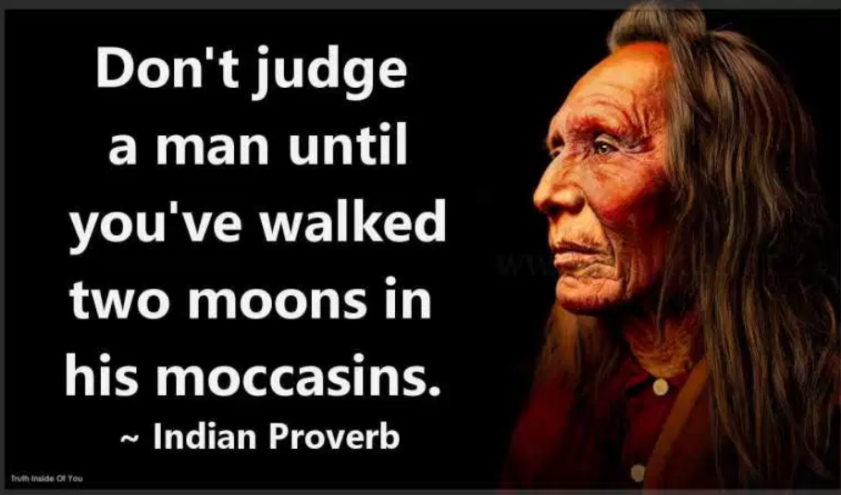
Use this proverb as a way in to think about why you would be doing the walking. Think about the prejudices we may have about people in different circumstances as us (the Basti Life activity will help with this), how can walking in their shoes help us to be more understanding of their situations?
Think about other ways that you, as a community, can ‘walk in another person’s shoes.’ This may include purposefully missing a meal, taking part in an event such as Share a Pencil Day https://www.hope.co.uk/share-a-pencil-day/ or even sleeping out rough in the school grounds.

Cross Curriculum Links

English
- learning new vocabulary, relating it explicitly to known vocabulary and understanding it with the help of context and dictionaries
- making inferences and referring to evidence in the text
- knowing the purpose, audience for and context of the writing and drawing on this knowledge to support comprehension
- checking their understanding to make sure that what they have read makes sense
- writing for a wide range of purposes and audiences, including: well-structured formal expository and narrative essays; notes and polished scripts for talks and presentations and a range of other non-narrative texts, including arguments, and personal and formal letters
- considering how their writing reflects the audiences and purposes for which it was intended
- giving short speeches and presentations, expressing their own ideas and keeping to the point
- participating in formal debates and structured discussions, summarising and/or building on what has been said
Science
- the content of a healthy human diet: carbohydrates, lipids (fats and oils), proteins, vitamins, minerals, dietary fibre and water, and why each is needed
- calculations of energy requirements in a healthy daily diet
- the consequences of imbalances in the diet, including obesity, starvation and deficiency diseases

Art and Design
- to use a range of techniques to record their observations in sketchbooks, journals and other media as a basis for exploring their ideas

Citizenship
- develop an interest in, and commitment to, participation in volunteering as well as other forms of responsible activity, that they will take with them into adulthood
- are equipped with the skills to think critically and debate political questions
- the roles played by public institutions and voluntary groups in society, and the ways in which citizens work together to improve their communities, including opportunities to participate in school-based activities
Design and Technology
- use research and exploration, such as the study of different cultures, to identify and understand user needs
- understand and apply the principles of nutrition and health understand the source, seasonality and characteristics of a broad range of ingredients
Geography
- extend their locational knowledge and deepen their spatial awareness of the world’s countries, using maps of the world to focus on Africa, Russia, Asia (including China and India), and the Middle East, focusing on their environmental regions, including polar and hot deserts, key physical and human characteristics, countries and major cities
- understand geographical similarities, differences and links between places through the study of the human and physical geography of a region in Africa and a region in Asia understand, through the use of detailed place-based exemplars at a variety of scales
- human geography relating to: population and urbanisation; international development; economic activity in the primary, secondary, tertiary and quaternary sectors; and the use of natural resources
- understand how human and physical processes interact to influence and change landscapes, environments and the climate; and how human activity relies on the effective functioning of natural systems

