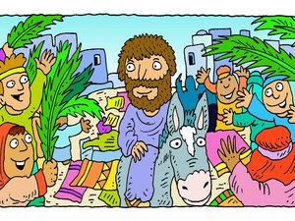

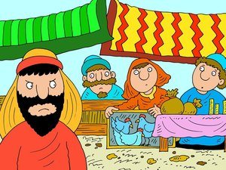

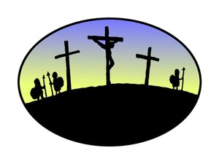

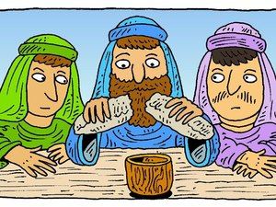

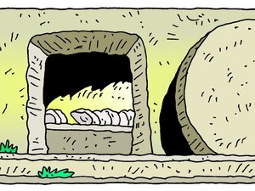





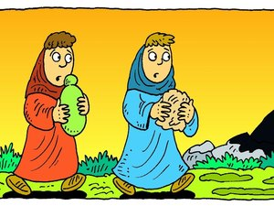

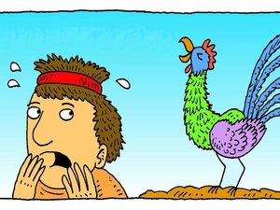

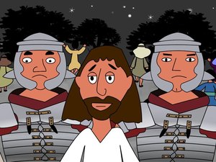

**Methodology**

* Cut out pictures & mix up.
* Hand to pupils in pairs.
* Can they sequence them in the right order?
* What caption would they give each picture?
* Can they link the following key words to a picture? Resurrection; Denial; Anointing; Myrrh; Servant King; Last Supper; Crucifixion; Sacrifice; Sin; Reconciliation; Suffering; Forgiveness; Hosanna; Saviour; Betrayal.
* Discussion with pupils & creation of an annotated collage.