AAQ Early Children’s Development
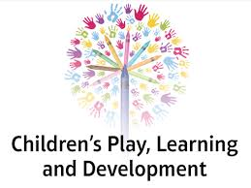

Bridging Course



You are now going to begin preparatory work relevant for Unit 1 Child Development. This unit explores the stages of growth and development in children from birth to 7years 11 months. For the purpose of this bridging module we will consider child development from 0-2years.

- Most children follow a sequence of growth and development. To get you to consider how this happens over a period of time, watch this video about a child’s development aged 0-2years on YouTube https://youtu.be/BmXl_2lVmi8. Make notes of the ages that she was able to achieve each activity. If you are unable to access the video please can you research when most children will be able to do these activities.
Activity | Age of Development
Run Fast
Roll over
Crawl upstairs
Hold a bottle on their own
Sleep, sleep and sleep…
Pretend play
Lift head up
Throw a ball
Walk on own
Sit up on own
Crawl very well
Use a spoon on their own
Repeat words they hear

- The video demonstrates that the little girl is developing her gross and fine motor skills. Gross motor (physical) skills are those which require whole body movement and which involve the large (core stabilising) muscles of the body to perform everyday functions, such as standing and walking, running and jumping. Fine motor skills refer to the coordination between small muscles, like those of the hands and fingers, with the eyes. Fine motor skills involve the small muscles of the body that enable such functions as writing, grasping small objects and fastening clothing. Conduct internet research to see how both the fine and gross motor skills are expected to develop from 0-2 years. Complete the table below.

 | Gross Motor Skills | Fine Motor Skills.
0-3 months

3-6 months

6 months

9 months

12 months

18 months

- Growth is variable meaning it is not smooth and continuous. Indeed during the first two years of a child’s life it is marked by a significant period of growth. After this time a child will grow more steadily until adolescence. There are three key principles of development:
- Development follows an orderly sequence.
- Development begins with the control of head movements and continues down the body.
- Development begins with uncontrolled large gross motor movements before becoming precise and refined.
Examine the pictures below and write a description of how their gross and fine motor skills have developed.

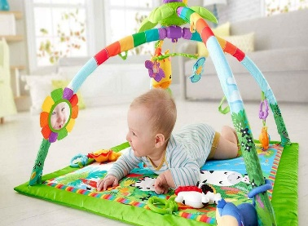 | 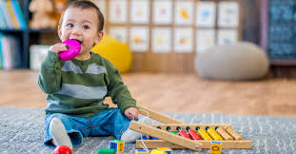 | 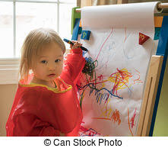

- The use of key technical terms is very important when answering exam questions for this unit. Complete the key technical terms table below to help you to become familiar with some of the phrases and concepts that will be regularly used in class.
Technical Term | Meaning
Growth and development

Gestation

Growth Spurt

Variable

Neural growth

Hand-eye coordination

Visual perceptual skills

Neural pathway

Atypical Development

2.
- There are many factors that affect healthy growth and development. Sometimes this can be due to biological and environmental factors. Biological factors include such things as prenatal care, genetic influences, brain chemistry, hormone levels, nutrition, and gender. If a pregnant mum drinks alcohol during pregnancy she risks causing harm to her baby. Sometimes this can result in mental and physical problems in the baby, called foetal alcohol syndrome. This can occur because alcohol in the mother's blood passes to her baby through the placenta. Go to the following NHS website and investigate the impact of a condition called ‘foetal alcohol syndrome’.
- https://www.nhs.uk/conditions/foetal-alcohol-syndrome/
- https://www.drinkaware.co.uk/alcohol-facts/health-effects-of-alcohol/fertility-and-pregnancy/foetal-alcohol-syndrome-fas/

Add as many facts to the box below about the impact of foetal alcohol syndrome on a child’s growth and development.
Impact of foetal alcohol syndrome on a child’s growth and development



- Environmental influences are wide-ranging and include infectious agents, toxins such as lead and air pollution, and social factors such as loving interactions with caregivers, socioeconomic resources in the family and community, and peer relationships, segregation, racism, culture, the availability and quality of services, and policies that directly or indirectly affect those caring for the child. Read the information published on the British Lung Foundation in September 2019. Then conduct your own research on how you would advise a parent to ‘improve the air quality in their own home’.
Children are more vulnerable to breathing in polluted air than adults. Their airways are smaller and still developing. They breathe more rapidly than adults. Buggies and prams put them at the level of car exhausts and hand-held cigarettes. If a child breathes high levels of air pollution over a long period, they might be at risk of:
- their lungs not working as well as they grow older
- developing asthma during childhood or as an adult - and if they have asthma already, air pollution can make it worse
- wheezing
- coughs
- lung cancer when they’re older
- infections like pneumonia
Air pollution can be very worrying. It may not be practical to move away from a busy city. But there are some steps that parents can take to reduce children’s exposure to air pollution:
- Avoid smoking during pregnancy
- Make sure the child does not breathe in cigarette smoke after they are born, by giving up smoking yourself and avoiding smoky environments
- Walk rather than drive whenever possible. On busy streets, exposure to air pollution can be worse inside car than it is outside
- Find out where your local pollution hotspots are and if you’re walking or cycling, avoid the worst pollution by taking quieter streets. Even walking on the side of the pavement furthest from the road and avoiding the busiest times can help
- Keep your home well aired
- Cut down your exposure to household chemicals.

Adele is 12 months old and enjoys picking up small objects and pointing at things. Lately she has been standing up and walking whilst holding onto furniture. Her mum smokes 5 cigarettes per day and drinks above government guidelines for alcohol intake. She has recently found out that she is pregnant with her second baby.
She is worrying that Adele is not growing and developing normally because her friend’s son is the same age and he can walk unaided.

- Do you think Adele is meeting the expected development for her fine motor skills, if so how?

- Do you think Adele is meeting the expected development for her gross motor skills?

- Adele’s mum is worried about her progress, what would you advise her to be able to reassure her on how Adele’s gross and fine motor skills should develop in the next 6 months?

- What can you advise her mum about Adele’s’ hand and eye coordination?

- What does the term ‘antenatal care’ mean?

- Adele’s mum is pregnant, how might her current lifestyle habit of smoking and drinking alcohol impact on the future growth and development of her unborn child?

- Explain how Adele’s mums smoking habit might impact on Adele’s growth and development?

We will now focus on the concept of play and how it supports the learning and development in children. Additionally we will consider what play opportunities Early Years settings provide to encourage children to play in a meaningful way. Developing on from this you will explore the emergence of outdoor play and Forest School principles that have influenced children’s learning in the UK.

Children learn so much from play; it teaches them social skills such as sharing, taking turns, self-discipline and tolerance of others. Children’s lives are enhanced by playing creatively and by playing children learn and develop as individuals; it assists in their emotional and intellectual development and mental health resilience which are core building blocks for their transition years. Children like to play as there is no “right way” or “wrong way”, they can use their imagination to develop games and interact with each other without being in an adult-led environment. Play is often called the ‘work’ of children. We therefore need to encourage unstructured free play, loosely supervised, as much as possible as over programming spoils the true benefits of play. Children’s play may or may not involve equipment or have an end product. Children play on their own and with others. Their play may be boisterous and energetic or quiet and contemplative, light-hearted or very serious.

Play is a very emotive word which means different things to different people, and has been defined in many ways. The meaning of play has been debated by philosophers and academics for centuries, and was recognised as far back as Plato who is quoted as saying ‘avoid compulsion and let your children play’! In the last century David Lloyd George stated that ‘play is a child’s first claim on the community’ (1926), and play gained wider recognition under the United Nations Convention on the Rights of the Child in which Article 31 enshrines the child’s right to play.

- Read through the following narrative about ‘play’ and how it underpins all aspects of child development. Prepare a written response to the following statement, giving reasons to support your opinions:
‘Play is very important and helps children to develop’

Play underpins the Early Years Framework. It also underpins learning and all aspects of children’s development. Through play, children develop language skills, their emotions and creativity, social and intellectual skills. For most children their play is natural and spontaneous although some children may need extra help from adults. Play takes place indoors and outdoors and it is in these different environments that children explore and discover their immediate world. It is here they practise new ideas and skills, they take risks, show imagination and solve problems on their own or with others. The role that adults have is crucial. Adults provide time and space and appropriate resources. These might include clothes, boxes, buckets, old blankets that will inspire play and fire children’s imaginations. They observe play and join in when invited, watching and listening before intervening. They value play and provide safe but challenging environments that support and extend learning and development.

Living, playing and learning are almost one and the same thing for babies and young children for much of the time. For young babies play begins in their first encounter in the womb with their mother’s hand touching the place where they have just kicked her stomach or when she sings or talks to them. A mother’s voice before the baby’s birth and her face, touch and gestures when the baby is born all play a part in creating emotional warmth and interaction which lead to play and learning for babies.

New babies are drawn to look at the human face and they begin to learn how to ‘read’ the face of their mother or another caregiver. They carefully watch her eyes and mouth – finding out all about her and they enjoy hearing her singing and seeing the different movements of muscles in her face. Playfulness begins in earnest – smiles become broader as the baby expresses delight at seeing special people like dad, or mum, big brother and grandparents. The movement of a mobile or seeing and hearing a black and white squeaky toy soon begins to interest young babies because they are finding out about the world through whatever they can see, hear, touch, smell and taste. By the time babies are reaching out and grasping small toys another phase has begun where baby may be able to shake a rattle or raise an object to the mouth to find out more about it by placing it in the mouth to explore it more thoroughly.

Movement leads to new possibilities for babies’ play and learning – rolling and reaching allows them to make things happen and by the time they are able to sit unaided they find out what they can do with a wooden block or a ball or a shaker. Physical dexterity then allows fuller exploration of scrunchy material, paper or anything within reach. As babies continue to explore the world in this way their understanding and enjoyment are enhanced by warm caregivers who know how to be partners in their play helping them to hold something the right way or showing them how to push or pull something; always watching over them yet allowing them ‘space’ so that they can enjoy some independence whilst keeping safe.

Babies and young children love to play with anything from their fingers and toes, to their toys, as well as with sounds and with adults and children. When young children play they learn at the same time, so play is a very important way for children to learn. If you watch very young children playing you will notice that they don’t always need other children or adults because they are quite happy playing alone, provided they can see and hear others nearby. When babies play, their whole bodies are involved in reaching, grasping, rolling and touching things. As they become more mobile and they gain control over their bodies babies enjoy putting things together such as piling blocks on top of one another or banging balls together, or filling and emptying containers. Two year olds love to pretend, basing their play on imitating things they have seen you, or other people do, like vacuuming, talking on the telephone or playing a trumpet. When they play like this they don’t always need the real thing, as they will make do with anything that they can adapt to their pretend play. By the time they are moving towards their third birthday children begin to play with others more, and increasingly enjoy playing with other children.

Babies and young children also enjoy looking at books, listening to stories and rhymes and joining in with songs. As they hear and join in with stories, songs and rhymes and look at books, young children become familiar with different sounds and words, and they begin to anticipate events. Babies and young children are learning all the time. They learn through looking, listening, touching, tasting, investigating, exploring, experimenting and through playing and talking. This means that young children need to have opportunities to:
• look at interesting things such as birds, animals, plants, trees, mobiles, shells, stones, boxes, tubes, mirrors
• listen to a range of sounds such as songs, rhymes, jingles, stories, music
• touch a variety of objects – hard, soft, bumpy, smooth, rough, cold, warm
• taste a range of flavours such as those in fruit, milk, vegetables, bread
• investigate things that open, close, float, sink, twist, turn
• explore objects such as large boxes, things that make noises, things that move
• experiment with water, sand, clay, dough, paint, glue, felt pens
• play for uninterrupted periods of time, alone or alongside others, with help from adults, and in their own way
• talk to other children and adults and to have their efforts rewarded

Play and learning cannot be divided during the earliest years because as children are finding out about what things do when they touch them and what they can do when sitting, crawling, cruising, clambering, climbing, standing, reaching, pulling, pushing and so on they are also gaining mastery and control of their bodies – so play is learning. At the same time the sounds and words and gestures that they have experienced in interactions with others help babies to understand ways of relating to others and whilst they will have had great fun blowing raspberries or squealing with delight when somebody has played peek-a-boo with them they have also begun to learn social and emotional skills which will help their development as people. Young children soak up the atmosphere around them and are affected and can be upset if others are depressed or sad so it would be fair to say that they are learning about emotions right from the start. And by the time a child is a year old their understanding of language is growing rapidly.

- There are many ways that children enjoy playing in an early years setting. One of the most common forms of play is the ‘home corner’. Whilst this may seem like an everyday play activity, it holds a rich importance in an early years setting. Research has shown that it can support literacy, numeracy, communication and social and emotional development.
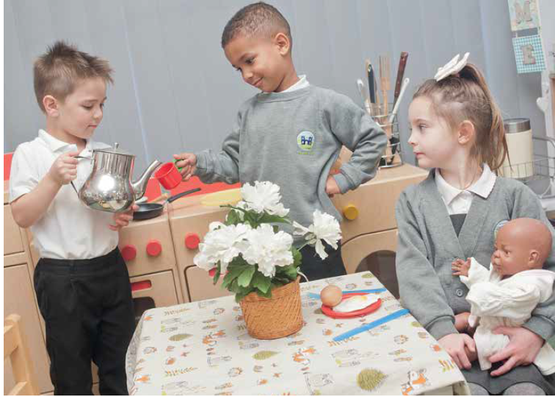

Activity
Read through the following journal article and present a detailed mind map of the importance of the ‘home corner’. You will also need to do your own independent research to support your mind map information.

Nursery World Journal (Jan 2019)
‘Home and Away’
Whether it is playing mothers and fathers in the home or superheroes battling villains in a magical land, role play has always been a crucial part of children’s play and development. Schools are increasingly aware of the importance of this kind of imaginative play, and opportunities for it have opened up as settings dedicate more time to outdoor play. However, schools also face barriers in their delivery of this vital part of provision. ‘Although there have been some real developments in practice because of the outdoor emphasis, there is still pressure to develop the school readiness agenda,’ says Professor Sue Rogers at the Institute of Education, University College London. ‘Opportunities for play are getting smaller in some schools,’ agrees early years trainer Alistair Bryce-Clegg. ‘Once you have done the register, then phonics, then assembly, then PE, play is squeezed. In lots of places, the issue is thinking that attainment happens only through adult-led, table-top activities.’

Even young babies engage in mimicry and imitative play, but by around the age of four, children’s imaginative play becomes more complex, expanding a simple premise like a birthday party with their own experience and imagination. Their creativity, detail, use of language and social interaction are all increasing significantly. ‘Very young children need more props in their play, and these must be realistic – they do a lot of imitative play and are just beginning to imagine that a banana is a telephone, for example,’ says Professor Rogers. ‘As they move into Reception, more open-ended resources come into their own and their imagination and social skills develop so they can imagine what it is like to be someone else. ‘Their play becomes richer as they are able to combine their own experiences with those of other children.’ The benefits of role play include the development of:
■ imagination and storytelling
■problem-solving skills
■understanding of mathematical concepts
■ language and communication
■self-regulation through negotiation co-operation and conflict resolution as children agree the roles and rules of play
■gross and fine motor skills.
Role play also enables children to:
■ take risks in a safe environment
■express feelings
■ learn about other cultures
■engage in sustained shared thinking.

Role play is particularly important for a child’s social and personal development. ‘There is a social dimension to role play, as the best role play is with others – you learn social skills around taking another person’s perspective,’ says Professor Rogers. ‘By the age of four or five, children understand that if they don’t play by the rules being set up in the fantasy game, their friends won’t want to play anymore, so there is learning around behaviour and social interaction as well as storytelling and the language it might reveal.’ Judith Twani, assistant head teacher and associate of Early Excellence, believes role play is especially important for children learning English as an additional language. ‘A home corner can provide real everyday vocabulary for them to get hold of and use in a relaxed way,’ she says. Adults need to recognise too when not to interfere in children’s play. ‘If you can see a child is immersed and in character, there is no need for us to interfere,’ says Sherise Richardson, vice-principal at Castle Hill Infant School in Suffolk. Far better sometimes to just observe, says Professor Rogers. ‘You get a lot of insight into a child’s speech and language development, and you may be able to pick up on their interests for learning opportunities later on.’

Rightly, the home corner is often the cornerstone of classroom role-play. Early years teachers can feel pressure from senior leadership to change it to a travel agent’s or a café depending on the term’s topic, but a permanent home corner is important, says Ms Twani.‘Home is the one thing all children have in common,’ she explains. ‘It is better to have a permanent home corner which you enhance, so it becomes a home celebrating Chinese New Year, rather than a Chinese restaurant.’ While home corners stocked with very open-ended resources are becoming more popular, Ms Twani prefers well-equipped realistic home corners over deconstructed versions. ‘I rarely see them done well,’ she says. ‘Of course, every classroom needs to have things children can create from loose parts, and we know children will create their own role play from these open-ended resources, but I’d rather have fabrics, tubes and so on as well as a home corner, not instead of.’

Specific themed role-play areas, such as a doctor’s, dentist or shop, can be created in response to children’s current interests or experiences. Continuous provision can also be enhanced easily to reflect their interests. ‘Again, there is a responsibility to be more proactive here,’ says Mr Dubiel. ‘An estate agent might not be somewhere a child has been nor understands. Visiting one in the locality would both broaden the child’s experience and also enhance the level of play within it because it would have a real “experienced” context. ‘Have a box of hairdressing resources, a pets’ box, a box of summer things,’ says Ms Twani. ‘And have coats, hats and wellies, not fairies and superheroes, otherwise they become obsessed with being princesses place they feel comfortable.’ Role play provides an invaluable means for children to consolidate their understanding of knowledge and skills through meaningful experiences, or to try out new ideas in a safe and familiar environment. When considering how to plan and resource role-play areas, Jan Dubiel, national director of Early Excellence, believes settings need to focus on children’s interests and experiences and acknowledge also their responsibility in introducing new ideas and situations in meaningful ways. ‘Children cannot develop an interest in something that they don’t know about,’ he says. ‘Some children start school with very limited experiences, and practitioners have a role to play in broadening and deepening their experiences, so there are opportunities – and responsibilities – for extending children’s experiences and knowledge of the world around them.’ It is also important to recognise that children will constantly want to play out scenarios that may be inspired by, say, recent experiences, books or computer games. So, says Mr Dubiel, ‘It’s vital that settings provide well-equipped continuous provision, including lots of open-ended resources, such as blocks and loose parts, so children have the spaces and means to create scenarios that support and extend their learning, understanding and knowledge.’ Thoughtful resourcing enables practitioners to maximise the learning opportunities within children’s role-play scenarios. ‘In the home corner, you can include a timer, clock, different types of measuring cups, so it is reflecting how maths is used in real life,’ says Ms Twani. ‘Have the book area next to the home corner so it looks like a lounge, with a couch and uplighter, and children engage emotionally with it as part of the home corner experience. Include recipe books, and catalogues, and have a whiteboard on the fridge, a calendar on the wall, providing writing opportunities that are meaningful.
In terms of technology, think about providing little angle lamps, or even a little vacuum cleaner that really works.

- Play and resources are often grouped into five different categories, each one has a particular benefit to children’s development. These categories are physical, imaginative, creative and construction.
Find a definition and an example for each of the 5 categories in the table below.

Play Type | Definition | Example of this type of play.
Physical Play

Imaginative Play

Sensory Play

Creative and Design Play

Construction Play

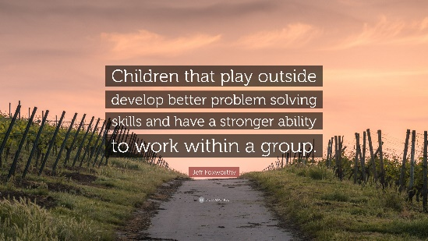
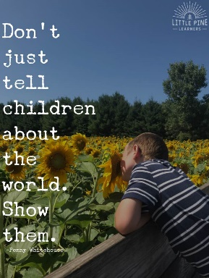
- Forest schools have their origins in Scandinavian countries, which have vast woodlands. The idea behind Forest schools is that by playing out in the woodlands and learning skills such as building a campfire will help children to develop their confidence and social skills. Forest School is an inspirational process that offers ALL learners regular opportunities to achieve and develop confidence and self-esteem through hands-on learning experiences in a woodland or natural environment with trees. Forest School is a specialised learning approach that sits within and complements the wider context of outdoor and woodland education. At Forest School all participants are viewed as: equal, unique and valuable, competent to explore & discover, entitled to experience appropriate risk and challenge, entitled to choose, and to initiate and drive their own learning and development, entitled to experience regular success, entitled to develop positive relationships with themselves and other people, entitled to develop a strong, positive relationship with their natural world. This learner-centred approach interweaves with the ever-changing moods and marvels, potential and challenges of the natural world through the seasons to fill every Forest School session and programme with discovery and difference.
Complete the below activities on the lined paper at the end of this booklet.
Activity 1:
To develop your knowledge further about the Forest school approach, watch both video clips that show how children have benefitted from this type of play.
https://youtu.be/9zat9ef1vHo
https://youtu.be/xOdAmwif2Kc
Reflection on videos:
- What do you think the benefits are of children playing outdoors to indoors?
- What do you think is the biggest benefit of Forest school for children?
- What two things have you discovered about Forest school approach?
Activity 2:
An important attribute of an early year’s worker is to be creative. Please can you create a poster A3 or A4 size that is very engaging and colourful? It must contain the following information:
- What is a Forest School?
- The benefits of a Forest School.
- Ideas and example of activities that can take place in a Forest School.

______________________________________________________________________________________________________________________________________________________________________________________________________________________________________________________________________________________________________________________________________________________________________________________________________________________________________________________________________________________________________________________________
_______________________________________________________________________________________________________________________________________________________________________________________________________________________________________________________________
_______________________________________________________________________________________________________________________________________________________________________________________________________________________________________________________________
_____________________________________________________________________________________________________________________________________________________________________________________________________________________________________________________________________________________________________________________________________________________________________________________________________________________________________________________________________________________________________________________________________________________________________________________________________________________________________________________________________________________________________________________________________________________________________________________________
_______________________________________________________________________________________________________________________________________________________________________________________________________________________________________________________________
_______________________________________________________________________________________________________________________________________________________________________________________________________________________________________________________________
_______________________________________________________________________________________________________________________________________________________________________________________________________________________________________________________________
______________________________________________________________________________________________________________________________________________________________________________________________________________________________________________________________________________________________________________________________________________________________________________________________________________________________________________________________________________________________________________________________
_______________________________________________________________________________________________________________________________________________________________________________________________________________________________________________________________
_______________________________________________________________________________________________________________________________________________________________________________________________________________________________________________________________
_______________________________________________________________________________________________________________________________________________________________________________________________________________________________________________________________
______________________________________________________________________________________________________________________________________________________________________________________________________________________________________________________________________________________________________________________________________________________________________________________________________________________________________________________________________________________________________________________________
_______________________________________________________________________________________________________________________________________________________________________________________________________________________________________________________________
_______________________________________________________________________________________________________________________________________________________________________________________________________________________________________________________________
_______________________________________________________________________________________________________________________________________________________________________________________________________________________________________________________________
______________________________________________________________________________________________________________________________________________________________________________________________________________________________________________________________________________________________________________________________________________________________________________________________________________________________________________________________________________________________________________________________
_______________________________________________________________________________________________________________________________________________________________________________________________________________________________________________________________
_______________________________________________________________________________________________________________________________________________________________________________________________________________________________________________________________
_______________________________________________________________________________________________________________________________________________________________________________________________________________________________________________________________
______________________________________________________________________________________________________________________________________________________________________________________________________________________________________________________________________________________________________________________________________________________________________________________________________________________________________________________________________________________________________________________________
_______________________________________________________________________________________________________________________________________________________________________________________________________________________________________________________________
_______________________________________________________________________________________________________________________________________________________________________________________________________________________________________________________________
_______________________________________________________________________________________________________________________________________________________________________________________________________________________________________________________________
______________________________________________________________________________________________________________________________________________________________________________________________________________________________________________________________________________________________________________________________________________________________________________________________________________________________________________________________________________________________________________________________
_______________________________________________________________________________________________________________________________________________________________________________________________________________________________________________________________
_______________________________________________________________________________________________________________________________________________________________________________________________________________________________________________________________
_______________________________________________________________________________________________________________________________________________________________________________________________________________________________________________________________

