Bridging Course 2022
Mr Holland
Computing Dept
Bridging Course 2022
Computer Science Week 4
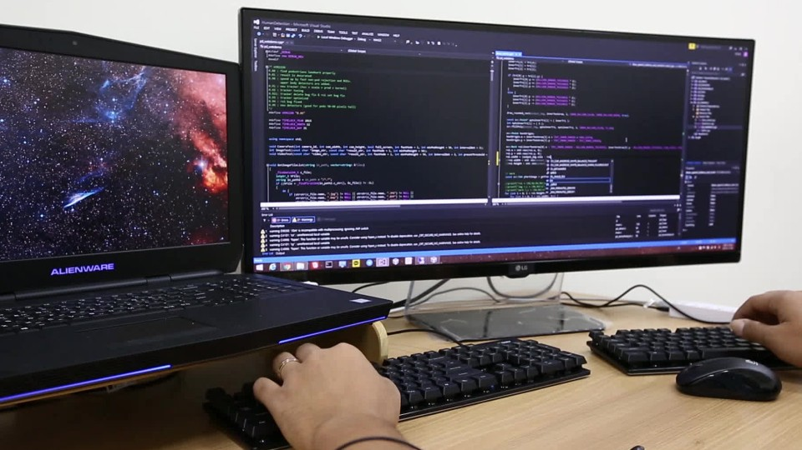

Recap on Week 3
In Week 2, we looked at using problem solving skills to develop algorithms. We can think of algorithms as being the ‘brain’ of any programs that we create. We refer to this as the backend. Programs however need more than a brain. They also need a ‘face’. We refer to this as the frontend.

Week 4: Web Development

INTRODUCTION
The frontend is the user interface of a program – that bridge to connect the complex program code with the human user. Humans may have varying levels of expertise with computers and as such the interface must be designed in such a way that the user can use the program easily, having that complexity hidden from them.
In the real world, backend and frontend development are very distinct processes and are carried out by different teams with bespoke skillsets. The term UX (user experience) is used to describe the development of a frontend. The term UI (user interface) refers the elements and layout of a frontend, but this is just part of the wider term of UX.
UX considers the psychology behind the design of software as well as just those elements of design. It is interesting to note that Mark Zuckerberg majored in Psychology at Harvard University (while also taking Computer Science modules).
Read the following article on the importance of UX design:
https://www.interaction-design.org/literature/topics/ux-design

The A-Level NEA Project
Consideration of your UX is a key factor in the development of your NEA (Non-Examined Assessment) for the A-Level course.
A key decision you will have to make is what kind of interface you need. This will be based around how you intend your software product to be used. The vast majority of projects will fall into 3 main types:
- A desktop application
- A mobile app
- A dynamic website
Regardless of which you choose, whether web based or not, a basic understanding of HTML and how web pages are delivered is very important in A-Level Computer Science. The Networking theory unit covers the delivery of webpages, and as such experience of creation of webpages and sites will be useful.

HTML Editors
Webpages (like everything) are written in code and as such you will need an editor to create your pages.
Many of the editors we looked at in Week 1 also allow HTML/CSS/JavaScript to be created too. As with before it’s personal preference as to which one you should use. Options include:
- Notepad++ (https://notepad-plus-plus.org)
- VS Code (https://code.visualstudio.com)
- Sublime (https://www.sublimetext.com)
Which each, you should get the option to choose HTML as the language and to save in the .html format.
The activities in the tutorials you will do use a 'built in' editor that you see on the tutorial, but it’s better for us to use an actual program – so we can save and take away things that we have done.

HTML Tutorials
HTML is the language in which web page are written and delivered. A ‘web browser’ such as Chrome or IE can read these files and construct the webpages.
You will undertake a series of online tutorials from W3 Schools. As you do this, you will apply the skills to create a site to serve as an ‘Online CV’. The site can contain the usual things you would expect to see in a CV. You can use the skills that you learned to lay out this information as you see fit.
Complete all activities from ‘HTML Introduction’ to ‘HTML Style Guide’
https://www.w3schools.com/html/default.asp
It’s also worth looking at HTML Forms as well. Have a go at creating a ‘contact me’ page for your site allowing someone to add their name and email, type a message and press a submit button.

CSS Tutorials
CSS or Cascading Style Sheets is a language used alongside HTML, with the purpose of defining the appearance of a webpage.
There is no need to complete all the CSS tutorials, but you should complete from CSS Introduction to CSS Colours at least. After this you can refer to the tutorials to help you do anything specific that you want to include on your Online CV.
https://www.w3schools.com/css/default.asp

JavaScript Tutorials
Unlike HTML or CSS, JavaScript is actually a programming language. As such we can do a lot of the same types of thing that you will be used to with programming. Where anything on a webpage is interactive, requiring the user to do something, JavaScript will be used. Rollovers, animations etc are examples. Some good examples to try out are:
Dropdown Menu - https://www.w3schools.com/howto/howto_js_dropdown.asp
Create tabs - https://www.w3schools.com/howto/howto_js_tabs.asp
Slideshow - https://www.w3schools.com/howto/howto_js_slideshow_gallery.asp
Social Media links - https://www.w3schools.com/howto/howto_css_social_media_buttons.asp
Validating form inputs - https://www.w3schools.com/howto/howto_js_validation_empty_input.asp

