Bridging Course 2022
Mr Holland
Computing Dept
Bridging Course 2022
Computer Science Week 3
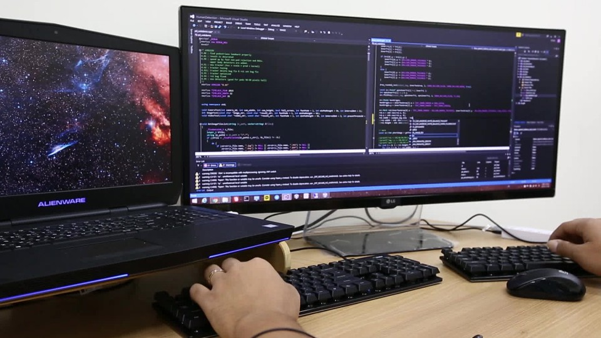

Recap on Week 2
In Week 2, we recapped the core building blocks of sequencing, selection and iteration.
This week we will focus on problem solving, applying abstraction and decomposition to be able to reduce a problem to the core building blocks.

Week 3: Problem Solving

INTRODUCTION
When approaching the problems, it’s a good idea to use the following strategy:
- Abstraction: Highlight key elements in the problem introduction that will help you solve the problem
- Identify repetition: Is there something that will be done over and over again? Is that number of times set or could it vary
- Solve a single iteration separately before trying it in a loop
- Test as you go and build the program up each time you get an element working
The first problem has a walkthrough commentary to help get you started.

Problem 1: Football Pools

Introduction

The pools is a game based on predicting the outcome of football matches.
The bet is placed on a list of 15 matches, normally 10 of Premier League and 5 of Championship. The possible values for each of the matches are 1 (meaning that the home team wins), X (meaning tie) or 2 (meaning that the visiting team wins).
You have been requested to develop a system to evaluate the number of hits of every bet.
Notes: This is a good example of where you need abstraction – for example, what league the matches were played in is not relevant to the solution.

As we can see this will always involve 15 matches – that number is fixed and will be important to us.

Input

The input will be two strings. The first string contains the 15 results of the matches while the second string represents a single bet that must be evaluated.
X111XXX21X21222
11XXX2XXX221111

Note: The inputs are strings, these can be entered using two regular input statements.

Often, I will get students who automatically think they need to convert this to a list. Is this necessary? No. Remember we can index strings in the same way as lists and that’s all we need to do in this case.

Set up a variable to count the number of hits with initial value of 0.
As the strings are always 15 chars long, this means we can use a FOR loop with Range 15.
We need to cycle through each element of the string and check it against the element in the other string at the same position. Use an IF statement to compare position i in results and in bet and add 1 to the hits variable if this is true

Output

The program must output the number of hits for current bet.
5

Your Solution

Code
Clipping of Running

Problem 2: The Arrival

Introduction

The YETI (Yet searching for Extra Terrestrial Intelligence) is receiving a signal from a remote solar system.
The message is a long sequence containing characters and numbers and as you may imagine, it seems impossible to decipher...
But you have been asked to isolate the signal by splitting it into two sequences -- one with characters and another with numbers – in order to continue the investigation. Let's do it!

Input

The input will be a string containing characters and numbers with no spaces.

0HELLO1WORLD2!3WE4CAME5FROM6A7GALAXY8FAR9FAR0AWAY

Output

The program must output two strings. The first one contains all the characters except numbers and the second contains only numbers.

HELLOWORLD!WECAMEFROMAGALAXYFARFARAWAY
01234567890

Your Solution

Code
Clipping of Running

Problem 3: Bike Race

Introduction

Next month, there will be a bike race in Byker and the race organisers have asked you to create an application to calculate the final classification. It will be a timed race, the competitors will start at different times, and the important thing is the time they take to complete the circuit.
To know how long a competitor takes, there will be two sensors that will save both the timestamp the cyclist starts and the time he crosses the finish line. This data will be sent to your application. The timestamps are UNIX epoch time, meaning that each timestamp will save the seconds elapsed since 1970.

Input

The input will be a sequence of all the competitors names with their initial and their final timestamp value, ending with a #.

Bernard 1483519913 1483523201
Joel 1483520440 1483523498
Lucas 1483521040 1483524254
#

Output

The output should be a list of all the competitors, each of them with their final result expressed in seconds, and sorted by first to last position.

Joel 3058
Lucas 3214
Bernard 3288

Your Solution

Code
Clipping of Running

Problem 4: The Apple Fall

Introduction

The Interplanetary Space Organization is studying the gravity in different planets with the most advanced orbital telescope by checking how long it takes for an apple to fall from the top of the apple tree to the ground on each planet.
The data collected by the scientists for each planet consist of the height of the tree and the time it took the apple to land on the ground.
Your mission is to find out which one of the planets in this research has the strongest gravity.

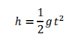

Input format:

[Number of planets in this research (N)]
[Height of the tree in meters] [Time to fall in seconds] <-- One line for each planet numbered 1, 2, 3,...,N

Output format:

Planet number [Number of planet] has the most gravity.

Input

2
3.25 2
20 2.474

Output

Planet number 2 has the most gravity.

Your Solution

Code
Clipping of Running

Problem 5: Magic Squares

Introduction

A magic square, is a n x n square grid filled with distinct positive integers in the range 1, 2, …, n^2 such that each cell contains a different integer and the sum of the integers in each row, column and main diagonal is equal. This sum is called the magic constant of the magic square. Even though magic squares do not have a known application, and they belong to the recreational mathematics space, they have a long history, dating back to at least 650 BC in China. Many times, these squares have acquired magical or mythical significance, and have appeared as symbols in works of art. In Europe, one of the most famous magic squares is the Albert Dürer order-4 magic square, immortalized in his 1514 engraving Melencolia I:

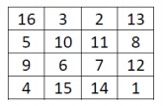

Write a program to check if a given square is magic or not.

Input

A series of rows with the corresponding columns of the magic square. As the order of the square might be variable the finish of the input will be marked with the character ‘#’.

Example 1

8 3 4
1 5 9
6 7 2
#

Example 2

8 13 2 11
1 12 7 14
15 6 16 4
10 3 9 5
#

Output

A string reporting whether the input is or is not a magic square.

Example 1
This is a magic square

Example 2
This is not a magic square

Your Solution

Code
Clipping of Running

Problem 6: Roman Calculator

Introduction
Maximilian lives in the Roman Empire and he has a grocery.
The business goes very well but he has a little problem: all the prices are in roman numerals and making sums with them is a painfully task.
Thank to Mercury, patron god of commerce, you are his friend, a well-known programmer in the empire.
Help to Maximilian making a roman calculator for attend customers faster.

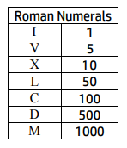

Input
The input will be a sequence of roman numerals ended with a +

I
II
IV
VI
+

Output
The output will be the sum of the given roman numerals, also in roman
The sum always will be less than 4000

XIII

Your Solution

Code
Clipping of Running

Problem 7: Goldbach’s conjecture

Introduction
In 1742 the Prussian mathematician Christian Goldbach wrote a letter to his friend Leonhard Euler where he stated that:
“Any even number greater than 2 can be written as the sum of two prime numbers”
This statement is known as Goldbach’s conjecture. Since then, mathematicians have been able to find such a pair of prime numbers for any even number greater than 2 that they’ve considered. It has been checked using computers for even numbers up to 4 × 1018. Up to date nobody has been able to prove that this result holds for all even numbers. So, the conjecture remains unproven despite considerable effort.

Input

The input will be an even number greater than 4 and lesser than 5000. For example:

128

Output

The output of the program is a list of pair of prime numbers that sum up the number provided in the input.
The list is ordered in increasing order considering the value of the first prime addend.
This is the output for the previous example:

19 + 109
31 + 97
61 + 67

Your Solution

Code
Clipping of Running

