Bridging Course 2022
Holland, Peter
Computing Dept
Bridging Course 2022
Computer Science Week 2
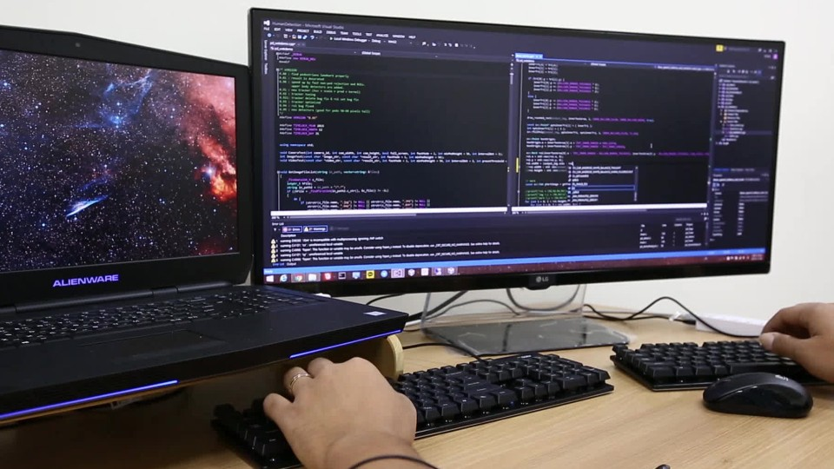

Recap on Week 1
In Week 1, we refreshed some of the core programming skills from GCSE. Regardless of what programming you do now or in the future, these core fundamentals will never change. What we are developing now is our ability to apply concepts such as abstraction and decomposition to larger problems, so that we can break a problem down sufficiently to be able to solve it with our core structures.
This week we will focus on being modular in our thinking, as we will be working with much larger programs from now.

Week 2

Part 1: Thinking Modular

What is Structured Programming?
In GCSE we learned about basic structure. In a high-level, procedural language such as Python, Pascal, Visual Basic or C#, an algorithm can be implemented using just three basic structures:
- Sequence
- Selection
- Iteration
To build on last week we can now look at these elements in more detail.

Sequence
A sequence consists of one or more statements following one after the other (all programs use sequence, you write them in a specific order).
Here is an example written in pseudocode:
hoursWorked = USERINPUT
hourlyRate = USERINPUT
totalCharge = hoursWorked * hourlyRate
OUTPUT “Total charge: ”, totalCharge

Selection
Selection is implemented using an IF…THEN…ELSE statement, it essentially makes a choice between one path or another.
Here is a pseudocode example:
IF sunIsShining THEN
takeSunhat
ELSE
takeUmbrella
ENDIF
The IF statement can also use ELSE IF to create more complex selection statements.
Here is a pseudocode example:
IF sunIsShining THEN
takeSunhat
ELSE if Raining
takeUmbrella
ELSE
takeCoat
ENDIF
Some languages also have a CASE statement (switch case in C#). This allows you to replicate complex IF statements in a more straight forward way.
Here is a pseudocode example:
SWITCH (sun)
CASE Shining:
TakeSunHat
CASE NotShining
TakeUmbrella
END SWITCH

Iteration
Iteration means repetition. Most high level languages have three iterative structures:

Unknown number of iterations, even potentially none
WHILE condition
statements
ENDWHILE

Given number of iterations
FOR x = n to m
statements
ENDFOR

Unknown number of iterations, but definitely once
REPEAT
statements
UNTIL condition

Structured Programming
Structured programming is a method of writing a computer program which uses:
- Top-down analysis for problem-solving
- Modularisation for program structure and organisation
- Structured code for the individual modules

WHAT ARE SUBROUTINES?
A set of instructions designed to perform a frequently used operation within a program. This makes it easy to repeat code. Subroutines can take two main forms:
- A procedure – simply a set of instructions carried out when called.
- A function – similar to a procedure but it also returns a value of a specific data type.

Watch the following video:
https://youtu.be/DC1Aw6BCrR8

Task
In the Battlefields program a structured approach has been used:
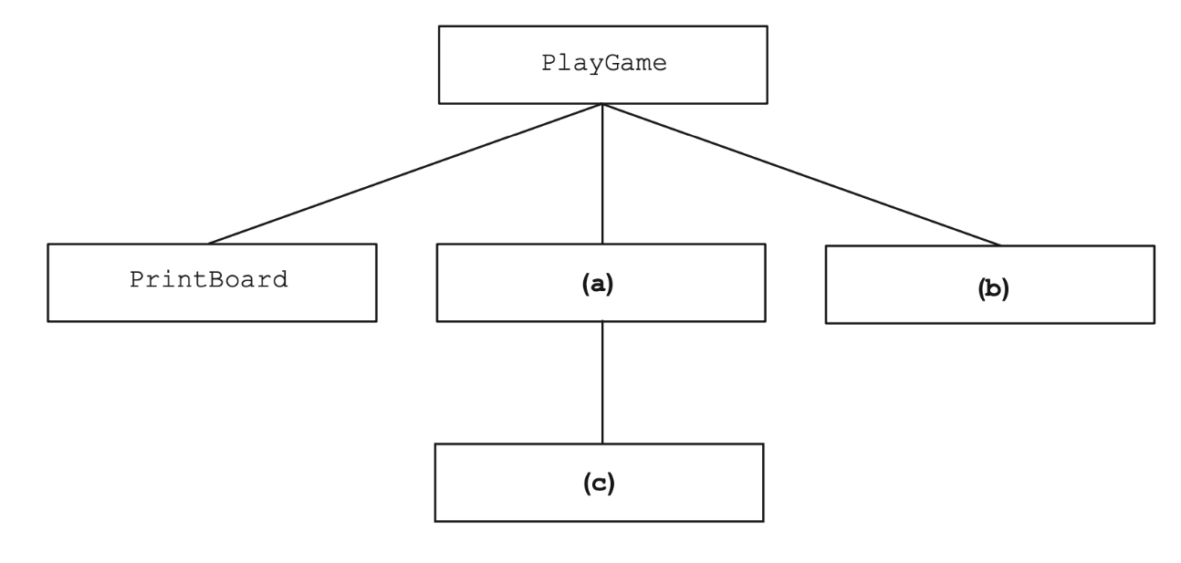
What components are represented by a, b and c?
(a)
(b)
(c)

Part 2: Pseudocode Refresh

ReaDING PSEUDOCODE
Download and store the document below – it will be useful in these and future tasks.
https://filestore.aqa.org.uk/resources/computing/AQA-8525-TG-PC.PDF

Task
The algorithm, represented using pseudo-code below describes a method to calculate the additive or multiplicative persistence of a two-digit integer. The examples below illustrate how additive and multiplicative persistence are calculated.
Example: calculating the additive persistence of 87
- 8 + 7 = 15
- 1+5=6
After 2 steps the method results in a one digit answer so the additive persistence of 87 is 2.
Example: calculating the multiplicative persistence of 39
- 3 * 9 = 27
- 2 * 7 = 14
- 1*4=4
After 3 steps the method results in a one digit answer so the multiplicative persistence of 39 is 3.
OUTPUT "Enter integer (0-99): "
INPUT Value
OUTPUT "Calculate additive or multiplicative persistence (a or m)? "
INPUT Operation
Count <- 0
WHILE Value > 9
IF Operation = "a" THEN
Value <- (Value DIV 10) + (Value MOD 10)
ELSE
Value <- (Value DIV 10) * (Value MOD 10)
ENDIF
Count <- Count + 1
ENDWHILE
OUTPUT "The persistence is: "
OUTPUT Count

Write the program in Python
Code
Clipping of Running

Part 3:Programming Tasks
For these tasks we will return to the Battleships program.

Sunken ships
Write new subroutines in the program to carry out the following tasks:
Task | The game needs to be changed so that a message is displayed when all the squares occupied by a ship have been hit.  In this example the player has made three shots and achieved 2 hits and a miss.  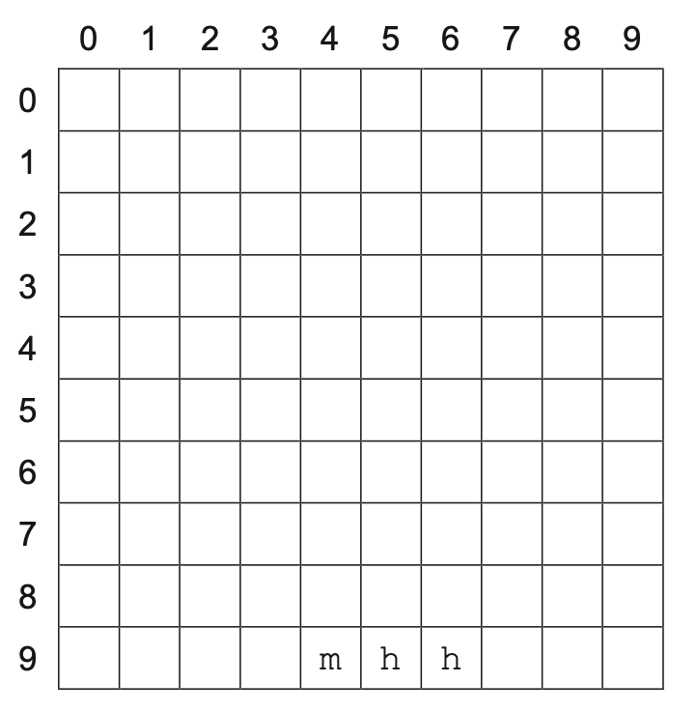  The player’s next shot into column 7, row 9 is a third hit and sinks the ship. The game displays the message 'Destroyer is sunk!' to the player.  Create a new subroutine CheckSunk that, when given the current shot location, board and list of ships, will:  - check the board to find out which kind of ship has been hit  - reduce, by one, the number of squares occupied by that ship in the list of ships  - display the message 'XX is sunk!' where XX is the type of the ship, if the ship now occupies zero squares.
Code

Task | Modify the MakePlayerMove subroutine so that the subroutine CheckSunk is called when appropriate.
Code

Task | Test your program works by conducting the following test:  • run the Skeleton Program  • select option 2 from the menu  • fire a shot at column 1, row 3  • fire a shot at column 1, row 4  • fire a shot at column 1, row 5.
Clipping of Running

End of the Game
At the moment the game only ends with the player sinking all the ships. There is no way to lose! Come up with your own ideas to improve the end of the game and have a go at implementing them.
You could:
- Limit the amount of moves a player can make to something reasonable
- Penalise errors
- Record the number of moves a player completes the game in
- Keep high scores
Code
Clipping of Running

Appendix

Battleships Code Listing
import random

def GetRowColumn():
print()
Column = int(input("Please enter column: "))
Row = int(input("Please enter row: "))
print()
return Row, Column

def MakePlayerMove(Board, Ships):
Row, Column = GetRowColumn()
if Board[Row][Column] == "m" or Board[Row][Column] == "h":
print("Sorry, you have already shot at the square (" + str(Column) + "," + str(Row) + "). Please try again.")
elif Board[Row][Column] == "-":
print("Sorry, (" + str(Column) + "," + str(Row) + ") is a miss.")
Board[Row][Column] = "m"
else:
print("Hit at (" + str(Column) + "," + str(Row) + ").")
Board[Row][Column] = "h"

def SetUpBoard():
Board = []
for Row in range(10):
BoardRow = []
for Column in range(10):
BoardRow.append("-")
Board.append(BoardRow)
return Board

def LoadGame(Filename, Board):
BoardFile = open(Filename, "r")
for Row in range(10):
Line = BoardFile.readline()
for Column in range(10):
Board[Row][Column] = Line[Column]
BoardFile.close()

def PlaceRandomShips(Board, Ships):
for Ship in Ships:
Valid = False
while not Valid:
Row = random.randint(0, 9)
Column = random.randint(0, 9)
HorV = random.randint(0, 1)
if HorV == 0:
Orientation = "v"
else:
Orientation = "h"
Valid = ValidateBoatPosition(Board, Ship, Row, Column, Orientation)
print("Computer placing the " + Ship[0])
PlaceShip(Board, Ship, Row, Column, Orientation)

def PlaceShip(Board, Ship, Row, Column, Orientation):
if Orientation == "v":
for Scan in range(Ship[1]):
Board[Row + Scan][Column] = Ship[0][0]
elif Orientation == "h":
for Scan in range(Ship[1]):
Board[Row][Column + Scan] = Ship[0][0]

def ValidateBoatPosition(Board, Ship, Row, Column, Orientation):
if Orientation == "v" and Row + Ship[1] > 10:
return False
elif Orientation == "h" and Column + Ship[1] > 10:
return False
else:
if Orientation == "v":
for Scan in range(Ship[1]):
if Board[Row + Scan][Column] != "-":
return False
elif Orientation == "h":
for Scan in range(Ship[1]):
if Board[Row][Column + Scan] != "-":
return False
return True

def CheckWin(Board):
for Row in range(10):
for Column in range(10):
if Board[Row][Column] in ["A","B","S","D","P"]:
return False
return True

def PrintBoard(Board):
print()
print("The board looks like this: ")
print()
print (" ", end="")
for Column in range(10):
print(" " + str(Column) + " ", end="")
print()
for Row in range(10):
print (str(Row) + " ", end="")
for Column in range(10):
if Board[Row][Column] == "-":
print(" ", end="")
elif Board[Row][Column] in ["A","B","S","D","P"]:
print(" ", end="")
else:
print(Board[Row][Column], end="")
if Column != 9:
print(" | ", end="")
print()

def DisplayMenu():
print("MAIN MENU")
print()
print("1. Start new game")
print("2. Load training game")
print("9. Quit")
print()

def GetMainMenuChoice():
print("Please enter your choice: ", end="")
Choice = int(input())
print()
return Choice

def PlayGame(Board, Ships):
GameWon = False
while not GameWon:
PrintBoard(Board)
MakePlayerMove(Board, Ships)
GameWon = CheckWin(Board)
if GameWon:
print("All ships sunk!")
print()

if __name__ == "__main__":
TRAININGGAME = "Training.txt"
MenuOption = 0
while not MenuOption == 9:
Board = SetUpBoard()
Ships = [["Aircraft Carrier", 5], ["Battleship", 4], ["Submarine", 3], ["Destroyer", 3], ["Patrol Boat", 2]]
DisplayMenu()
MenuOption = GetMainMenuChoice()
if MenuOption == 1:
PlaceRandomShips(Board, Ships)
PlayGame(Board,Ships)
if MenuOption == 2:
LoadGame(TRAININGGAME, Board)
PlayGame(Board, Ships)

